**COSF**

***Vers. 3/2018***

**CIS: Early Intervention Program**

**Child Outcomes Summary**

**Region:**  Date Entry COSF Completed: ____/_____/______  Date Exit COSF Completed: ____/_____/____

**Child’s Name: _________________________________________ DOB: _____/_____/_____ Gender:**  M  F

**Who was involved in determining Child Outcome Codes?**

|  |  |  |  |
| --- | --- | --- | --- |
| **Name** | **Role** | **Name** | **Role** |
|  | Service Coordinator |  |  |
|  | Family |  |  |

**What evidence was used to determine Child Outcome Codes?**

|  |  |  |  |
| --- | --- | --- | --- |
| **Check all that apply:** | **Date(s)** | Other, explain (*e.g. child care observations, specialty assessment*) | **Date(s)** |
| Family Observations |  |  |
| Assessment Tool:  AEPS  HELP  IDA |  |

**Child Outcome Codes**

*(MUST be a* ***whole*** *number between 1 and 7 using the decision tree on reverse to identify that number)*

|  |  |
| --- | --- |
| **Child Outcome Area** | **Code** |
| **Outcome A:** Positive social-emotional skills – including relationships with adults and children (and following rules if over 18 months old). *Ex: attachment/separation/autonomy, expressing emotions and feelings, and social interactions and play.*  Evidence:  **Exit only**: Have any new skills been acquired since entry? ¨ No / Not yet ¨ Yes |  |
| **Outcome B:** Acquiring and using knowledge and skills – thinking, reasoning, remembering, problem solving, language / communication. *Ex: attends, explores, imitates, object permanence, early concepts, expressive language and communication, problem solving.*  Evidence:  **Exit only**: Have any new skills been acquired since entry? ¨ No / Not yet ¨ Yes |  |
| **Outcome C:** Taking appropriate action to meet needs – taking care of basic needs (e.g., showing hunger), getting around, using “tools” (i.e., a spoon). *Ex: independent mobility, use of objects to make things happen, feeding, toileting, dressing, requests.*  Evidence:  **Exit only**: Have any new skills been acquired since entry? ¨ No / Not yet ¨ Yes |  |

**Decision Tree for Part C Child Outcome Summary Code Discussions**

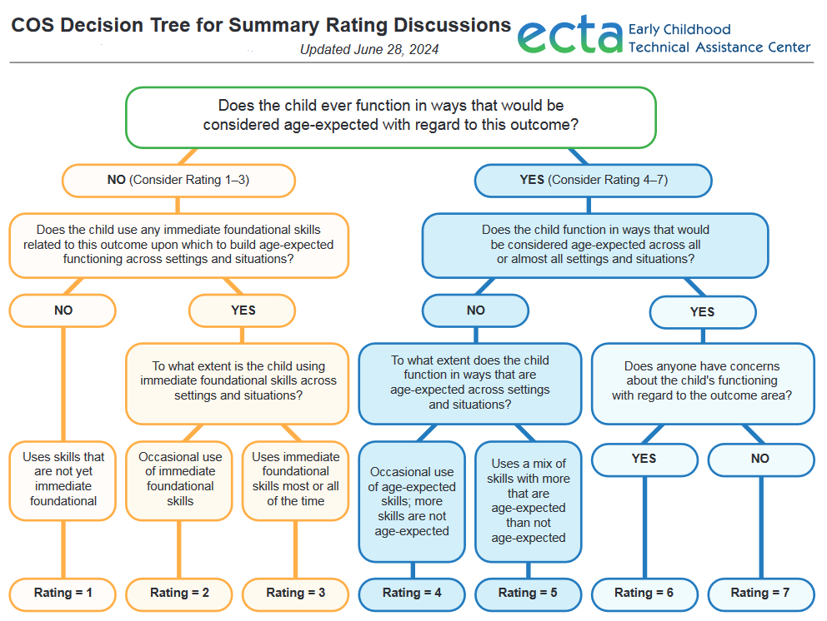

An accessible text version of the Decision Tree is available under the third section, ‘COS Decision Tree for Summary Code Discussions’ on the [ECTA website](https://ectacenter.org/eco/pages/cosform.asp).