9 DRAFT Social Cost of Carbon

The Science and Data Sub-committee (SDSC) oversaw of development and presentation of material on the method and discount rate assumptions for estimating the social cost of carbon (SCC) for the Vermont CAP , as well as a review of the Vermont Department of Public Service’s (PSD) “Cost of Carbon Reductions” (CCR) spreadsheet model.
The economic analysis of climate action plans and mitigation scenarios needs to account for the value of avoided emissions. The National Academy of Sciences defines the Social Cost of Carbon as "an estimate, in dollars, of the present discounted value of the future damage caused by a metric ton increase in carbon dioxide (CO2) emissions into the atmosphere in that year or, equivalently, the benefits of reducing CO2 emissions by the same amount in that year." The SDSC adopted the SCC findings from the report completed for the Climate Council Titled “Social Cost of Carbon and Cost of Carbon Model Review Analyses and Recommendations to Support Vermont’s Climate Council and Climate Action Plan” and recommended a damage-based approach to valuing emissions – in other words an estimate of the value of economic, environmental, and health damages associated with a unit (typically a metric tonne) of emissions. Specifically, the SDSC recommended that Vermont should:
1) Value greenhouse gas emissions costs (and avoided costs) by utilizing a global damage-based estimation of the Social Cost of Carbon (SCC), based on models developed for the New York Department of Environmental Conservation (NYDEC) by Resources for the Future.
2) Recognize that the NYDEC guidelines offer a range of possible discount rates that value future damages and cost of those, and based on polling of the Science and Data Subcommittee and meeting attendees, that it is reasonable to utilize the SCC that was developed using the central discount rate of 2%. 2% is one reasonable discount rate to reflect the time value of money from society’s perspective.
3) Plan for updating of the SCC and discount rate on a regular basis, taking into account new research that may be published that impact SCC and application of the discount rate.
The resulting Social Cost of Carbon Dioxide (and range of outcomes) is provided in Exhibit X, below:
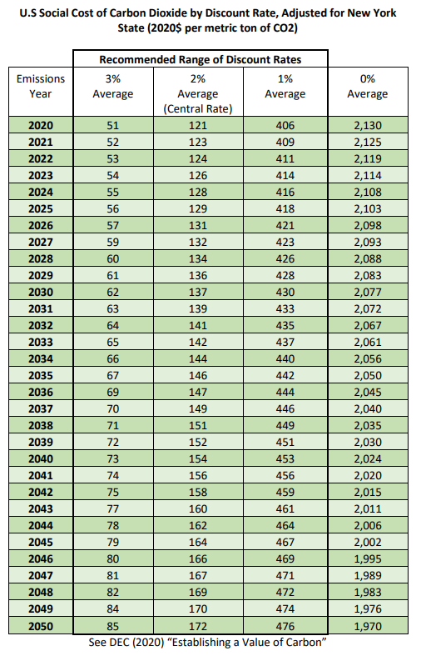
Source: Appendix: Value of Carbon, New York Department of Environmental Conservation, revised June 2021. https://www.dec.ny.gov/docs/administration_pdf/vocapprev.pdf.

With regard to the review of the PSD’s CCR tool, the Technical Consultants found that it has value for understanding the relative cost-effectiveness for near-term investment provided by several technological measures, as it was intended to be. However, a number of improvements were recommended, and a greenhouse gas mitigation technology/policy supply curve will be developed in conjunction with ongoing modeling. The SDSC recommended that no further action by the Council was necessary, but that Vermont:
1) Continue to maintain and update the accounting for mitigation pathways to promote transparency and consistency in assumptions. This could come in the format of the “Cost of Carbon” model that the Department of Public Service creates, or through other reasonable means.
2) Initially through technical consultant and to be updated regularly by the State of Vermont, create a greenhouse gas mitigation technology/policy supply curve that estimates the relative net cost of mitigation policies and/or technologies per ton of greenhouse gas emissions saved.
The full Technical Report that provides recommendations on both of these issues is available on the Council’s website.

A full description of the model can be found as part of the Public Service Department’s Annual Energy Report.
Energy Futures Group, August 14, 2021 (Revised August 31, 2021) https://aoa.vermont.gov/sites/aoa/files/Boards/VCC/SCC%20and%20Cost%20of%20Carbon%208-31%20DH%20revised.pdf
Greenhouse Gas Emissions other than CO2 can and should appropriately value the cost of greenhouse gas emissions or benefit associated with mitigation of those emissions. The Energy Futures Group report presents Social Cost of Methane and a Social Cost of Nitrous Oxide values. Other gases, until better information can be developed, can and should be converted to Carbon Equivalent emissions.
A discount rate is a method to place a present value on costs or benefits that will occur at a future date.

