9 DRAFT Social Cost of Carbon

The Science and Data Sub-committee (SDSC) oversaw the development and presentation of material on the method and assumptions for estimating the Social Cost of Carbon for the Vermont CAP, as well as a review of the Vermont Department of Public Service’s “Cost of Carbon Reductions” spreadsheet model. The Climate Council approved the recommended SCC, underscoring the need for
the economic analysis of climate action plans and mitigation scenarios to account for the value of avoided emissions.
The Social Cost of Carbon is an estimate of the value of economic, environmental, and health damages associated with a unit (typically a metric tonne) of emissions. The SDSC adopted the Social Cost of Carbon findings from the report completed for the Climate Council Titled “Social Cost of Carbon and Cost of Carbon Model Review Analyses and Recommendations to Support Vermont’s Climate Council and Climate Action Plan” and recommended a the use of a stream of values that can be used to estimate the avoided damages of emissions associated with greenhouse gas mitigation measures. Specifically, the SDSC recommended, and the Council agreed that Vermont should:
1) Value greenhouse gas emissions costs (and avoided costs) by utilizing a global damage-based estimation of the Social Cost of Carbon, based on models developed for the New York Department of Environmental Conservation (NYDEC) by Resources for the Future.
2) Recognize that the estimation of the Social Cost of Carbon is highly dependent on how costs and savings that occur in the future are valued in the present, as represented in a “discount rate”, and that the NYDEC guidelines offer a range of possible discount rates that value future damages and cost of those. Based on literature review conducted in the report, polling of the Science and Data Subcommittee and meeting attendees, as well as discussion of the whole Council, the Council determined it is reasonable to utilize the Social Cost of Carbon developed using the central discount rate of 2%. Because the value of the Social Cost of Carbon is highly dependent on the assumption for a discount rate, it was agreed that sensitivities to the economic analysis using Social Cost of Carbon’s developed using discount rates of 1%-3% should be completed, illustrating a range of possible economic outcomes associated with different valuations of future costs and benefits of mitigation measures.
3) Plan for updating of the Social Cost of Carbon and discount rate on a regular basis, taking into account new research that may be published that impact Social Cost of Carbon and application of the discount rate.
The resulting Social Cost of Carbon Dioxide (and range of outcomes), which will be utilized in estimating the economic impact of this Climate Action Plan and its mitigation scenarios is provided in Exhibit X, below. As the Exhibit shows, a higher discount rate represents a lower valuation of costs the future relative to the present, and thus the Social Cost of Carbon is lower, while a lower discount rate values the future more highly and results in a higher Social Cost of Carbon (which in turn improves the economic benefit/cost analysis for mitigation measures).
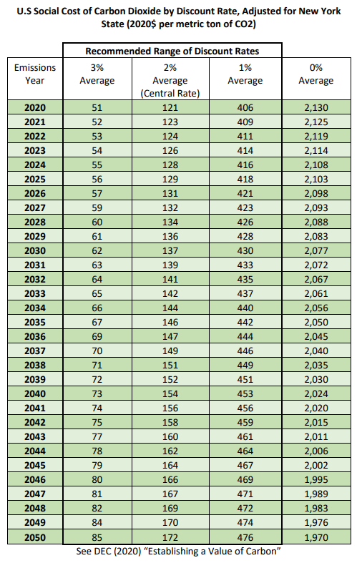
Source: Appendix: Value of Carbon, New York Department of Environmental Conservation, revised June 2021. https://www.dec.ny.gov/docs/administration_pdf/vocapprev.pdf.

With regard to the review of the Public Service Department’s “Cost of Carbon Reductions” tool, which presented an initial cost-effectiveness comparison between selected technologies and/or policies on the basis of dollar per ton of Carbon Dioxide, the Technical Consultants found that the model has value for understanding the relative cost-effectiveness for near-term investment provided by several technological measures, as it was intended to be. However, a number of improvements were recommended. In addition, a greenhouse gas mitigation technology/policy supply curve will be developed in conjunction with ongoing modeling. The SDSC recommended that no further action by the Council was necessary with regard to the specific Cost of Carbon model evaluated, but that Vermont:
1) Continue to maintain and update the accounting for mitigation pathways to promote transparency and consistency in assumptions. This could come in the format of the “Cost of Carbon” model that the Department of Public Service creates, or through other reasonable means.
2) Initially through technical consultant and to be updated regularly by the State of Vermont, create a greenhouse gas mitigation technology/policy supply curve that estimates the relative net cost of mitigation policies and/or technologies per ton of greenhouse gas emissions saved.
The full Technical Report that provides recommendations on both of these issues is available on the Council’s website.

A full description of the model can be found as part of the Public Service Department’s Annual Energy Report.
The National Academy of Sciences defines the Social Cost of Carbon as "an estimate, in dollars, of the present discounted value of the future damage caused by a metric ton increase in carbon dioxide (CO2) emissions into the atmosphere in that year or, equivalently, the benefits of reducing CO2 emissions by the same amount in that year."
Energy Futures Group, August 14, 2021 (Revised August 31, 2021) https://aoa.vermont.gov/sites/aoa/files/Boards/VCC/SCC%20and%20Cost%20of%20Carbon%208-31%20DH%20revised.pdf
Greenhouse Gas Emissions other than CO2 can and should appropriately value the cost of greenhouse gas emissions or benefit associated with mitigation of those emissions. The Energy Futures Group report presents Social Cost of Methane and a Social Cost of Nitrous Oxide values. Other gases, until better information can be developed, can and should be converted to Carbon Equivalent emissions.
A discount rate is a method to place a present value on costs or benefits that will occur at a future date.

