Energy Economy and Opportunities Related to Climate Action
Current Vermont Context Regarding Energy & the Economy
In 2018, Vermont’s Gross State Product included roughly $32 billion in economic transactions. Over the last decade, the cost of energy expenditures for Vermont households and businesses has averaged above $2.7 billion per year.
Figure 1. Vermont Average Annual Energy Consumption and Expenditures, 2009 - 2018
 | Volume | $ Spent
Gasoline (gallons) | 321,103,421 | $ 938,120,000
Diesel (gallons) | 64,716,958 | $ 238,330,000
Fuel Oil (gallons) | 129,851,400 | $ 386,400,000
Propane (gallons) | 105,638,400 | $ 261,660,000
Natural Gas (bcf) | 10.5 | $ 104,760,000
Electricity (MWh) | 5,530 | $ 784,170,000
Wood |  | $ 80,000,000
TOTAL |  | $ 2,793,440,000
Source: EIA

Of this total, an average of about $2 billion a year has been spent on fossil fuels (gasoline, diesel, fuel oil, propane, and natural gas) over the last decade. Vermont’s current dependence on fossil fuels leads to high and unpredictable energy costs for Vermont households and businesses. As shown in Figure 2, gasoline and diesel have been much more expensive and price volatile as transportation fuels compared to electricity. Similarly, the two most expensive and price volatile primary heating options have long been propane and fuel oil (note: while resistance electric heat is more expensive than propane and fuel oil, Vermont building code does not allow it to be a primary heat source). In comparison, heating with cold climate heat pumps and/or wood generally provides lower operating costs, with greater price stability.
Figure 2: Cost Comparison of Different Transportation Fuels Over Time
Figure 3. Cost Comparison of Different Heating Fuel Options Over Time
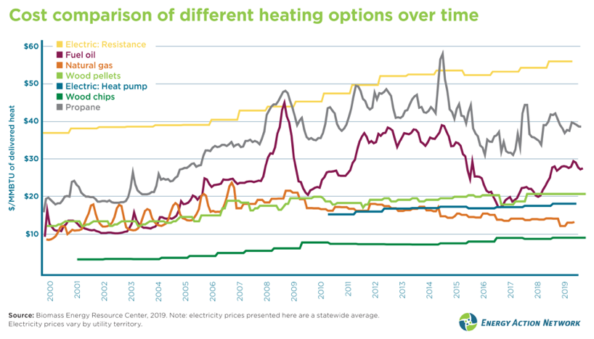
Not only do fossil fuel expenses represent a cost burden on Vermont consumers: they also generally create a drain on the Vermont economy. 100% of fossil fuels used in Vermont are imported. As commodities that have a relatively small amount of in-state labor represented in their overall price, much of the total amount Vermonters expend on fossil fuels (especially fuel oil, gasoline, and diesel) represents an outflow of dollars, with comparatively little value to the State economy in terms of local economic activity. In contrast, energy-related expenditures like weatherization, electricity purchases, and wood heating contribute more, per dollar spent, to local economic activity and Vermont-based jobs.
Figure 4: Local Economic Activity Related to Different Energy Sources in 2018
 | Total sales (2018) | Percent of retail price with local economic activity | Vermont economic activity | Employment estimate | Vermont compensation estimate
Fuel oil | $340 million | 25% | $85 million | 1,400 | $85 million
Propane | $310 million | 45% | $140 million
Natural Gas | $115 million | 50% | $60 million | 135 | $15 million
Electricity | $737 million | 50% | $370 million | 1,250 | $140 million
Wood for thermal | $65 million | 90% | $60 million | 1,200 | $60 million
Wood for electric | $25 million | 80% | $20 million
Gasoline and diesel | $1021 million | 30% | $300 million | 4,150 | $165 million

There are important demographic differences in energy use and energy cost burdens. On average, upper-income households consume more fossil fuels for transportation and heating, spending more on energy than lower-income households. However, the share of income that lower-income households spend on energy – their energy burden – is higher than the share spent on energy by upper income households. Far too often, those who can least afford it are stuck with the highest costs for energy, from renters who have to heat with resistance electric heat because landlords have not upgraded heating systems, to lower-income Vermonters who often drive older vehicles that are more expensive to operate and maintain.
Another important difference is that rural households tend to spend more on transportation than urban households. Indeed, average total energy burden (spending on transportation and heating fuels as well as electricity, as a share of total income) varies by region, from a lowest average of 6.7% to a highest of 17.4%, in multiple Northeast Kingdom towns.
Figure 5. Total Energy Burden (Average) by Town
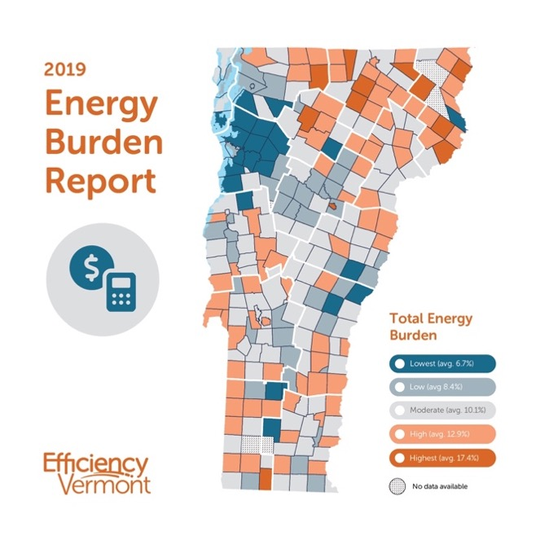
Economic Opportunities Related to Climate Action
Transitioning off of fossil fuels presents significant opportunities for Vermonters: lower energy prices; greater investment in the Vermont economy; and more and better paying local jobs.
The extent to which Vermonters can efficiently utilize electricity for transportation (electric vehicles) and heating (heat pumps for space and water heating) presents an opportunity to use an energy source that can now be used more economically and that can contribute more to the Vermont economy. The same is true of wood heating. Other renewable fuels, such as B100 biodiesel or renewable natural gas can not necessarily be counted on to provide energy cost savings, even if they can provide GHG emissions reductions when replacing fossil fuels.
There are up-front costs related to equipment replacement or change-outs that also have to be considered alongside fuel costs (i.e., capital vs. operating costs). However, with federal, state, and utility incentives, the up-front cost of electric or renewable alternatives can often be lower than those for fossil fuel equipment (though prices vary by model).

Historically, we have used fossil fuels mainly out of necessity: to get to work or school; to keep our homes and businesses warm; to mow our lawns or clear our driveways of snow. However, over the last decade it has become increasingly possible to do each of these things without needing fossil fuel. Whenever a vehicle, a heating system, or other piece of fossil fueled equipment reaches the end of its life, we now have proven and available electric technology or renewable alternatives ready to take the place and do the same job—oftentimes better and more affordably. In some cases, however, such as heavy duty applications, electric or renewable alternatives are not yet as advanced in terms of economic and technical feasibility.

Yet many opportunities are ready now. Take electric vehicles (EVs), for example. The Union of Concerned Scientists estimates that EVs, on average, can save rural Vermont drivers over $1,500 a year compared to gas vehicles. On average, charging an EV costs about the equivalent of $1.50 a gallon in Vermont. However, depending on electric utility territory, if customers enroll in off-peak charging programs, charging an EV can cost even less: the equivalent of only $1.03 (Green Mountain Power territory) or even as low as $0.60 (Burlington Electric). That’s a big difference when compared to gas prices that have been well over $3.00 a gallon since July, 2021 having spiked nearly 50% in the last year. EVs also cost less to maintain (no oil changes, for instance). Finally, with federal, state, utility, and other incentives, EVs—whether new or used—can cost less up-front than comparable gasoline models, though the extent to which this remains the case depends on continued incentives (and can be true more consistently with both expanded incentives and future projected cost decreases, as EVs reach scale).
Home and building weatherization can significantly reduce heating costs while improving health and comfort. And heat pump systems and efficient wood heat—whether with efficient stoves or automated boilers and furnaces—both reduce greenhouse gas emissions and can save consumers money compared to fossil heat. It is important to note that potential savings or costs related to heat pumps do vary depending on utility territory and other factors. Meanwhile, cost savings from use of efficient wood and pellet stoves are often more straightforward than cost savings from automated wood pellet boilers, which often depend on equipment purchase incentives to achieve price parity.

Of course, the energy transition will not and cannot happen overnight. Many Vermonters are tied to investments they made in fossil vehicles or heating systems, with no choice but to keep using them in the near term. Instead, a cost-effective and practical approach is to focus on the next point of purchase: that time—whether one, five, or ten years away—when a piece of equipment reaches the end of its life and needs to be replaced anyway. When that situation comes, we should use multiple policy, program, and incentive-based tools to equitably help people choose clean transportation and heating options and discourage locking in decades more of fossil fuel dependence that we can no longer afford—for consumer protection, health, and climate reasons.

It’s not just utilities, electricians, and HVAC professionals who stand to benefit from this transition. Delivering efficient and clean energy services can also be a major opportunity for local businesses that have historically sold fossil fuels and serviced heating equipment. Thankfully, there are some forward looking energy service providers (which used to call themselves fuel dealers) that are already shifting their business models to sell less fossil fuel by providing weatherization, wood pellet delivery, B100 biodiesel, and/or heat pump installation services. Similarly, VGS is expanding weatherization services and increasing the amount of renewable natural gas in their system.

Indeed, while fossil fuels are a problem, the local fuel dealers and utilities who have historically provided them have the opportunity to be part of the solution, creating new business models that better serve their customers, allowing fuel dealers to have more sustainable business futures.

While VELCO reports that our current transmission system is capable of handling high levels of electrification through 2030, significantly expanding the amount of transportation and thermal energy needs met by electricity will eventually necessitate new investments in our transmission and distribution system. The extent to which Vermont households and businesses save money via beneficial electrification of transportation and thermal energy use will depend in part on Vermont’s ability to secure low-cost carbon-free electricity resources, as well as efficient and effective demand response and load management strategies.

Figure 6: Clean Energy Jobs by Sector, 2014 – 2021
The Clean Energy Industry Report has tracked Vermont employment in the clean energy sectors since 2014. As of 2020, clean energy jobs made up about 6% of total employment in Vermont. Generally speaking, the median wage for clean energy jobs (approx. $27/hour) is much better paying than the statewide median wage (approx. $19/hour). Meeting our climate commitments via investments in energy efficiency and clean energy can be a win-win-win for Vermont consumers, the Vermont economy, and Vermont workers.

Note: Data for wood is available on an irregular basis, so this figure represents the estimate for 2018 from the Department of Forests, Parks, and Recreation, not the EIA average from 2009 – 2018.
Note: Total sales in 2018 were lower than the 10 year average (2009 – 2018), which was: fuel oil: $386 million, propane: $262 million, natural gas: $105 million, electricity: $784 million, gasoline: $938 million, and diesel: $238 million.
The percent economic activity varies with the commodity price of fossil fuels. Higher commodity prices result in lower in-state percent activity. Note: these figures have been updated with additional information as of November, 2021 and differ from previous ACCD estimates.
2018 Quarterly Census of Employment and Wages
Many Vermont fuel oil dealers also provide propane services. The employment figure includes both fuel oil and propane delivery services
The propane figures may be high. The sales figure is taken from EIA but price estimates may be larger than actual, as described in the propane section of the longer economic chapter in the appendix.
Includes a large number of self-employed, sole proprietors
Include $110 million in Vermont transportation taxes
Includes other services sold at gasoline stations
See page 18, 2021 EAN Annual Progress Report for Vermont. https://www.eanvt.org/tracking-progress/annual-progress-report/2021-annual-progress-report/
Note: potential savings related to use of heat pumps depends on a number of factors, including but not limited to: utility territory (i.e., differential electricity rates); the fuel it is displacing (i.e., savings potential is greater for fuel oil and propane users, perhaps not for natural gas users) variable efficiencies depending on temperature (i.e. heat pumps are less cost effective when temperatures drop below zero); and proper programming and use.
https://www.ucsusa.org/about/news/rural-communities-could-benefit-most-electric-vehicles
See the Drive Electric Vermont website to learn more
https://publicservice.vermont.gov/sites/dps/files/documents/Renewable_Energy/CEDF/Reports/2021_VCEIR_FINAL.pdf
https://publicservice.vermont.gov/sites/dps/files/documents/Renewable_Energy/CEDF/Reports/2020%20VCEIR%20Final.pdf

