
Transmission Right-Of-Way
Management Plan

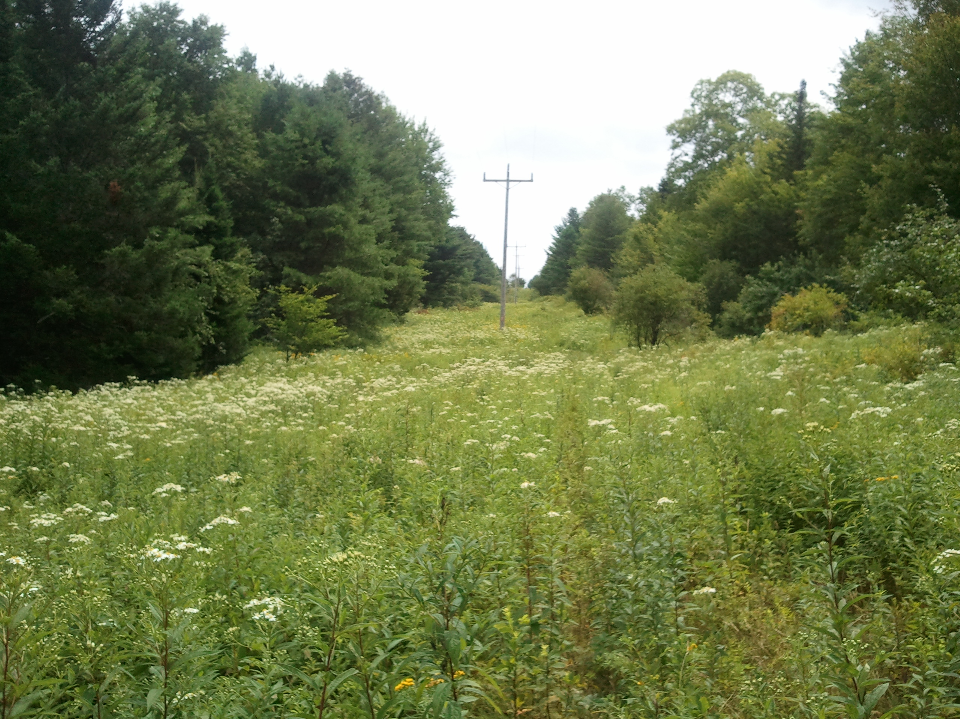

TABLE OF CONTENTS

PAGE

- HISTORY OF RIGHT-OF-WAY MANAGEMENT 1

A. Summary of Operations

- DESCRIPTION OF SYSTEM 4

A. Territorial Description

B. Management Description

- THE RIGHT-OF-WAY MANAGEMENT PROGRAM 4

A. General Background Information

B. Geographical Description

C. Description of GMP Transmission System

D. Cost effectiveness of Right-Of-Way Management

E. Right-Of-Way Management Policy

F. Invasive Species Assessment & Control

G. Environmental Effects of Right-Of-Way Management

- GENERAL PLAN OF OPERATIONS 21

A. Framework For Integrated Vegetation Management Cycle

B. Systems of Vegetation Control

C. Control Schedule- Description of Cycle

D. Right-Of-Way Inspection and Monitoring Standards

E. Right-Of-Way Management Records.

F. Cooperation & Education

G. Internal Review

- APPENDIX A 38
-Five Year Cycle Map of GMP Transmission System

-Five Year Cycle of GMP Transmissions System

-Compatible Plant List

-Incompatible Plant List

-Composition of Cutting Crew

-Composition of Spray Crew

-Sample Time Sheet

-Sample Spray Report

-Landowner Contact Report Form

- APPENDIX B 53

-Maintenance Cutting Procedures

I. General Field Consideration

II. General Maintenance Practices

III. Cutting Specifications

IV. General Operational Policy

V. Vermont Fire Warden and Slash Law

VI. Definitions

- APPENDIX C 71

-Maintenance Herbicide Application Procedures

I. General Field Considerations

II. General Maintenance Practices

III. Herbicide Responsibilities

IV. State Regulations

V. Herbicide Spills-Emergency Action Procedures

VI. Definitions

- APPENDIX D 100

-Sketches of ROW Conditions

- APPENDIX E 103

-Literature Cited

GREEN MOUNTAIN POWER CORPORATION

RIGHT-OF-WAY MANAGEMENT PLAN

- HISTORY OF RIGHT-OF-WAY MANAGEMENT AT GMP

The history of right-of-way management at Green Mountain Power Corporation (hereinafter referred to as GMP) is related to land use and electric power demand.

In the early years of GMP, much of Vermont was pastured or open land. This was especially true near the many small farming towns where power was needed. The vegetative maintenance of these early lines was done with men using axes and handsaws. Hedgerows and scattered tree growth, that cattle found undesirable, made up much of the maintenance cutting.

As time passed, and electrical demands increased, the need for more and larger lines became evident. Some lines were rebuilt from 33 to 46 KV. New lines were built, and distribution lines were converted to transmission lines. Some of these lines crossed hilly, wooded areas that were left idle. These areas re-grew with sprouts from stumps and from the roots of the large trees at the edge of the right-of-way. Where the soil was sandy, and ground conditions were right, pine seeded in. In some right of ways, hardwood species became established.

In the 40’s and 50’s, the transmission line crews did a large portion of the cutting. If there was an area of extensive brush, the company would hire a contract crew.

In the 60’s, contract crews were used more frequently. The use of helicopter applied herbicides was the prescribed and accepted method at that time.

In the early 70’s, cutting was emphasized as a maintenance tool. Herbicide application was done on a limited basis. The intent was to have a controlled application to selected trees. The herbicides used had very limited effectiveness. Across Vermont, more acres were succumbing to forest succession. For the next several years, an intensive cutting and treating program was carried out to bring GMP rights-of-way into a manageable condition. The herbicides used in the early and middle parts of this decade were not as effective as the ones used today. Some hardwoods were affected, but many were just slowed or not affected at all. The softwood growth was slowed somewhat by the oil based product. These products have a limited affect on existing root systems. The net result was continued tree growth, which demonstrated the need for a more extensive vegetation management program.

The first true management cycle began in 1979. During the first five years, adjustments were made for individual lines. In 1983, it was evident from line conditions that the basic
five-year cycle was the desirable frequency. The average tree height was down, as was the overall density.

The following is an integrated vegetative management plan based on knowledge, experience, and shared industry research over the years.

A. Summary of Operations

Any management plan is subject to the whims of nature. It must be remembered that a well-organized plan will tend to be affected by unknown variables that lay in the future. The primary way to handle these situations is to have flexibility in approaching right-of-way management. Examples of these unknowns are: an unusually high tree seed source ; severe wind and ice storms; a series of high growth rate years. The vegetative environment is not static and each growing season changes plant growth and production.

A systematic approach that has a tendency to encourage the development of the grass, herb, and shrub stages of plant succession is a desirable approach to ROW management. Research studies, as well as the history of other utilities, have shown this to be a practical management system. This approach is termed integrated vegetation management.

Manual cutting creates sprout growth of sufficient size to be easily identified and controlled by the herbicides. In herbicide controlled areas, there is a tendency for tree population to decrease and shrub-herb-grass population to increase. The net result is a gradual decrease in the amount of herbicide needed to control the undesirable trees and shrubs.
The following list demonstrates the trend of herbicides applied per acre in the year indicated. Our methods reflect the historical decrease in herbicide use at GMP:

Average Gallons Herbicide
Concentrate Per Brush Acre

1979 1.02 1996 0.26
1980 0.88 1997 0.29

1981 0.82 1998 0.31
1982 0.83 1999 0.22

1983 0.69 2000 0.12
1984 0.64 2001 0.11
1985 0.65 2002 0.12
1986 0.70 2003 0.14
1987 0.71 2004 0.12
1988 0.67 2005 0.10
1989 0.77 2006 0.20
1990 0.55 2007 0.17
1991 0.51 2008 0.15
1992 0.50 2009 0.18
1993 0.29 2010
1994 0.31 2011
1995 0.23 2012

There are several types of areas that require high maintenance. These locations include: screens at road crossings and near homes, feathered areas, no treat areas (springs, erosion areas, streams and wet lands). These areas require careful monitoring, frequent evaluation and may require more pruning or cutting.

- DESCRIPTION OF GMP

A. Territorial Description

Most of the GMP service area and transmission lines are situated in the State of Vermont, which is located in the northwest corner of New England. GMP Transmission lines cross through several other small utility companies’ distribution areas. A small number of GMP’ transmission circuit miles are located in the State of New Hampshire and New York.

B. Management Description

Green Mountain Power Corporation is primarily electric power delivery organization. The company is wholly owned subsidiary of Gaz Metro. Within GMP, there are specialized technical and service departments (such as Engineering, Legal, Environmental and Right-of-Way) which provide support to the Transmission Vegetation Management Department.

- THE RIGHT-OF-WAY MANAGEMENT PROGRAM

A. General Background Information

Right-of-way (ROW) management has been under study for many years. In 1953, a cooperative study with a public utility (Northeast Utilities) was begun on the Connecticut Arboretum (Connecticut College, New London, Connecticut). This was done to show the effects of the controlled use of herbicides in trying to create a shrub community in a ROW. The implications from the study were that “selective use of herbicides has practical application in rights-of-way and wildlife habitat management, naturalistic landscaping and maintenance of habitat diversity.”

Another study, which was started in 1953, was done by Professors W.C. Bramble and W.R. Byrnes in connection with long term effects of herbicides on plant cover, game feeding habits and overall ecological effects. Much valuable information was obtained. It indicated that there was increased use of ROW by game, and improved food and cover for wildlife. The study has been conducted over a period of 60 years, and is ongoing to the present time.

In 1972, treated utility transmission rights-of-way in New Hampshire, Georgia and West Virginia were studied for wildlife use as compared to untreated plots. The herbicide treated plots showed greater wildlife use than adjacent habitats that were not treated.
Other studies indicate the desirability of selective cutting and treating over flat cutting and broadcast herbicide application. Utilities in New England have used
integrated vegetation management for the last 25 to 30 years or more.

Based on the results of these vegetation management studies and field experience, GMP has been developing a ROW management policy that is consistent with the general land use of the State.

B. Geographic Description

Because of the geography of the State of Vermont and its inter-relation with the GMP transmission system, the following section has been included to provide a perceptual view of the type of terrain encountered in rights-of-way management.

- Physiographic

GMP transmission lines traverse many types of landforms, which are mostly located in rural wooded areas. ROW’s tend to follow an average elevation. The tops of higher hills are avoided to minimize the effects of severe mountain weather, and for the aesthetic reasons. The backbone of Vermont is the Green Mountain chain, which ranges in height from about 2,000’ to the peak of Mt. Mansfield (4,396’). Mt. Mansfield, Killington, Mt. Ellen and Camel’s Hump are the highest in this range.

Vermont has 400 lakes of which Champlain, Bomoseen, Memphremagog, Whitingham, Willoughby and Dunmore are the largest.

Rivers and streams that cross Vermont are generally small and feed either the Connecticut River on the east or Lake Champlain on the west. A few tributaries run north to Canada or south to Massachusetts. These rivers also have influenced farming. The largest of cultivated lands are found in the Champlain Valley and the Connecticut River Valley.
Vermont’s terrain is primarily rolling to steep, often rocky, and strewn with boulders and ledge areas. Side slope and hidden gullies are frequently found in GMP rights-of-way.
Dense ferns, berry bushes and tree sprouts conceal holes, rocks and ditches. Traversing the right-of-way can be an extremely difficult and hazardous task.

- Forest Groups

Three major forest groups in Vermont make up the tree species found in the GMP rights-of-way. These groups, or bands of forest, relate somewhat to elevation, site and macroclimate of a region. The three main groups in Vermont are: (a) spruce-fir, (b) northern hardwood, and (c) white pine, hemlock, hardwood group. There are a large number of sub-groups, which exist within these larger groups.

- Spruce-Fir is the group found in the upper elevations and mountainous areas. Primary species include Red Spruce, Balsam Fir, Yellow Birch, Red Maple and Hemlock. Other species may also be found within this group. Tree growth rate varies widely and depends on a number of factors, such as aspect of slope, moisture, availability, competition, seed source and soil makeup.

- Northern Hardwood Group is the group generally found in the elevations below the Spruce Fir type. This is the predominant forest group that GMP ROW’s cross through. Primary species are Yellow Birch, American Beech, and Sugar Maple. In some southern areas of Vermont, Oak is an important addition to this group. Other associated species include Red Spruce, Quaking Aspen, Basswood, Cherry, and White Ash. In the central and northern part of the State, White Pine and Hemlock become more evident within this group. A group found in the southern part of the State is Basswood-Ash-Oak. This is often moderate to fast growing and among the most difficult to control.

On drier sites and areas that have been burned over, we find such species as Pine Cherry, Yellow Birch, Poplar and Paper Birch. These are aggressive and fast growing. Some of these areas will eventually be taken over by the Beech, Birch and/or Maples. Tree growth in this group varies widely. The overall trend tends to be faster than in the Spruce Fir group.

- White Pine Hemlock Hardwood Group is the third major group found in Vermont. This combination is found in many pockets or areas where conditions are right. One of the largest areas is on Vermont’s side of the Connecticut River Valley. The dominant species are the White Pine and/or Hemlock. In heavy seed years this group aggressively invades GMP ROW’s.

- Agricultural Use

Dairying is the dominant form of agriculture within this state. The primary dairy areas are located in Addison, Franklin and Orleans counties; although there are many small hill country farms scattered throughout the Green Mountain State. Horses, sheep, and beef cattle farming are being carried out to some extent with beef production slowly growing. Other Vermont agriculture includes market gardens, fruit orchards, and maple syrup production.

- Soils

Vermont has a wide variety of soils most of which create desirable conditions for tree growth. The parent materials range from hard crystalline rocks to lake-plain sands and clays. The glaciers caused a mix of solid with sandstone, limestone, clays and shales. Podzolic soils tend to dominate our landscape. Hydromorphic soils are also found in Vermont. In the higher elevations we find rough stony land with shallow podzols.

The soils that are dominant in the eastern and central portion of Vermont, from the northern to the southern end, are loams and clay loams that came from glacial drift. Stony and gravely loams, also from glacial drift, are found prevalent in the Connecticut and Champlain Valleys. The latter soils have lower bulk densities and higher permeability rates than clay and silt clay soils.

Soil structure is important in our concern for field stabilization or erosion. Some areas require extra care and maintenance such as water bars and seeding.

Although soils in the state are often acid and fairly low in phosphorous, they are generally very suitable for vegetative growth. In general, vegetation requires low nutrient levels for good growth conditions.

- Climatic Conditions

Vermont is near the middle of the North Temperate Zone and the prevailing winds are from a westerly direction. Climate in Vermont can be described as variable and on some occasions violent. Extremes of temperatures of both heat and cold are common. Temperatures often range from 100ºF above to 42ºF below zero.

Ice storms and heavy wet snows are not an uncommon condition in Vermont. When rain falls from a warm upper layer, into a shallow freezing cold area near the earth, ice is formed on exposed objects. Ice on the side of a dense, unbroken evergreen, 50 feet high with an average crown width of 20 feet, weighs about 5 tons. It is obvious why this is of great concern to a electric utility company.

Transmission rights-of-way are usually 100 feet wide and the tree crown is almost always heaviest on the side toward the sunlight, which is also, the side facing the transmission line.

Wind, in combination with rain, wet snow and/or ice, can have devastating results. Heavy rains, especially in the spring or late summer, have the affect of softening up the typical Vermont soils, thus increasing the likelihood of tree wind throw. As increasing amounts of water are absorbed by certain species of trees during rainy periods, they tend to soften and slowly bend over which could result in a hazard to transmission lines.

Severe cold occasionally causes problems. This is especially true when the drop in temperatures is sudden. Water in branch seams, expanding when it turns to ice, can break limbs off. Rapid drops in temperature can cause other mechanical damage to bark resulting in rot and eventual breakage.

Throughout the year, Vermont’s climate is extremely variable. The wet spring season, combined with suitable soils, often results in rapid tree and shrub growth. Large root systems, with sprouts, may develop growth of 6 to 8 feet per year in our ROW’s. The variable nature of Vermont’s soils also results in erosion and wind throw conditions.

- General Land Use

Forests uses of various types are the dominant land use in Vermont. About 80% of Vermont’s surface area is forested. Hunting, fishing, skiing, snowmobiling and camping are carried out on many public and private lands.

A second important use of land in Vermont is that of dairying and farming. Crops such as corn, alfalfa, soybeans, apples and mixed farming are also found in many areas. A third land use is that of residential areas. Small villages as well as chalets, country homes and condominiums are found throughout Vermont.

A fourth land use is that of quarrying and mining. The primary minerals that are mined are marble, granite, slate, and limestone.

Industrial land use is located near the larger towns. Our transmission system serves the machine tool industry, electronics and many other manufacturing and processing industries.

The GMP transmission system passes through all of these areas. Through the use of proper rights-of-way management techniques, GMP contributes to improved wildlife habitat and recreational corridors for the general public. (Refer to Page 18, Section G, subsection 2)

C. Description of GMP Transmission System

- General Description

The transmission system contains 34.5kV, 46kV, 69kV, and 115kV lines. There are 155 lines, which total approximately 950 miles in length. The ROW area is approximately 10,000 acres of which approximately 55% are treated, 25% are hand cut, 5% are mowed, and 15% is either open or in higher use.

The average GMP transmission right-of-way width is 100 feet, (50 feet each side of the centerline). Due to the rolling & steep topography, side slope occurs in many areas. (See drawing of danger tree condition, Appendix C.)

Penstocks are large wooden and/or metal pipes which carry water from a water source to a hydroelectric facility to produce bulk transmission power. GMP owns 15 penstocks in the State of Vermont which total approximately 17.5 miles in length. The ROW is approximately 42 acres which have historically been hand cut and brush-hogged. The average GMP penstock width is 20 feet, or 10 feet on either side of the pipe.

2. Right-of-Way Ownership Policy
Lands within the rights-of-way in our system are owned by any of the following: private individuals (95.4%), State & Federal lands (4%), and lands owned by GMP (6%). A perpetual easement is the most common type of utility right-of-way document. Most easements provide for cutting, trimming, burning and application with herbicides, any and all growth within the easement strip, along with the right to remove danger trees outside the limits of the easement. They also include the rights of ingress and egress.
The owners are free to use their land, as long as it does not create an unsafe condition or prevent or inhibit access for maintenance. Any type of activity which decreases conductor to ground clearance is not allowed within the ROW.

- Reliability of Lines
The transmission power system reliability is different from that of distribution systems. The former is a main supplier of power to large areas such as cities and villages, whereas the latter supplies power to individual homes or streets in a neighborhood. A typical cleared right-of-way is shown in Drawing B-1, on Page 11-A.

In some situations, screens are left for aesthetic and environmental reasons. To insure transmission reliability, the following standards shall be followed:
a. Adequate clearance for maintenance of vegetation.
b. Suitable native low growing vegetation.
c. Shallow depth for ease of maintenance.
d. Not act as a major barrier to ROW access for line maintenance.
e. The vegetation shall not be allowed to grow any closer than 15 feet from the lines.

As is shown in Drawing B-2, on Page 11-B, the minimum clearance is 12 feet from the side of, and over the trees in screens. Drawing B-3 on Page 11-C, shows the minimum distance from the falling tree top to the nearest conductor.

Hydroelectric generation is an important component of GMP's transmission system which supplies power to large areas such as cities and villages. Managed ROW's are important for inspections, safety, maintenance and reliability of penstocks.

Management of penstocks will coincide with the Transmission Management Program as a whole. ROW's will be managed with the same Integrated Vegetation Management philosophy, management methods and cycle as used along transmission corridors.

- Cost Effectiveness of Right-of-Way Management

This is demonstrated by comparing costs of treating versus cutting.
Multiplier
Herbicide Costs Cutting Costs Treating vs.
Year Based on Based on Cutting
1988 $194/Acre $776/acre 4.0
1989 216 1070 4.9
1990 198 924 4.6
1991 205 1196 5.8
1992 255 1125 4.4
1993 322 1455 4.5
1994 388 1213 3.2
1995 280 1267 4.5
1996 203 1824 8.9
1997 218 1370 6.2
1998 305 1503 4.9
1999 188 471 2.5
2000 177 1178 6.7
2001 195 990 5.1
2002 222 1044 4.7
2003 272 916 3.4
2004 242 1617 6.7
2005 180 990 5.5
2006 302 1152 3.8
2007 270 448 1.7
2008 198 886 4.5
2009 342 752 2.2
2010 221 659 2.9
2011 211 667 3.2
From the above table, it can be concluded that the cost of cutting is at least three times the cost of treating. The cost of cutting versus treating between 1988 and 2011 demonstrates the cost effectiveness of maintaining rights of way vegetation with herbicides as opposed to manual cutting.

Many factors influence tree growth and costs of maintenance. It is evident that idle land in GMP ROW’s often results in rapid tree growth. The most cost-effective way to manage these areas is through the selective use of herbicides and the preservation of compatible vegetation.

- Right-of-Way Management Policy

The policy of GMP is to operate within the State laws and recommended guidelines and to manage the vegetation in our rights-of-way in such a manner that GMP will:

1. Provide reliable electrical service in conformance with the Electrical Safety Code.

2. Be done in a safe and routine manner, following OSHA 1910.269 and ANSI Z133 standards.

3. Be environmentally sound.

4. Protect all material and equipment needed to transmit power between substations.

5. Be sensitive to the concerns of property owners. GMP shall encourage property owners to use the land in its right-of-way in a manner compatible with the transmission of electricity.

6. Use the services and knowledge of employees and contract crews who are professionally trained and inherently concerned with proper ROW management techniques in harmony with the environment.

7. Coordinate, inspect and supervise the activities of contract crews.

8. Follow the GMP procedure manuals as specifications for contractors.

- Be done in the most economical cost.

- New technologies for both mechanical and herbicide applications will be investigated for value as a tool in our integrated vegetation program. Test plots may be established to demonstrate their value.

- Be done in manner to enhance wildlife habitat and promote vegetation beneficial to wildlife.

- Beginning in the 2016 maintenance cycle, Green Mountain Power will be migrating to a wire zone - border zone maintenance approach. All woody vegetation shall be targeted for control within the wire zone. Compatible woody vegetation shall be left in the border zone. Refer to diagram below.

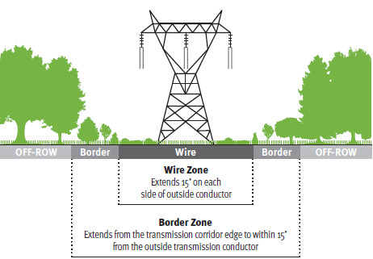
Records of work location, kinds of work performed, and costs shall be kept. This will allow historical data of trends that occur, and will be an aid in planning for future operations.

Contractors will be expected to train and control the functions of their crews in all aspects of their work. The supervisors and foremen of these crews shall be familiar with GMP current maintenance procedures. The GMP utility forester and the procedure manual will provide a guideline for contractor operations.

Special situations shall be handled with common sense and a high degree of caution. Contractors shall contact a GMP utility forester if they have a potentially dangerous situation at hand. All operations shall be carried out in a safe and efficient manner.

A good working rapport with property owners is an important aspect of these operations. As the vegetation management crew moves over the ROW there will be a positive effort made, where practical, to inform the resident landowners and tenants of ongoing activities.

- Invasive Species Assessment and Control

Discussion
The Vermont Agency of Agriculture has established noxious weed quarantine regulations. Under these regulations a noxious weed means “any plant in any stage of development, including parasitic plants whose presence whether direct or indirect, is detrimental to the environment, crops or other desirable plants, livestock, land, or other property, or is injurious to the public health.” Included in this classification are many nuisance exotic species. A Class A Noxious Weed is “any noxious weed on the Federal Noxious Weed List (7 C.F.R. 360.200), or any noxious weed that is not native to the State, not currently known to occur in the State, and poses a serious threat to the State.” A Class B Noxious Weed is “any noxious weed that is not native to the state, is of limited distribution statewide, and poses a serious threat to the State, or any other designated noxious weed being managed to reduce its occurrence and impact in the State.” (6 V.S.A. Chapter 84, Pest Survey, Detection & Management) The movement, sale, possession, cultivation, and / or distribution of Class A Noxious Weeds is prohibited. The movement, sale, and/or distribution of Class B Noxious Weeds is prohibited.
(B) Class B Noxious Weeds
(1) Aegopodium podagraria L. (goutweed)
(2) Ailanthus altissima (tree-of-heaven)
(3) Alliaria petiolata (A. officinalis) (garlic mustard)
(4) Butomus umbellatus (flowering rush)
(5) Celastrus orbiculatus Thunb. (Oriental bittersweet)
(6) Fallopia japonica (Polygonum cuspidatum) (Japanese knotweed)
(7) Hydrocharis morsus-ranae L. (frogbit)
(8) Lonicera x bella (Bell honeysuckle)
(9) Lonicera japonica (Japanese honeysuckle)
(10) Lonicera maackii (Amur honeysuckle)
(11) Lonicera morrowii (Morrow honeysuckle)
(12) Lonicera tatarica (Tartarian honeysuckle)
(13) Lythrum salicaria (purple loosestrife)
(14) Myriophyllum spicatum (Eurasian watermilfoil)
(15) Nymphoides peltata (Gmel.) Ktze. (yellow floating heart)
(16) Phragmites australis (common reed)
(17) Potamogeton crispus L. (curly leaf pondweed)
(18) Rhamnus cathartica (common buckthorn)
(19) Rhamnus frangula (glossy buckthorn)
(20) Trapa natans L. (water chestnut)
(21) Vincetoxicum nigrum L. (black swallow-wort)

In many parts of the state, invasive species are well established both within the utility rights of way and in lands adjacent to the ROW. Currently, the Vermont Invasive Exotic Plant Committee does not currently recommend eradication programs for invasive species, but, instead emphasizes spread prevention and control. The basis for this recommendation is twofold. First, the most effective means of eliminating nuisance exotic species will in most, if not all cases, be the application of pesticides. An unnecessary increase in pesticide usage is contrary to the goals of the Vermont Agency of Agriculture relative to utility line maintenance.
Second, because these plants, where established, tend to be prevalent both inside and outside utility rights of way, any eradication strategy focused on utility corridors will be ineffective.

Preventing the movement of nuisance exotics into new areas, particularly where utility line construction and maintenance may provide an avenue for their spread, should be encouraged where practical. Prevention measures are more critical to the success of the quarantine program, have a greater likelihood of success and are unlikely to result in large-scale increases in the use of pesticides.

Control Strategies
- Assessment - GMP conducts a cyclical assessment on all Transmission ROW’s. Cyclical reviews place us in an ideal position to identify pioneering communities of invasive species. Pioneering communities of exotic invasive plants should be addressed if an infestation review shows containment within the ROW. Eradication of well established populations should be considered only in cases where findings can be made that there is an obvious benefit to the goals and objectives of either ROW management or overall invasive exotic species control.

- Control measures – Non-chemical control methods do exist but require intensive labor and may cause unnecessary ground disturbance. Control with herbicides is the most effective and economically feasible method available. A wide scale control of exotic invasive species would incorporate greater volumes of herbicide use and is contradictory to the goals of GMP, Agency of Agriculture, and Vermont Pesticide Advisory Council. (Herbicide permit conditions only allow for the control of such plants for safety and reliability purposes)

GMP may apply resources to a proactive spread prevention consciousness within the utility industry.

- Environmental Effects of Right-of-Way Management

Implementation of an integrated right-of-way management program, which employs selective and judicious use of modern herbicides and techniques, will reduce environmental impacts to wetlands. Proper utilization of modern mechanical equipment in defined areas can eliminate soil compaction, erosion, and disturbance. Unnecessary soil disturbance can allow for invasive species to populate the ROW’s. Therefore the correct tool should be prescribed.

Low volume foliar and direct stump/basal application techniques will be employed while high volume applications will be prohibited within wetland buffers. The products used are very low in toxicity, not prone to leach laterally or vertically at our prescribed concentrations and application rates, and biodegrade quickly. This is especially true in areas of high organic material such as wetland buffers. No applications will take place in standing or running water.

1. Manage the vegetation in such a way as to:

a. Encourage the establishment of a semi-stable native plant and shrub community that will not interfere with work operations, is not a danger to lines and poles in the ROW, and keeps vegetation maintenance to a minimum.

- Provide for compatible landowner use and be in harmony with multiple use of the ROW (i.e. crops, pasture & recreation).

c. Establish and carry out the most accurate, safe, efficient and thorough method for keeping the right-of-way free of undesirable tree growth using current technology.

- Establish a maintenance cycle of five years on each line that will result in a systematic method to keep GMP rights-of-way free of vegetation that could be a safety hazard, inhibit maintenance or affect reliability.

- Establish and maintain low growing semi-stable native plant & shrub community to protect stream banks by maintaining shade, reducing erosion, and buffering herbicide applications.

- Encourage and promote vegetation that is beneficial to wildlife habitat improvement.

2. Manage the Rights-of-Way for Acceptable Joint Uses

A properly maintained right-of-way results in desirable conditions for other compatible uses. Many landowners are finding, instead of large piles of brush and areas of thick sprout growth, that they have attractive semi-open land that is accessible and often rich in wildlife.

a. Provides access and a corridor for recreation with the landowner’s and if applicable, the utility’s consent, for:
1. Fisherman;

2. Snowmobiles;

3. Snow Shoeing;

4. Cross-Country Skiers;

5. Hikers;

6. Hunters;

7. Horseback Riders;

8. Berry foraging;

9. Photographers and sightseers; by providing scenic vistas for observation through Vermont’s woodland; and

10. Audubon Members.

b. For Forest Management:
1. Access to work areas, skid roads;
2. Ease of constructing firebreaks.

c. Wildlife Management:
1. Diversify plants and shrubs to provide better food sources especially plants that hold feed for winter months;
2. Diversify plants and shrubs to provide better cover;
- Diversify plants and shrubs to provide better nesting and
brooding habitat for ground nesting birds.
4. Create wildlife plantings beneficial to winter feed areas (i.e.
NWTF Operation Appleseed).

3. Endangered/Threatened Species
GMP is currently working on BMP’s with Vermont Department of Fish & Wildlife Non-Game & Natural Heritage Program (NNHP) to help protect, maintain and encourage restoration of endangered and or threatened species.

4. Agriculture:
- ROW’s are often suitable for grazing land;
- Cropland use;
- Fruit tree and Christmas tree crops when approved by the utility.

IV. GENERAL PLAN OF OPERATIONS

The integrated vegetation plan includes the flexibility to adjust for conditions both as they are found in the field, as well as future changes in land use. GMP rights-of-way are treated on a prescription basis. Each property, or area, is evaluated and one or more management tools are used in performing routine maintenance.

- Framework For Integrated Vegetation Management Cycle
IVM is a system based on a continuous cycle of information gathering, planning, implementing, reviewing, and improving vegetation management treatments and the related actions that a utility or other management organization could undertake to meet its business and environmental needs. (Nowak and Ballard 2005) This methodology of cyclical management activities is core to GMP T&D Forestry goals, both short-term and long-term. Research and practice has shown that two or more of the steps described below may occur simultaneously and perhaps not in specific order.

1. Understanding Pest and Ecosystem Dynamics – ecological understanding of the biotic (plants and animals) and abiotic components of the managed system, with an aim to understanding why and how individuals and ecosystems function certain ways and variably respond to disturbance (e.g., management);

2. Setting Management Objectives and Tolerance Levels – input from affected people with regard to objectives for, and objections to, management;

3. Compiling Treatment Options - development of a cadre of methods to produce desired plant or plant system effects;

4. Accounting for Economic and Environmental Effects of Treatments – an accounting of all direct and indirect costs and benefits, usually via measures of cost effectiveness and applied research that serves to address how treatments affect ROW ecosystems and socioeconomics;

5. Site-Specific Implementation of Treatments – expectations of treatment needs and responses on a site- and pest-specific basis; and

6. Adaptive Management and Monitoring – monitoring treatment effects as a basis for adaptation and improvement.

IVM component steps is a continuous process that helps the vegetation manager evaluate and improve the IVM program. Opportunities and shortfalls of the program can be identified and modified, allowing for GMP to address management schemes to better accomplish management objectives.

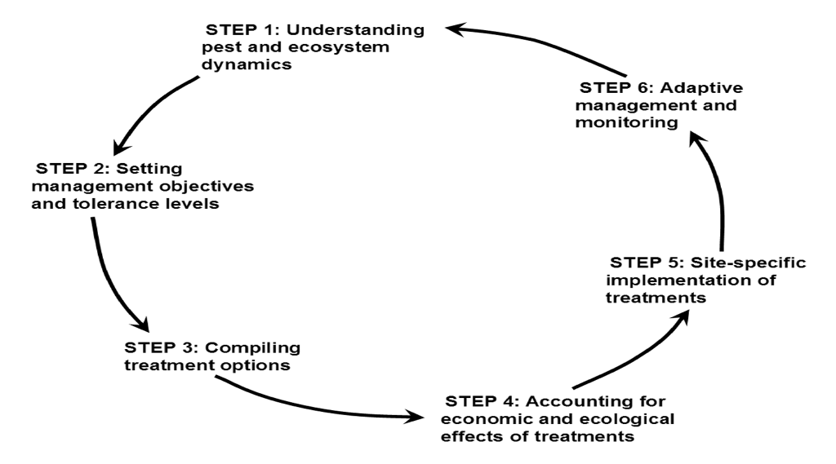
Figure 1. Component steps of Integrated Vegetation Management, a system for managing rights-of-way vegetation (adapted from Nowak and Ballard 2001, and Nowak 2002, from Witter and Stoyenoff 1996)

- Systems of Vegetation Control

- Ultra-Low Volume Foliar
...the selective placing of an herbicide upon the leaves of a growing plant.

This method uses a thin invert emulsion of water and mineral oil as a carrier for the herbicide. The application technique uses specialized tips that deliver 1/10 of 1 gallon per minute.

It maximizes spray effectiveness, while minimizing off-target movement by reducing spray drift and virtually eliminating spray evaporation. Spray drift is reduced by the THINVERT nozzles which make small uniform droplets, and by the thin invert emulsion which reduces the number of small droplets formed. With this method, 85-95% of the targeted plant growth is controlled in one year. This is CV’s primary method of vegetation control.

2. Selective Stem Foliar

…the selective placing of an herbicide upon the leaves of growing plants.

This method is one of the most effective, economical and efficient ways to control plant growth. This method eliminates 85-95% of the targeted plant growth in the right-of-way in one year.

In areas where undesirable plant density is low, this method becomes a spot type treatment. Proper application techniques can make the foliar method highly selective.

3. Cut and Stump Treatment

…the placing of an herbicide upon the cut surface of a stump.

In certain situations, the cut and stump treatment is the preferred method. The primary aesthetic advantage is that the tree is not left standing in a browned out condition.

Stump treating is useful in hedgerow areas, high visibility areas (i.e. screens, near residences, and for spot treatments).
This method is difficult to use on an extensive basis. An 80% effectiveness is the best that can be expected from this method. A 65-75% effectiveness appears to be typical on an extensive basis. Because of small surface areas, seedlings and sprouts less than 2 inches in diameter are difficult to treat. Stumps of this size are often hidden and difficult to identify.

Stump treating is a very useful and selective tool in our vegetation management program when other superior methods cannot be used.

4. Selective Low Volume Basal Treatment

…the placing of an herbicide upon the stem at the base of a growing tree or shrub.

This system has value for a number of reasons. Because of the application method, it is very selective. Another benefit is that it can be used in the dormant, as well as the growing season.

Basal works best when mixed with specially blended basal oil or mineral oil as a carrier and applied using a low volume backpack and wand.

5. Cut and/or Trim

…the removal of stems by manual and mechanical means.

This system is used in many areas where herbicides are either not practical, or are not permitted. It is also used as a primary control for softwood, and hardwood trees too large to effectively treat. Lands adjacent to watercourses are often thick with tree growth. Fortunately, streams are usually low points in the profile of a right-of-way providing a greater phase to ground clearance. Another area where cutting is the primary tool is in active pastureland. Care must be taken when cutting cherry, since the leaves become poisonous as they wilt. Cherry trees have to be physically removed from the pastureland. This removal is both time consuming and costly.
The biggest disadvantage to the cut/trim system is that paradoxically, cutting generates more trees. Hardwood trees resprout from stumps as well as from underground roots. This process is stimulated when cutting is done. The net result is a dense mass of sprout growth being fed by a large strong root system. When such a situation occurs, hardwood species will ultimately invade after the cut.

Manual cutting is a far more dangerous method of brush control. The hazards to the worker from chainsaw operation far outweigh that of the herbicide application.

Manual cutting with chainsaws has serious environmental effects caused from bar and chain oil, which is a contaminant that does not biodegrade quickly and is prone to leach.

As previously mentioned on Page 18, another important factor is that the cost of cutting per acre is much higher than herbicide application. It can be as much as two to eight times as expensive and will increase with each cycle.

Cutting is the least desirable system of vegetation control and should only be used where there is no alternative. The exception would be where the
right-of-way has non-sprouting vegetation such as white pine or spruce. Cutting may be done any time of year as long as snow conditions allow.

6. Mow

Mowing is one of our tools and is employed where, due to environmental factors and customer concerns, herbicides cannot be used. Mowing may be applied to portions of ROW that have high densities of woody vegetation. This tool has a significant environmental impact because it removes most desirable and all undesirable plant species and has a potential to compact soil and cause erosion. Hydraulic fluid can be present after a ROW has been mowed. After mowing, well developed root systems of hardwood trees sprout prolifically and dominate the re-growth. It is GMP’ policy to reduce mowing projects during shrubland bird nesting periods from April 15th to August 15th.

7. Hazard Tree Removal/Trim

Hazard tree is any tree, due to its location and condition that is tall enough to strike the transmission facilities. (See Pages 11-A and 11-B.)

Many of the trees at the edge of the ROW have crowns that are heavily grown in towards the lines.
Many factors influence a tree’s physical condition. Some examples are: disease, insect damage, structural defects, frost cracks, lightning and mechanical damage (i.e. logging, road construction, etc.), age, soil conditions and genetic factors. Some appear normal and healthy yet are in a poor condition having serious rot with only a thin wooden shell on the outside. Signs of a dying tree can be very evident or very subtle, and often only recognized by an experienced forester or arborist.

When checking for hazard trees, it is important to know at what size each species is mature and which are most susceptible to failure. Signs to keep in mind are: seams, fungus, fruiting bodies, bark condition, root condition, wood cellular condition and tree configuration. Another consideration when marking and cutting trees is the effect that removing a tree will have on the remaining trees.

The removal of hazard trees is slow, costly, and at times, a difficult procedure.

A primary consideration when cutting hazard trees is the safety factor to both crew, and facilities. Some tree removal conditions require de-energizing the line prior to the operation. The risk of removing trees from outside the
right-of-way is far greater than standard right-of-way cutting.

8. Non-Herbicide Alternatives

When reviewing these alternatives, GMP has an obligation to all of its customers to provide safe, reliable power in an efficient manner at a reasonable cost. The decision whether or not to use non-herbicide alternatives must be based on factors that transcend the desires or possible benefits of one individual. The safety of the right-of-way condition is of primary importance, both to the property owner, as well as GMP employees.

Many ROW areas are maintained by landowners through compatible uses (such as pasture or cropland). If these areas do not require herbicides for tree sprout control, none will be used. If herbicides are required for maintenance, they will be used in accordance with their labels, within State and Federal Laws.

When a property owner does not wish the use of herbicides on his land, he may enter into an agreement with GMP based on PSB Rule 3.600. All work, within the ROW’s, will be performed by GMP or their representatives under the direct supervision of GMP. The Transmission and Distribution Vegetation Management Department continuously explores alternatives to herbicides to control woody vegetation.

9. Other

There are a number of other options for controlling vegetation. Most of them are expensive and have only limited use on Vermont’s ROW’s.

- Aerial Herbicide application – this is a low cost/acre method. Good control can be achieved with modern application techniques and proper additives. The major disadvantages are that it is a broadcast system, which may be non-selective. This results in the elimination of desirable plants, as well as undesirable. GMP does not presently apply herbicides aerially due to this technique not meeting our objective of selectivity and the general adverse public concerns.

- Broadcast Ground Herbicide application – this type of application is not done on an extensive basis, because, as in the aerial application, it is not desirable to eliminate all vegetation in the ROW. Some herbicides on the market allow for selective control of broadleaf species yet allow for grasses and forbs to exist within the ROW.

- Planting and Seeding Grass, Shrubs and Certain Species of Trees – this is another form of managing the vegetation. Pruning and mowing is used to do maintenance on these locations. To prepare the site for this condition requires grading and filling with topsoil. It is often used near substations and is costly to establish and maintain. Planting shrubs and trees in a right-of-way condition is often difficult. The mass of roots and organic matter is not conducive for survival of planted material. The shallowness of the soil and rocky ground condition are also obstacles. This management technique is also used in instances of erosion control.

- Cutting and Chipping – in some areas, trees that have to be cut are within eyesight of homes or scenic areas. Cutting and windrowing into piles can be unsightly once the vegetation turns brown. In this situation, cutting and chipping is often the most desirable, but costly technique.

- Control Schedule-Description of Cycle

GMP has established a firm five-year cycle of herbicide application (see Appendix A for breakdown). The establishment of a control schedule is done after lines have been brought into a manageable condition. Lines that have had little or no herbicide work have many areas that are thick with sprout growth from large root systems. Good control cannot occur until these roots have been eliminated. Both hardwood and softwood trees seed in young trees, which do not have the advantages of a large root system. Their growth rate varies, but in general, they are not as aggressive as sprouts. By maintaining a ROW dominant with seeded trees and shrubs, a better job can be done maintaining the vegetation.

A large portion of GMP’s herbicide work is done with the foliar application method. Field reviews of all techniques of herbicide application have consistently shown the foliar method to be the most effective for plant and root control. One disadvantage of this type of application is that the work must be done during the short foliar season. GMP starts application earlier on the more southern lines and/or lines that are at the lower elevations. This allows for maximum development of leaf area at the start of the growing season.

Herbicide application shall be scheduled by general geographic area whenever possible (i.e. southern, central, northern). This divides GMP’s system into five general areas providing a systematic approach. By necessity, in some years there will be some overlapping of areas. (See Appendix A).

Overall, density and size of reduction of undesirable vegetation due to a maintenance cycle has another positive result. The net affect is that less herbicide is needed to control undesirable plant growth. (Refer to Page 3.)

D. Right-of-Way Inspection and Monitoring Standards

- Type and Frequency of Inspections:

- Helicopter Patrols – This type of patrol is done to determine general ROW conditions. Aerial patrols are also an aid in the advanced budget planning procedure. The Transmission and Distribution Forestry Department staff determines frequency of helicopter patrols. This patrol gives an overview of vegetation growth and general changes in right-of-way conditions, which provides the data to pinpoint areas for further review. Trees beginning to windthrow or starting to bend due to water conditions and/or unbalanced crown can often be spotted. Aerial patrols are followed up by more extensive and exacting ground patrols.

- Routine Patrol – Ground – This type of patrol can be divided into three areas as follows:

Cyclical Operations Patrol – This is done on circuits that have maintenance in the upcoming year. The circuits are foot patrolled to determine control methods through field observations with historical information. During this patrol, assessment notes are made regarding brush type, density, & height. Environmental buffers are noted and delineated.

Danger Tree-Ground Patrol – Information concerning danger trees is received by helicopter patrols, field observation by line crews, and cut and herbicide crews. To determine the number and a more accurate evaluation of these “danger” trees, a foot patrol is carried out.

- Field Review – This is done to determine the nature of a specific condition or situation. Some examples of this type of activity are: logger working near lines; erosion due to new road on ROW; new plantings observed under lines or any other type of encroachment. Notification of the individuals involved may also be carried out. Frequencies of these reviews are as needed.

E. Right-of-Way Management Records

- ROW Land Owner Contacts

Information is gathered as calls, generated by public notification through the news media and company billing inserts, come into the Transmission and Distribution Vegetation Management Department staff. This same information is gathered for on site field contacts. (See Appendix A, Landowner Contact Report Form). Following is a list of information taken:

- Name and phone number of landowner.

- Town property is in.

- Time and date of call.

- Nature of conversation.

- Line names and pole numbers if possible (often this information is added upon field investigation).

- Directions to property.

- Any action taken.

The landowner’s concerns and questions are recorded by the Transmission and Distribution Vegetation Management Department Administrative Assistant, when a Utility Forester is not available. The Utility Forester will return the call and/or make personal contact. Each property and its condition are evaluated individually. A permanent, Special Line Information file is established for each line so that each time a given line is worked on, the file is reviewed and past concerns are noted.

- Inspection Records

GMP has a set of procedures manuals for its vegetative management work both for cutting and herbicide application, copies of which are made a part of this plan (See Appendix B & C). All contractors working for GMP, and their crew foreman, are required to study, and be familiar with the procedures and their contents and keep a copy in their possession. GMP keeps records as to location, progress, equipment, crew complement and quality and quantity of work. (See attached Crew Inspection Report).

- Cutting and Spray Work Records

The foreman of the cut or herbicide crew fills out two or more forms each day of the week. One is his company’s time sheet and/or work log; the other is a GMP Transmission and Distribution Forestry report form. (See Appendix A.)

4. Vegetation Maintenance Program –Data Reporting System

Use of a data processing system in the ROW management program involves maintaining stored information and data associated with cutting, herbicide application and right-of-way operations. These facts and figures include information about the following: historical vegetation management operations, right-of-way land use conditions, easements and special right-of-way agreements. These are listed on a line by line basis.

5. Plan & Profile Map (Strip Map)

A strip map is a topographic representation of the transmission rights-of-way, lines and equipment. Pertinent features such as springs, wells, streams, roads, structures, environmentally sensitive areas, pipe and property lines, and town and county lines are also plotted on these maps.

Two sets of strip maps are kept, one for office use and one for field use. Both are updated regularly to be sure they contain the same information.

6. Overall Review Policy

Herbicide work is spot reviewed at various time intervals after it is completed to determine effectiveness and quality of work. This also helps to determine which products and application methods are most effective.

F. Cooperation & Education

An Integrated Vegetation Management Plan can only be successful through
cooperation of landowners. GMP encourages cooperation through education of
Integrated Vegetation Management programs. GMP accomplishes this two ways:

First, prior to any type of vegetation management activity preformed on a property, a reasonable attempt to notify and educate the landowners by either the GMP Utility Forester or crew foreman.

GMP also seeks and maintains affiliations and partnerships. Listed below are the partnerships and affiliations in which GMP is currently involved.

1. National Wild Turkey Federation

- Energy for Wildlife – Energy for wildlife is a membership based certification program for all energy companies. NWTF staff work directly to integrate wildlife management into the management plan.

b) Operation Appleseed – Operation Appleseed is a NWTF program that plants crabapple orchards on transmission row to create winter food plots for turkeys and other wildlife. Since 2000, we have planted 20 crabapple orchards consisting of 25 trees in each throughout the state.

- Vermont Urban and Community Forest Council - The Vermont Urban and Community Forestry Council is a 20 member advisory council to assist the Vermont Department of Forest, Parks and Recreation in developing an urban and community forestry program to meet the needs of communities and volunteer groups around the state.

The director of Forest and Park appoints council members. Members represent groups, which have roles in urban forestry activities around the state.
Legacy Central Vermont Public Service was appointed a seat on the council in 1995 and is the only organization that represents industry.
GMP benefits by being at the forefront of political changes that are proposed to towns.

- Vermont Tree Warden Association - Vermont State statute requires every town to appoint a tree warden to maintain and protect public trees within town parks and town right-of-way. GMP foresters have been appointed tree wardens within their respective town.

The Vermont Tree Warden Association provides training and updated legislation information regarding tree protection laws and ordinances.

GMP affiliation provides benefit to our over all vegetation management program by providing us with the most up to date changes in environmental tree protection laws.

Vermont Forest, Parks and Recreation Educational Programs - Vermont Forest and Parks sponsors the annual Arbor Day Education programs for schools all around Vermont each spring. GMP Foresters volunteer their time to go to various schools and present the National Arbor Day education program. We also use this time to educate students on the need to maintain vegetation along utility right-of-way and provide electrical safety to students.

- Vermont department of Fish and Wildlife - T & D Forestry has obtained GIS overlays of deer wintering areas. We are working with state biologists to manage vegetation in these areas to benefit wildlife habitat.

- Society of American Foresters (SAF) - The SAF is the national organization representing the forestry profession in the U.S. The goal of the SAF is to ensure and promote the wise use of our forest resources for the benefit of our whole society through education and research.

GMP' association with the SAF demonstrates our commitment to managing our estimated 400 acres of timber in a sustainable manner using the most appropriate methods available. In 2002, we began sustainable timber harvesting on approximately 85 acres of land with the goal of becoming part of the American Tree Farm system in the future.

- International Society of Arboriculture - The T& D Forestry Department employs a staff of Arborists certified through the International Society of Arboricultural. The ISA is devoted to improving the level of knowledge and standard of practice within the tree care industry. The certification program helps identify the professionals that through a commitment of time and effort have attained a level of knowledge above the standard in the industry.

Having a staff of certified Arborists at GMP ensures a high level of credibility when working with the numerous governing bodies (select boards, tree wardens, PSB, DPS) that are such an important part of our program. This credibility is also extremely helpful when working with the frequent customer contacts and issues that arise.

The fact that GMP employs a staff of ISA certified Arborists overseeing the Vegetation Management Program proves we are committed to managing the best environmental stewardship program possible while maintaining and improving reliability for our customers.

- National Arbor Day Foundation / Tree Line USA - The T & D Forestry Department has received the designation as a Tree Line USA utility. This award recognizes public and private utilities across the nation that demonstrates practices that protect and enhance America's urban forests. This program promotes the dual goals of dependable utility services and abundant, healthy trees along Vermont's streets and highways. GMP has met the strict requirements that have been developed and is recognized as a company that employs conscientious individuals who collectively make a difference in the community and truly care about the need for continuous professional tree care. News releases announcing the honored utilities will be distributed and a presentation will be made on Arbor Day along with recognition in the Wall Street Journal.

Vermont Institute of Natural Science (VINS)

Raptors in the Right-of-Way - The T & D Forestry Department along with The Vermont Institute of Natural Sciences are in the process of forming a partnership that will provide American Kestrels and possibly Screech Owls with nest boxes along our utilities right-of-ways. These boxes will be placed with the permission of landowners in areas that provide these birds with proper habitat. This program will raise public awareness regarding the important habitat our vegetation management plan provides. As the success of this program grows, so will the understanding of a sound, environmentally conscious vegetation management plan implemented by a dedicated staff of professional arborists.

Environmental Learning for the Future Program - T & D Forestry staff has been involved with the Environmental Learning for the Future Program (ELF) with the Vermont Institute of Natural Science (VINS). This involves training sessions with VINS staff members, then participating in the elementary school classroom and teaching environmental subjects and issues on a monthly basis. Many of the monthly session's subjects involve trees and their interaction with the natural environment.

Rutland County Resource Conservation District - GMP traditionally participates in educational Arbor Day events. One annual event is in conjunction with the Rutland County Natural Resources Council and the Vermont Forest and Parks Department. This program consists of working with school children at numerous workstations in a park setting. Groups of children move throughout all of the workstations, discussing forestry based environmental subjects. Our arborist staff regularly participates at the GMP Right-of-Way Management workstation.

Vermont Tree Society - The Vermont Tree Society (VTS) was formed to bring awareness to specimen trees around the State of Vermont. We assisted with the direction the society wanted to go and the functions they wanted to develop to bring awareness to notable trees. We now participate on a level of providing knowledge and assistance when needed.

VTS hosts their own website noting events and items they offer as well as a way to share their enthusiasm for trees.

- Vermont Agency of Agriculture - Invasive Plant Species - We have committed ourselves to communicate with The Agency of Agriculture to find the latest information to help us modify our management style to help with controlling invasive plant species. With the evidence of invasive species causing value loss to the Vermont landscape, we now eliminate invasive plants in the right-of-ways when feasible. By doing so, we are encouraging native low growing plants to re-establish.

G. Internal Review

T & D Forestry as a department will review annually this management plan to ensure that goals have been met. At this review process, certain topics will be reviewed to measure accomplishments and seek areas to improve. List of topics will include:
- Cost per Acres / Year End Reports
- Special Management (i.e. Target Species, Threatened And Endangered Species, Stream Management And Wildlife Travel Corridors)
- Visual impact
- Research (i.e.; Wildlife, Vegetation Management)
- Cooperation And Education (i.e.; Affiliations And Partnerships)
- Management Of Properties
- Best Management Practices (i.e. Integrated Vegetation Management, Water Quality, Sustainable Forestry)
V
APPENDIX A

Five Year Cycle Map of GMP Transmission System
Five Year Cycle of GMP Transmission System
Compatible Plant List
Incompatible Plant List
Composition of Cutting Crew
Composition of Herbicide Application Crew
Sample Time Sheet
Sample GMP Spray Report
Sample Weekly State Report
Landowner Contact Report Form
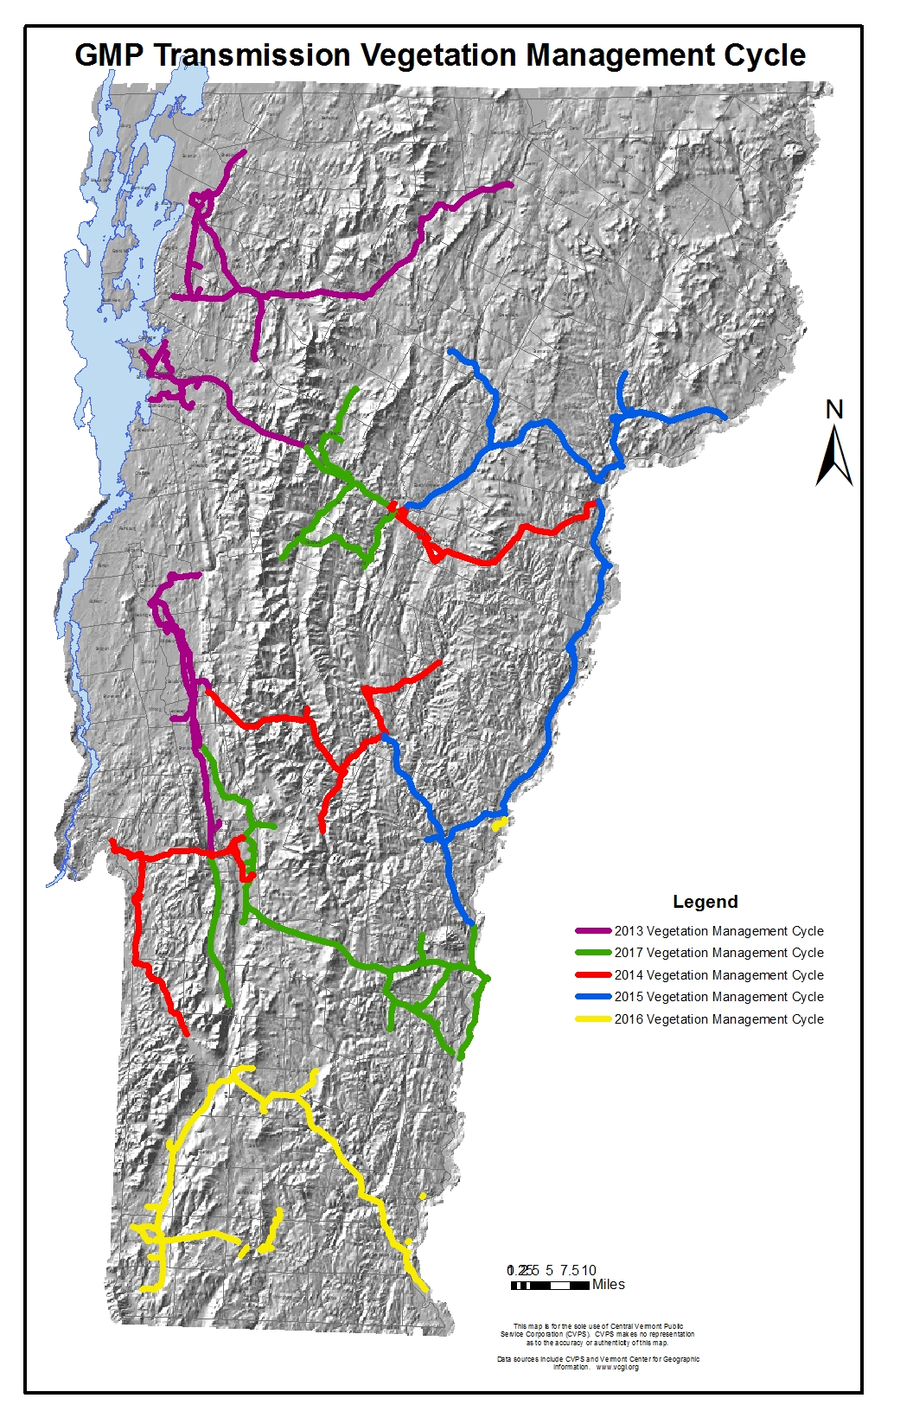

Five Year Cycle of GMP Transmission System

2013 Maintenance Program

Line ROW Total Treating
Number Line Name Miles Acres Acres

37 Florence to Marble St. 6.87 66.61 45
38 Proctor Tap 1.81 17.55 12
60 Huntington Falls – Florence 29.37 284.80 115
61 Omya Tap .21 2.03 1.7
66 Salisbury - Brandon 6.41 76.92 21
67 Salisbury - Leicester Jct. 4.73 56.76 18
68 Salisbury - Vt. Marble Tie .28 3.36 1
69 Salisbury - Quarry Road 6.81 81.37 12
73 Weybridge - New Haven 5.08 61.57 15
71 Middlebury Up - Middlebury Low 1.01 12.12 5
72 Middlebury Lower - Weybridge 3.93 47.16 16
74 New Haven - Bristol 4.22 50.64 18
77 Middlebury Lower - Quarry Road 2.56 31.07 23
79 Salisbury - Silver Lake 5.14 61.68 29
125 Milton - Woods Falls (Peterson) 2.29 27.48 18
126 Fairfax - Milton 6.92 83.04 28
126A Husky Tap 1.30 Roadside
127 Milton - St. Albans 12.31 147.72 18
127A Clark Falls Tap .18 2.18 0
127B Wyeth Tap 1.46 17.69 13
128 St. Albans - Fairfax 12.86 154.32 41
131 Fairfax - Johnson 17.18 206.16 96
131A Johnson Village Tap .29 3.48 1
132 Jeffersonville Tap .29 3.48 0
133 Johnson - Lowell 19.01 228.12 104
134 Fairfax - Underhill 8.79 105.48 39
135 East St. Albans Loop 3.75 45.00 15
136 West St. Albans Loop 3.82 45.84 25
136A N. Elm St. Tap .72 8.73 4
137 St. Albans - Sheldon 8.27 99.24 35
138 National Carbon Tap .53 6.36 2
139 Nason St. - Weldon St. .50 6.00 0
140 Irasburg - Lowell 9.30 111.60 90
TOTAL: 144.73 1737.04 677

2014 Maintenance Program

Line ROW Total Treating
Number Line Name Miles Acres Acres

39 W. Rutland - Vt. Marble Tie .54 6.48 2
40 N. Rutland - Lalor Ave.
(incl. Glenn Tap) 3.02 36.24 16
41 N. Rutland - Lalor Ave.
(Express Ckt.) 2.86 34.32 18

42 N. Rutland - W. Rutland 5.06 60.72 25
43 Lalor Ave. - W. Rutland 3.14 37.68 7
44 W. Rutland - Hydeville 10.37 124.44 42
45 Hydeville - Carver Falls 5.45 65.40 24
46 Fair Haven Tap .56 6.72 5
47 Poultney - Blissville 3.64 44.12 36
47A Blissville - Hydeville 1.58 19.15 9
48 Poultney - Pawlet 8.88 106.56 75
49 Poultney Village Tap .92 11.04 8
50 Pawlet - Dorset 9.63 116.72 31
52 Lalor Ave. - Gas Turbine .41 4.92 0
52A Vicon Tap .23 2.78 2
53 Lalor Ave. - N. Clarendon 4.44 53.28 18
80 Rochester - Silver Lake 15.55 188.47 135
81 Rochester Village Tap 1.31 15.72 4
83 Rochester - Bethel 17.13 205.56 136
84 Sherburne - Stockbridge 9.37 112.44 98
85 Bethel - Randolph 6.70 80.40 46
85A Randolph Tap 1.63 19.75 10
88 Waterbury Tap .35 4.20 0
89 Chelsea - Randolph 10.62 127.44 94
TOTALS: 123.39 1484.55 841

2015 Maintenance Program

Line ROW Total Treating
Number Line Name Miles Acres Acres

105 Windsor - Taftsville 10.55 127.88 70
105A Windsor (CV) - Windsor (Velco) 1.52 18.42 5
106 Woodstock - Taftsville 2.22 26.64 14
107 Bethel - Taftsville 16.89 202.68 95
108 Taftsville - Wilder 10.34 124.08 65
109 Wilder - Bradford 24.75 295.69 141
109A Bradford Tap .62 7.52 3
109B Wilder Tap .23 4.07 4
110 Bradford - Wells River 13.69 165.94 106
112 Wells River - Ryegate 5.26 63.12 40
113 Woodsville 46kv Tap 1.00 12.00 1
116 Bay St. - Comerford 7.01 126.18 65
118 St. Johnsbury - Gilman 15.04 180.48 115
119 St. Johnsbury - Lyndonville 7.57 90.84 45
120 Fairbanks Morse Tap 1.00 12.00 3
121 Barker Ave. Tap 1.29 15.48 11
TOTALS: 118.98 1473.02 783
2016 Maintenance Program

Line ROW Total Treating
Number Line Name Miles Acres Acres

2 Woodford - N. Bennington 5.75 69.00 55
4 Silk Road - Mill Street 2.17 26.04 15
5 Lyons St. Tap .76 9.12 7
6 Bennington - Searsburg 10.44 187.92 162
7 Bennington - Pownal 5.70 102.60 33
8 Pownal Tap 2.63 47.34 20
9 S. Bennington Tap 1.61 19.49 12
15 Bennington - E. Arlington 12.83 155.51 91
16 S. Shaftsbury Tap 2.03 24.36 14
17 E. Arlington - Arlington 1.11 13.32 9
18 E. Arlington - Manchester 10.15 121.80 71
18A Wallace Computer Tap .21 1.45 1
19 Manchester - Rawsonville 13.79 165.48 127
20 Bromley Tap 3.04 36.48 25
21 Stratton Mt. Tap 1.43 17.16 16
22 Rawsonville - Londonderry 4.70 56.40 23
25 Ladder Hill - Vernon Rd 3.81 45.72 NH 23
26 S. Brattleboro - NEPCO .37 6.66 3
27 N. Brattleboro - Vernon Rd. 2.12 38.16 10
28 Georgia Pacific Tap .60 10.80 2
30 N. Brattleboro - NEPCO .27 4.86 2
31 Moore Assoc. - NEPCO .27 4.86 1
32 Brattleboro - Dummerston 7.44 89.28 65
33 W. Dummerston - Rawsonville 19.84 238.08 180
50 Pawlet – Dorset 3.87 46.91 9
TOTALS: 116.94 1,538.8 VT 953
NH 23

2017 Maintenance Program

Line ROW Total Treating
Number Line Name Miles Acres Acres

54 N. Rutland - S. Rutland 5.22 62.64 35
55 E. Rutland - Tap .52 6.30 3
56 S. Rutland - Cold River (Velco) 2.70 32.72 27
56B G. E. Tap .91 11.02 3
57 Wallingford Tap 2.83 33.96 20
58 Cold River (Velco) - Mt. Holly 12.75 154.55 96
58A Mt. Holly - Ludlow 7.62 92.36 26
59 Ludlow - Cavendish 5.13 61.56 50
62 N. Rutland - Pittsford 4.76 57.12 34
63 Mendon Tap 3.07 36.84 27
65 Brandon - Pittsford 11.78 141.36 78
91 Cavendish - Ascutney 9.75 117.00 89
92 Ascutney - Claremont 3.39 40.68 VT 6
NH 39
93 Cavendish - Springfield 11.13 133.56 93
94 Chester Tap 4.00 48.00 24
95 N. Springfield Tap .70 8.40 7
96 Riverside Tap .40 4.80 0
97 Fellows Gearshaper Tap .25 3.03 1
98 N. Springfield - Ascutney 8.61 103.32 81
99 Springfield - Conn. River 4.86 58.32 37
100 Brownsville Tap 3.81 45.72 18
102 Claremont - Charlestown 12.89 154.68 NH 74
104 Claremont - Windsor 6.06 72.72 NH 43
104A Windsor Mfg. Tap .16 1.93
TOTALS: 123.3 1482.59 VT 755
NH 156

COMPATIBLE PLANT LIST

Common Name Scientific Name Mature Height
American Elder Sambucus canadensis 12’
Arrowwood Viburnum recognition 15’
American Cranberrybush Viburnum trilobum 12’
Witchhazel Hamamelis virginiana 10’
Chokecherry Prunus virginiana 5 - 15’
Hawthorn Crataegus 5 - 15’
Mountain Holly Illex montana 20’
Winterberry Illex verticillata 10 - 12’
Mountain Laurel Kalmia latifolia 15’
Speckled Alder Alnus rugosa 10 - 15’
Winterberry Ilex verticillata 10 - 12’

LOW SHRUBS AND PLANTS

Alpine Azalea Loiseleuria procumbens 6 - 12’
American Barberry Berberis canadensis 6’
American Yew Taxus canadensis 3 - 6’
Bramble Rubus 4 - 6’
Brush Honeysuckle (dwarf) Dierilla lonicera 3’
Dogwood Cornus alba 7 - 8’
Dwarf Willow Salix tristis 2’
Fern Polypodium 1 - 4’
Juniper Juniperus 5 - 6’
Laurel Kalmia angustifolia (sheep) 4 - 6’
Kalmia polifolia (swamp) 2 - 2 ½’
Leatherwood Dirca palustris 6’
Meadowsweet/Steeplebush Spirea sp. 3’
Partridge Berry Mitchella repens 1’
Prickly Gooseberry R. synosbati 3 - 8’
Rhododendron R. caatabiens 6 - 7’
R. carolinianum 6 - 7’
Serviceberry A. cadadensis 4 - 5’ Va.
Creeper Parthenocrissus 1’
Wintergreen Gaultheria procumbens ½’
INCOMPATIBLE PLANT LIST

Common Name Scientific Name Mature Height

American Beech Fagus grandifolia 70 - 80
Ash (White, Green) Franxinus 40 - 80
Aspen (Quaking, Big Tooth) Populus 50 - 80
Basswood (Linden) Tilia americana 60 - 80
Birch (Black, White, Yellow, Grey) Betula 50 - 70
Blue Beech Carpinus caroliniana 30 - 50
Boxelder Acer negundo 50 - 70
Butternut Juglans cinerea 40 - 60
Catalpa Catalpa speciosa 90 - 120
Cherry (Black, Pin) Prunus 30 - 60
Cottonwood Populus sect. Aegiros 80 - 100
Elm (American, Slippery) Ulmus 60 - 90
American Larch (Tamarack) Larix 40 - 80
Fir Abies 40 - 60
Hemlock Tsuga canadensis 60 - 80
Hickory (Bitternut, Shagbark) Carya 70 - 80
Hophornbeam Ostrya 30 - 50
Maple Acer 60 - 90
Oak (Black, White, Chestnut) Quercus 60 - 80
Pine (White, Red) Pinus 70 - 100+
Sycamore Plantanus 80 - 100
Spruce Picea 60 - 80
Yellow Poplar (Tulip tree) Liriodendron 70 - 90
Willow Salix 30 - 40

COMPOSITION OF CUTTING CREW

FOREPERSON

CLIMBER
CLIMBER

GROUNDPERSON

COMPOSITION OF HERBICIDE APPLICATION CREW

FOREPERSON (Certified Applicator)

APPLICATOR APPLICATOR
SAMPLE GMP T&D TIMESHEET
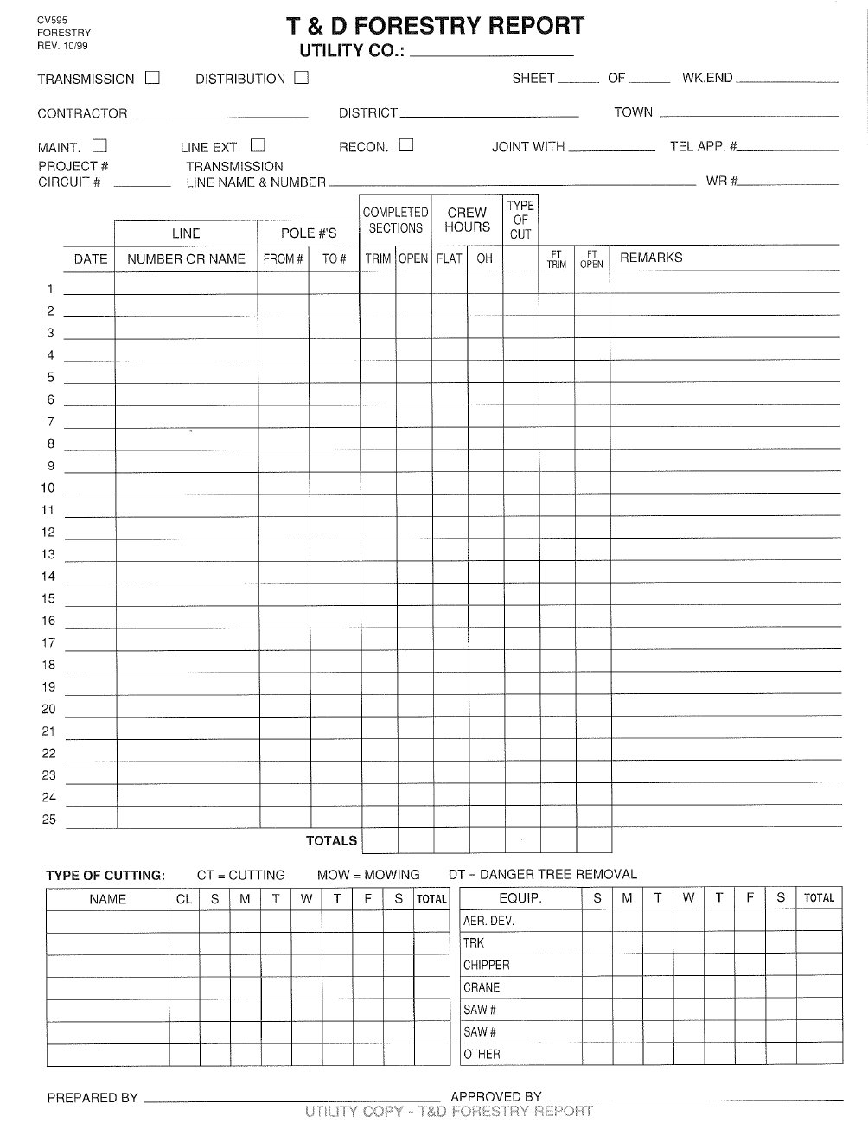
SAMPLE GMP SPRAY REPORT
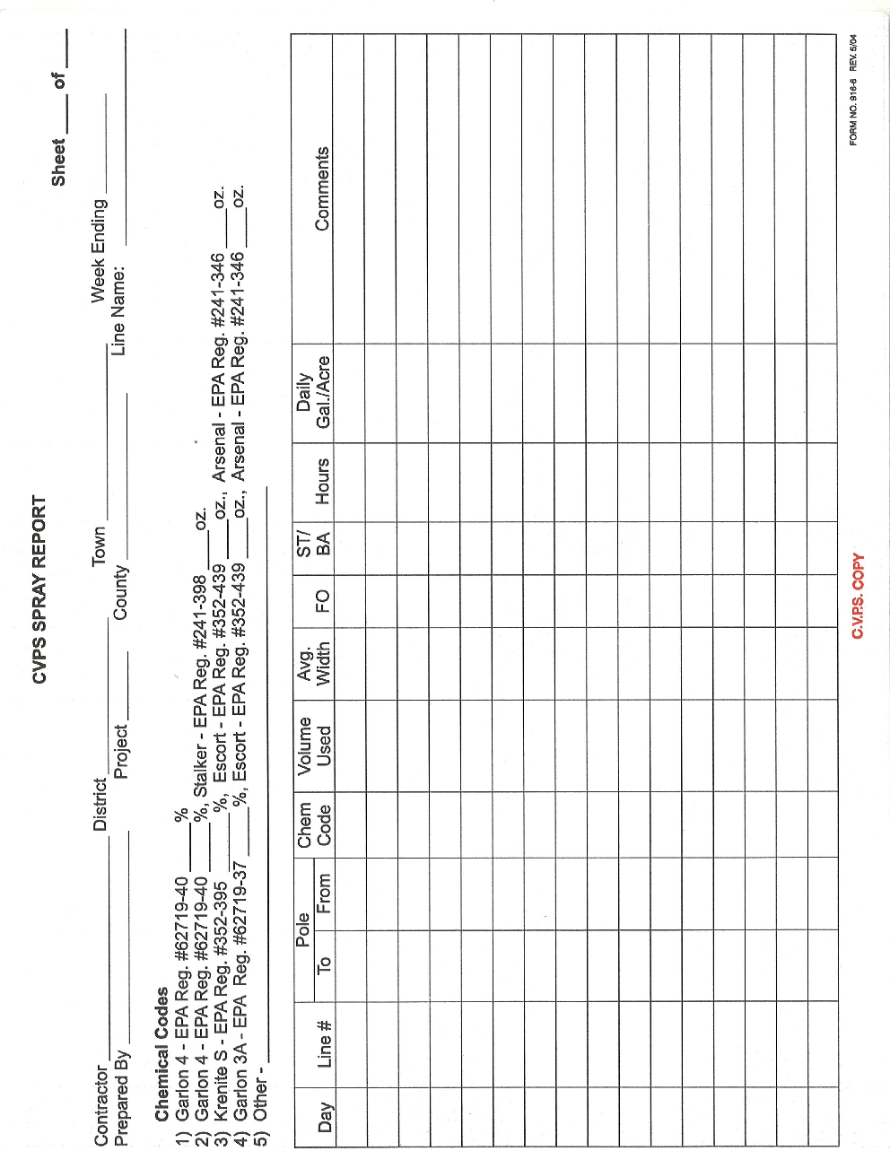
SAMPLE WEEKLY STATE REPORT
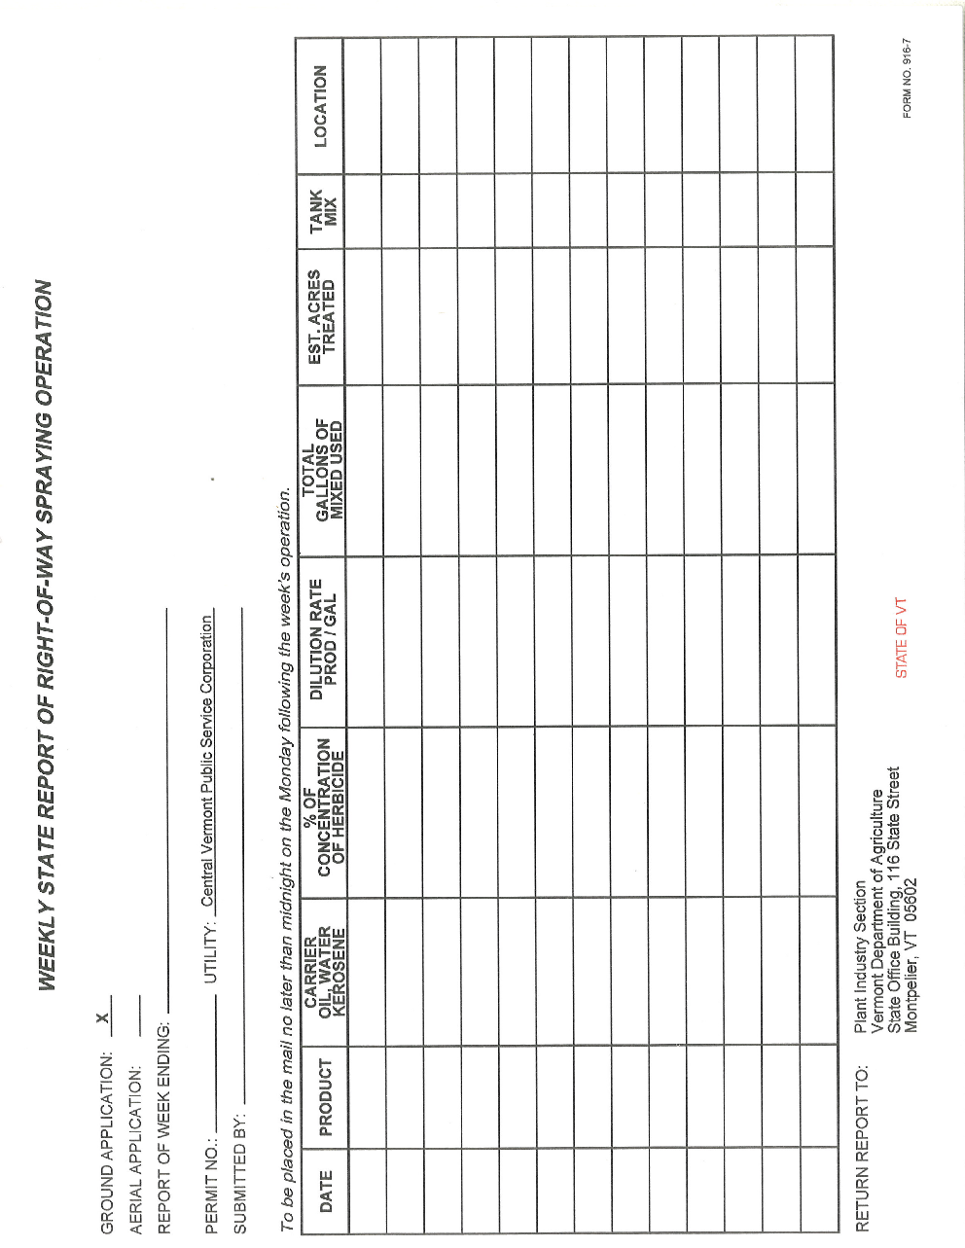

HERBICIDE PROGRAM

LANDOWNER CONTACT REPORT FORM

Line Name Structure No.’s

Name Town Tel.

Date of Contact Time of Contact

Nature of Conversation

Directions to Property

Action Taken

Comments

VI
APPENDIX B

MAINTENANCE CUTTING PROCEDURES
MAINTENANCE CUTTING PROCEDURES

TABLE OF CONTENTS

I. General Field Consideration 55
Accessibility 55
Water Quality and Supply Areas 55
Management of Wetlands and Riparian Zones…….......................................................................................................55
Fences, Stonewalls, Blazed Property Line......................................................................................................................56
Other Environmental Concerns 56
Cutting Crew – Landowner Coordination 58

II. General Maintenance Practices 59
Supervision 59
Data Reporting 59
Improper Work Techniques 60
Calling In 60
Dispatch Procedures 60

III. Cutting Specifications 61
General Maintenance Cutting Sequence 61
General Crew Information 61
Cutting Procedures 62
Safety 64

IV. General Operational Policy 65
Certificate of Insurance 65
Contractor Responsibility 65

V. Vermont Fire Warden and Slash Law 66

VI. Definitions 67

MAINTENANCE CUTTING PROCEDURES

I. General Field Consideration

A. Accessibility – The first field consideration is how to get to the work area, or that of accessibility. The normal route of access is along the utilities R.O.W. of established routes. There may be exceptions noted on the map or in the files. Some property owners require access only by way of company R.O.W.

Once an access road is established, all vehicles shall use only the one route. If any variations from the first road location are needed, the contractor must have the approval of the property owner or his representative. If permission is received, the contractor shall restore, to its original condition, or the landowner’s satisfaction at contractor’s expense, all property so damaged during the operation.

B. Water Quality and Supply Areas – The contractor shall not cause the discharge of any materials into the waters of Vermont or New Hampshire. Examples of these are: petroleum products, organic material, silt, and herbicides.
All man-made and natural water supply areas will be left undisturbed. Springs, pipelines and natural watercourses fall into this category. When the GMP Utility Forester finds information not on the work maps, he shall add it immediately. The foreman shall make a note of those areas not shown on GMP strip-maps on his weekly T&D Forestry Report.

C. Management of Wetlands and Riparian Zones - It is recognized that wetlands and riparian areas are environmentally sensitive and ecologically important for a variety of flora and fauna. Vegetation within these areas serves valuable functions in maintaining water quality and providing aquatic and terrestrial habitat.
Common species encountered in wetlands are Speckled Alder, Pussy Willow as well as many other low growing plants and shrubs. Most of the species found in wetlands are acceptable to have under the power lines; it is possible to maintain power lines corridors across wetlands with minimum impact. Preserving and encouraging low growing herbaceous plants within these areas helps support their functions such as erosion control, shoreline stability and shading of water to help protect from rising water temperatures.
Where tall growing species occur, such as in Red maple wetlands, care is taken to minimize impact and leave the area as undisturbed as possible. Large equipment such as mowing machines should not be used until the ground is frozen to protect the soils from erosion.

D. Fences, Stonewalls, Blazed Property Lines – Fences or stonewalls that are damaged within the R.O.W. or along access roads, will be restored to the condition they were in before the job began. Brush & wood shall not be left on stonewalls. All gates and fences will be kept closed unless otherwise directed. The contractor will be responsible to see that any livestock in or near the work area are kept safe and not allowed to escape their pasture area as a result of vegetation management activities.

Blazed property lines will be maintained where practical. The contractor will contact the GMP Utility Forester when blazed trees are found in or on the edge of the R.O.W. If a blazed property line tree is a danger tree, then is should be left as a post and/or pruned.

E. Other Environmental Concerns

1. Screens – As a general policy, some screens have been established on 46kv lines. These should have the following characteristics:

a. Adequate clearance for maintenance of vegetation present.

b. Suitable for low growing vegetation.

c. Shallow depth for ease of maintenance of vegetation (less than 25 feet).

d. Not act as a major barrier to R.O.W. access and line maintenance.

e. Adds to the overall aesthetics (e.g. a hedgerow at the edge of a field often may be suitable because of low growing shrubs and it tends to maintain an existing natural area).

If the above criteria cannot be met, then the screen shall be cut or not established. A GMP Utility Forester shall make this determination.

2. Vegetation to Avoid When Cutting – This situation occurs when we have vegetation that will not be a problem to the lines or to accessibility. The contractor’s supervisor and foreman shall be trained to differentiate between low growing desirable shrubs, trees, and high brush. If there are questions, then contact the GMP Transmission and Distribution Vegetation Management Department. Many plants, such as alder, arborvitae, sumac (in some cases), bayberry, hawthorns and others are suitable for wildlife habitat and will tend to discourage encroachment of trees. Some conifers may be left in areas where there is suitable species and/or clearance. This shall be determined by a utility forester of the GMP Transmission and Distribution Vegetation Management Department.

a. Christmas Trees – Christmas tree plantations may be allowed to grow as determined by ROW agreement. If an area appears to be used for harvesting Christmas trees, it shall be skipped and the GMP Utility Forester notified.

b. Ornamental Plantings – All plantings of this type should be referred to the GMP Transmission and Distribution Vegetation Management Department for review. If plant species are of acceptable mature height and are environmentally compatible with the R.O.W., poles, lines and equipment; then no further action should be required.

If they are not, then the property owner should be notified. When the latter situation results in vegetation that is less than 15 feet away from the conductors, if proper pruning can result, the GMP forester will have the tree pruned back to a minimum 20 feet or more. Removal of the tree(s) may occur in these conditions.

c. Cherry Trees in Pastureland – CAUTION! Cherry tree leaves that are wilting are poisonous to animals. It is important that these trees be removed from pastures or left uncut until the farmer is notified and animals can be removed. When this situation occurs, it will be reported on company reports including specific location.

d. Natural Tree Near Residences or Commercial Buildings – Unless properly maintained, trees of this nature should be cut after notification of property owner.

If the owner does not wish to have some trees cut, the property owner may be required to enter an agreement to carry out or pay for their maintenance. Only qualified tree workers shall perform work near Transmission facilities.

- Maintenance Agreement Locations – Specified sections on some lines are to be maintained by property owners. These areas shall be skipped unless otherwise directed by the GMP Utility Forester.

f. Wildlife Plantings – Specified sections on some lines are maintained as Wildlife planting areas. These areas shall be skipped and reviewed with GMP Utility Forester.

g. Rare, Threatened, & Endangered Species (RT&E)– GMP coordinates, with assistance and guidance from Vermont Department of Fish & Wildlife, the preservation of such species within our ROW. Areas of ROW with identified RT&E species are mapped with specific management strategies.

3. Erosion Control – Of prime concern with maintenance work is gullying of access roads and damage to fragile parts of the ROW. Most potential problems can be handled with shovels and picks. Putting in hand waterbar to drain wet sections of access roads often will stop erosion problems. Caution is needed where soil on the R.O.W. is sandy or where the terrain is steep. The brush shall be cut and left on the ground or hand piled on one side of the access roads. Some areas may be left covered with vegetation to help stabilize the soil.

F. Cutting Crew – Landowner Coordination – When a crew is about to begin on a new property, a serious effort will be made to notify the owner of the cutting activity to be done. This shall be carried out by the supervisor and/or the tree crew foreman or other tree company representative. If there is merchantable timber that must be cut, every effort shall be made to notify the owner so he can make arrangements to market it before it spoils.

If a property owner has questions or concern about the operation, the following shall be done:

1. Each situation must be examined by the GMP Utility Forester and tree company foreman. If justified, correct it as soon as possible.

2. If the concern involves commitment of extra work, approval shall be received from the GMP Utility Forester before proceeding.

II. General Maintenance Practices

A. Supervision

- Each crew will have minimum, one foreman, one climber and one groundperson.

- When there are two or more crews from the same tree company, the general foreman will act as coordinator.

- The gereral foreman will direct the foremen to the work areas. The general foreman will be in charge of the operation, making his communications to the crew through the foremen.

- GMP will provide assistance to foreman for locations of access, and parking areas. All lines will be previewed with the general foreman before operations begin. The general foreman will procure all records pertinent to the line from the Special Line files. This information will be reviewed and given to the foreman in charge.

B. Data Reporting

1. Reports – Will be made out accurately each day. The GMP Transmission and Distribution Forestry Report will be made out by the crew foreman. Separate reports will be made out for each line. Line name and number will be on each sheet.

2. Billing – Depending on contract structure, billing will be done weekly or at the end of project by line name. Line number will be listed on the sheet. If two different lines had been worked on during one week, there will be two invoices for that period.

3. Time Sheets – All time sheets must be approved by the general foreman or supervisor before billing invoices will be approved.

C. Improper Work Techniques – Any variance from instructions given to the crew by a GMP Utility Forester or from GMP policy as stated herein, will be grounds for dismissal of foreman and/or all or any member of the crew from the property of GMP.

D. Calling In – Every morning, prior to starting, the crew foreman or supervisor will call the Transmission and Distribution Vegetation Management Department (1-800-547-2877) and System Control Center (1-800-358-2877) and indicate what line and pole number they are starting at. He will also indicate work type. When the crew completes a line, changes lines, or leaves the line at the end of the day, the foreman shall call in again to Control Center to report “all clear” from the ROW. In the case where GMP radios are installed in the contractor’s vehicle, the radio shall be the primary means of contact to Control Center. If a crew ceases operations prior to normal work hours, the crew foreman shall call the Transmission and Distribution Vegetation Management Department.

E. Dispatch Procedures

1. The contract tree crew foreman will contact the System Controller and provide work locations by line and pole numbers, at the start of each workday.

2. The GMP Controller will remove automatic re-closing on the transmission line(s) affected. The controller will properly tag the diagram board and Scada. When a foreign utilities breaker is involved, the GMP Controller will request same from the respective utility; ie; VELCO, National Grid, VEC.

3. The contract tree crew will be provided with a pager, mobile phone, and respond to all calls immediately. In the event the contractor has a tree contact the line, he will get clear and notify the GMP System Controller immediately.

4. In the event of an automatic trip out of a line, the GMP Controller will not reenergize the section of line being worked on until talking with the crew on that line, and an “all clear” is received.

5. At the end of each work day, the tree crew(s) will notify the System Controller that the crew(s) are clear, each crew foreman or supervisor being responsible for their own crew.

6. The GMP Controller will remove tags from the diagram board and Scada, and restore automatic reclosing.

7. If the tree crew(s) do not clear off the line(s) by 5:00 p.m. or they can’t be reached, unless otherwise notified, the GMP Controller will contact the Transmission Forester directly or the Transmission and Distribution Vegetation Management Department.

Transmission Forester or the Transmission and Distribution Vegetation Management Department have the authority to report and “all clear” for the tree crew(s).

8. Tree crew(s) must clear off the line in the event of a thunderstorm. Once the thunderstorm passes, crew(s) can go back to work after obtaining proper clearances from the GMP Controller.

III. Cutting Specifications

A. General Maintenance Cutting Sequence – Ordinarily, the line will be cut in numerical sequence. This may vary due to specific situations. Examples are: accessibility, terrain, natural barriers, R.O.W. restrictions, man-made barriers, budgetary considerations and vegetative conditions.

B. General Crew Information

1. Supervision – The GMP Utility Forester will provide direction to the contractor as to the work areas. The GMP Utility Forester will indicate the circuits and priority of work. Communication is through the contractor supervisor or foreman of the crew.

2. Crew Coordination – The general foreman or tree company supervisor will coordinate activities and assist the foreman on a regular basis.

3. The Crew Foreman

a. Shall be capable of supervising all work performed by his crew to the satisfaction of the GMP Utility Forester.

b. Shall maintain accurate records and notes concerning his crews work.

c. Shall be familiar with the contents of these procedures and carry them out.

4. Crew Size – The standard cutting crew will consist of a minimum of three personnel. There will be at minimum, one forperson, one climber and one laborer. In events where light maintenance applies there may be one foreperson and laborer. In a specific situation it may be necessary to have a crew of four or more as per the GMP Utility Forester.

5. Equipment – A standard crew will consist of saws and a 4-wheel drive vehicle, and necessary ropes, climbing gear and necessary tools.

a. Saws – Saws will be billed according to the number of saws in actual use. GMP will not be billed for spare saws.

b. Chipper – Brush will be pre-piled for chipping prior to bringing the chipper to the job. If continuous chipping is required, then chipping and cutting may go on at the same time.

c. Bucket Truck, Crane Truck or Log Loader – When this equipment is needed it must be approved by a GMP Utility Forester.

d. Brush Mower, (Excavator mounted, Hydro Axe, Flail Mower) – When proper conditions exist, this type of machinery may be requested for maintenance purposes.

e. ATV - ATV’s may be required and used in area with poor access with a 4X4 vehicle.

C. Cutting Procedures – All stumps will be cut as close to the ground as possible. The maximum allowable height will be two inches or less. This standard may vary with approval of GMP Utility Forester as per field conditions.

1. Special Cutting Areas – Special areas that the company has set aside in the R.O.W. require cutting techniques that should be done following discussion with a GMP Utility Forester. These areas are called “selective areas”.

2. Windrows – Unless otherwise indicated by maps or a GMP Utility Forester, all brush will be neatly windrowed out from under the wires. The specific location will not interfere with roads, trails, streams, and property lines.

When brush from maintenance cutting is heavy, it will be windrowed between the edge of the R.O.W and outside the wire zone. There will be a 20’ firebreak in the piles every 100 to 125 feet. It will be piled at least 10 feet from the edge of the R.O.W. and piles shall not be more than 2 feet high.

3. Brush – All brush will be moved away from poles, out from under wires, out of access roads, trails, brooks, etc. When brush is small, it may be left where it was cut.

4. Large Trees – When cutting trees larger than 5 or 6 inches in diameter, the foreman will determine proper manner to leave wood and brush. Normally wood will be left in log length.

5. Methods of Cutting

a. Initial Flat Clearing – Initial cutting of a R.O.W. to establish a corridor for a transmission line.

b. Maintenance Cutting – Cutting vegetation in an established R.O.W. to allow accessibility and protection for existing transmission lines. Where practical low growing beneficial vegetation will not be cut or damaged.

c. Maintenance Cutting and Stump Treatment – The same as (b) above with the additional use of stump treatment to inhibit sprouting. Requires state permit and certified applicators. Used only in limited locations where special conditions exist (hedgerows, low density, urban situations, etc.).

d. Reclamation (Widening) and Side Pruning – Reclamation is cutting encroaching trees back to the ROW limits. Side pruning is the cutting of lateral limbs that are growing over or toward phase wires. This work shall be done in a safe manner. Direct supervision by a qualified tree worker is necessary for these conditions.

e. Selective Cutting – This refers to cutting in special areas (screens, urban, ornamentals, parks, or other established pruning work). These areas are usually indicated on plans by shading or shrub markings. Often selective cutting requires climbing or bucket work and usually chipping and/or brush removal. In areas, crown reduction on evergreen species or pruning is also done.

Tree removal is done when:

(1) Further trimming is likely to result in tree’s death.

(2) Species not compatible to screen due to:

(a) Growth characteristics.

(b) Crown configuration.

(c) Limited ground to phase clearance.

- Attempting to trim the tree would be too dangerous for the crew.

(3) Property owner agrees with possible replacement with a suitable species.

f. Herbicide Prep Cutting - This refers to cutting done prior to herbicide crew’s arrival to remove softwood species and/or hardwood trees too tall or dense to effectively control with herbicides.

D. Safety - Under the direction of their supervisors, general foreman and foreman, the contract crew will be responsible for abiding by GMP safety, OSHA 1910.269, and ANSI Z133 regulations, this will include the following:

1. General safety supervision.

2. Instruction of new employees.

3. Use of correct protective equipment and gear.

4. Proper equipment operation.

5. Location and use of safety equipment and signs on the job.

6. Other miscellaneous safety considerations (hidden guy wires, brush covered holes, barbed wire, hidden ledges, boulders).

7. Observation of a dangerous situation. When there is a tree that is leaning toward the line, broken insulators, or other hazardous or unusual situation, the foreman will contact the Transmission and Distribution Vegetation Management Department as soon as possible. It will be the contractor’s responsibility to takedown all danger trees in a safe manner. The trees will be properly roped and the contractor’s foreman will direct the removal. If there is question as to the safety of removing the tree, it will be skipped and a temporary outage may be scheduled. When such a danger tree is cut, a GMP Utility Forester will be on site and in communication with GMP Control.

IV. General Operational Policy

A. Certificate of Insurance – Contractors will not be allowed to commence operations until GMP receives a certificate of insurance from a carrier approved by GMP, or other evidence indicating compliance with insurance bonding, that GMP may specify. Insurance coverage must be satisfactory in all respects and have a clause for thirty (30) or more days prior notice to GMP of any change in coverage, including its cancellation. These certificates will be submitted to GMP prior to acceptance of a contract, or before commencing work.

B. Contractor Responsibility – If the contractor refuses, neglects, or is unable, for any reason, to supply and maintain a sufficient number of properly skilled work personnel and/or proper equipment to maintain the scheduled program for this work, or fail in the performance of any covenants contained in these procedures, GMP shall exercise its right to terminate the services of the crew and/or equipment.
V. Vermont Fire Warden and Slash Law

AN ACT RELATING TO ESTABLISHING A UNIFORM FIRE PREVENTION TICKET, ESTABLISHING QUALIFICATIONS FOR FIRE WARDENS AND ESTABLISHING UNIFORM LAW RELATING TO SLASH REMOVAL.

It is hereby enacted by the General Assembly of the State of Vermont:

Sec. 1. 10 V.S.A. 2641 (a)

(a) Upon approval by the selectmen and acceptance by the appointee, the commissioner shall appoint a town forest fire warden for a term of five years or until a successor is appointed.

The warden may be removed for cause at any time by the commissioner with the approval of the selectmen. A warden shall comply with training requirements established by the commissioner by rule.
Sec. 2. 10 V.S.A 2648 (a)

(a) A person may cut, or cause to be cut, forest growth only if all slash adjoining the right-of-way of any public highway, or the boundary lines of wood lots owned by adjoining owners, is treated as follows:

(1) All slash shall be removed for a distance of 50 feet from the right-of-way of any public highway or from the boundary lines of wood lots owned by adjoining property owners.

(2) All slash shall be removed for a distance of 100 feet from standing buildings on adjoining property.
VI. Definitions

Broadleaf Plants – Plants with wide flat leaves and netted veins. Example: Poplar, Cherry, and Dandelion.

Certified Arborist – an individual who has three years documented experience in some aspect of tree care. The individual has passed a comprehensive examination developed by an international panel of experts who review the exam reliability on an ongoing basis. The individual must achieve a level of competency in biology, diagnosis, nutrition/fertilization, safe work practices, tree/soil/water relations, installation and establishment, pruning, cabling/bracing/lightening protection, trees/people/ecology, construction management, risk assessment, and identification and selection.

Christmas Tree Policy – See Environmental Concerns.

Clearance – The distance between conductor and vegetation crown edge.

Conductors – Conductors are defined as the wires strung from insulator and pole to insulator and pole that carry the electrical current. Usually located in the central part of the R.O.W.

Contractor - Refers to the company that is applying herbicide to undesirable vegetation and/or engaged in trimming or cutting in the R.O.W.

Cutting – Spray Cycles – A coordinated system whereby a R.O.W. is cut free of undesirable brush and then is treated by a selective foliar or basal method to reduce regeneration.

Cutting Sequence – The orderly routine of cutting a R.O.W. Generally, this is done by starting at one substation and working progressively through the line to the next substation.

GMP Utility Forester – Refers to any individual employed by GMP and designated by GMP Management to be involved in the R.O.W. Management Program. GMP Utility Foresters are ISA Certified Arborists and Vermont State certified applicators.

Danger Tree – A tree on or off the right-of-way that could contact electric supply lines.

VI. Definitions (Cont’d)

Depot – A location mutually agreed upon by utility and contractor where crew(s) will begin their operation each day.

Drawings or Plans – These words refer to the strip-maps, sketches, topographic maps, road maps used to indicate locations or power line R.O.W.’s, property lines, special situations, details, and conditions that the contractor and his employees should be aware of.

General Construction Areas – Refers to an area where equipment is used for line construction. Usually in the central portion of the R.O.W.

A. Primary construction areas – refers to pole locations, anchor locations, ground wire locations, etc.

B. Secondary construction areas – are primarily access roads, yarding areas, fence gates, erosion control work areas.

Hazard Tree – A structurally unsound tree that could strike a target when it fails. As used in this clause the target of concern is electrical supply lines

Herbicide – A pesticide that is used to control unwanted vegetation.

Herbicide Prep Cutting – Cutting of tall trees (over 10’ average height), in areas of rapid growth before spray treatment.

Integrated Vegetation Management (IVM) – A system of managing plant communities in which compatible and incompatible vegetation is indentified, action thresholds are considered, control methods are evaluated, and selected control(s) are implemented to achieve a specific objective. Choice of control methods is based on effectiveness, environmental impact, site characteristics, safety, security and economics.

VI. Definitions (Cont’d)

Natural Trimming – Is a method by which branches are cut a branch collars, at a suitable parent limb, back toward the middle of the tree. This method is also called lateral trimming or drop-crotching. This can also be called directional trimming, since it tends to guide future growth away from wires.

Nuisance Tree – Any tree that is just outside the R.O.W. boundary that looks unsightly or is blocking an access road. Often the top bends over into R.O.W. Usually small diameter trees that are future potential danger trees.

Restricted Area – Area on the R.O.W. where special conditions are applicable. (Such as: no spraying, access limited to R.O.W. location, screens, limited access, etc.)

Root Suckering Species – A woody plant that is likely to sprout from lateral roots even though the main stem has been cut or is dead. Examples of common root suckering species are: Black Locust, Poplar, Sassafras, Sumac.

Right-Of-Way (ROW) – The right, established by common or statutory law, to acquire a strip of land, usually by easement, over which the utilities electric power line passes.

Riparian Zone - Typically a 50 foot swath of land measured inland perpendicular to the
body of water or wetland.

R.O.W. Boundary Tree – Any tree that is located so that the trunk is in line with the edge of the R.O.W. limits.

Shrub – A woody plant whose normal mature height is less than 20’. Shrubs often have a bushy appearance because of their spreading stems.

Slash – Debris made up of leaves, twigs, branches, limbs, stems, bark, etc. that result from a clearing operation.

VI. Definitions (Cont’d)

Specification – This refers to the detailed description of the method and manner of performing work. It also is the quantity and quality of units or material production as described herein or within a contract.

Stump Treatment – The use of a chemical such as Garlon 4 and oil on the fresh cut surface of a tree stump to prevent sprouting.

Survey Markers – Stakes, wooden markers, pins, drill holes, and/or other property land markers. These shall not be disturbed by contractor.

Topography – The relative elevations of different features in a landscape.

Trimming Clearance Distance – This is the minimum distance between conductor and tree at which time vegetation should be cut or pruned. A GMP Utility Forester will determine distance based on voltage and other considerations. Clearance after trimming should be maximum possible for vegetation conditions.

Vegetation Crown – This refers to the upper portion of the tree or brush. It is made up of branches, leaves or needles.

Windrow – A long low heap or pile of brush. This is located near the edges of the R.O.W. away from roads, poles, or other structures.

Water Supply Areas – Areas controlled or owned by a public or private agency used for water supply purposes.
VII
APPENDIX C

MAINTENANCE HERBICIDE APPLICATION PROCEDURES

MAINTENANCE HERBICIDE APPLICATION PROCEDURES
TABLE OF CONTENTS
COMMENTS AND OBJECTIVES 73
I. General Field Considerations 74
Accessibility 74
Water Quality and Supply Areas 74
Fences, Stonewalls, Blazed Property Lines 75
Environmental Concerns 75
Herbicide Crew – Landowner Coordination 77
Safety 77
II. General Maintenance Practices 77
Supervision 77
Data Reporting 78
Improper Work Techniques 78
Calling In 78
III. Herbicide Responsibilities 79
General Foreman Responsibilities 79
The Crew Foreman Responsibilities 80
Specific Techniques and Procedures 82
Preparation for Application 84
Spraying Specifications – Ground Spraying Techniques 84
Plant List 90
IV. State Regulations 90
Licensed Companies, Dealers and Certified Applicators 90
V. Herbicide Spills – Emergency Action Procedures 91
Introduction 91
Immediate Preventive Action 91
Notification 92
Conditions – Notification 92
Uncontrollable Spills 92
First Aid 92
Emergency Equipment to be Available 93
VI. Definitions 94

COMMENTS AND OBJECTIVES

The goal of vegetation management is to encourage landowners to put their land to a compatible higher use. If higher use is not practical then the goal is to establish a natural low growing vegetative cover.

Vegetation management can be accomplished through property owner contact and education. Any landowner activity in the R.O.W. will be monitored by authorized C.V.P.S. personnel. Safety and line access will be discussed thoroughly.

The establishment of a natural low growing vegetation cover can be accomplished in a number of ways. The primary means is selective herbicide application to unwanted tree species. Mechanical cutting in specific locations helps to promote low growing species, especially where conifers dominate.

When all plants are destroyed (e.g. a severe fire) and only soil is left, the result is an unoccupied site. A variety of things can happen depending on soil, seed source, site and microclimate. The usual occurrence is called primary plant succession. Lichens, mosses, annuals, perennials, including grasses, move onto the site. Herbaceous plants and shrubs will finally become established at varying time periods. Selective herbicide applications attempt to move the plant successional stage back toward the shrub, herb condition. Some species of shrubs are much more persistent than others but eventually trees will invade and take over.

Herbicide use discourages natural tree succession and encourages shrub growth. However, tree invasion cannot be stopped.

I. General Field Considerations

- Accessibility – The first field consideration is that of accessibility. The normal route of access is along the owner’s R.O.W. or established route. There may be exceptions to this noted on the map or in the files. Some property owners require access only by way of company R.O.W. In some cases it may be necessary to skip ahead and then work backward to the property.

Once an access road is established, all vehicles shall use only the one route. If any variation from the first road location is needed, the contractor must have the approval of the property owner or his representative. If permission is received, the contractor shall restore to its original condition, or to the landowner’s satisfaction at his own expense, all property so damaged during the operation. The contractor may be required to contact the landowners and obtain written releases. These releases will state: first, that the contractor has permission to use additional access; and second, the property owner is satisfied with the manner in which the new access has been restored. The property owner will sign and date under each item.

- Water Quality and Supply Areas – The contractor shall not cause the discharge of any material into the waters of Vermont and New Hampshire. Examples of these are: petroleum products, organic materials, silt and herbicides.

All man-made and natural supply areas will be left undisturbed. Springs, pipelines and natural watercourses fall into this category. When the GMP Utility Forester finds information not on the work maps, he shall put it on as soon as possible. The foreman shall make a note of these areas if not on GMP strip maps.
C. Fences, Stonewalls, Blazed Property Lines – Fences and/or stonewalls, that are damaged within the R.O.W. or in access roads, will be restored to the condition they were in before the job began. All gates will be kept closed if found that way when starting the job. The contractor will be responsible to see that any livestock near the work area are not allowed to escape their pasture area as a result of his activities.

Blazed property lines on access roads or near the R.O.W. will be protected. Trees with blazes will not be treated. When these trees are in the R.O.W., contact a GMP Utility Forester.

D. Environmental Concerns

- Screens – As a permitted requirement, GMP has developed some screens on 46kv lines. Screens should have the following characteristics:

- Adequate clearance for maintenance of vegetation present.

- Suitable low growing vegetation.

- Shallow depth for ease of maintenance of vegetation (less than 25 feet).

- Not act as a major barrier to R.O.W. access and line maintenance.

- Adds to overall aesthetics. (e.g. a hedgerow at the edge of a field often may be suitable because of low growing shrubs and it tends to maintain an existing natural area.)

If the above criteria cannot be met as determined by a GMP Utility Forester, then the screen shall be cut. If a vegetative screen is required per a permit requirement a new screen shall be established.

- Vegetation To Avoid During Herbicide Application – This situation occurs when there is vegetation that will not pose a threat to the lines or to accessibility. The contractor supervisor and contractor’s foreman shall be trained to differentiate between low growing desirable shrubs, trees, and high brush. If there are questions, contact the GMP Utility Forester.

Many plants, such as alder, arborvitae, sumac (in some cases), bayberry, apple and others are suitable for cover and will tend to discourage encroachment of trees. Some conifers may be left in areas where there is suitable species and/or clearance. A Utility Forester of GMP’ Transmission and Distribution Vegetation Management Department shall determine this.

- Christmas Trees – Christmas tree plantations may be allowed to grow if there is a joint use agreement in place. The height shall be determined by a GMP Utility Forester in consultation with the land owner. If any area appears to have been used for harvesting Christmas trees, it shall be skipped and the GMP Utility Forester notified. If the trees are seeded in and there are no restrictions, they should be treated as wild.

- Ornamental Plantings – All plantings of this type should be referred to the GMP Transmission and Distribution Vegetation Management Department for review. If plant species are of acceptable mature height and are environmentally compatible with the R.O.W., poles, lines and equipment; then no further action should be required.

If they are not, then the property owner should be notified. When the latter situation results in vegetation that is less than 15 feet away from the conductors, if proper pruning can result, the GMP forester will have the tree pruned back to a minimum 20 feet or more. Removal of the tree(s) may occur in these conditions.

- Natural Tree Growth near Residences or Commercial Buildings – Unless previously maintained, trees of this nature should be cut and the stumps treated after notification of property owner. If the owner does not wish some trees to be cut, then he should be willing to enter an agreement to carry out or pay for their maintenance, following GMP specification. Only qualified tree workers shall perform work near Transmission facilities.

- Maintenance Agreement Locations – Specified sections on some lines are to be maintained by property owners. These areas should be skipped unless otherwise directed by the GMP Utility Forester.

- Wildlife Management - Some trees may be avoided or trimmed for wildlife benefits if possible. This shall be determined by a GMP Utility Forester.

- Wildlife Planting Areas- Specified sections on some lines have been planted with various species of plants to improve wildlife habitat. These areas shall be skipped and reviewed with GMP Forester to determine the type of maintenance required.

g. Rare, Threatened, & Endangered Species (RT&E)– GMP coordinates, with assistance and guidance from Vermont Department of Fish & Wildlife, the preservation of such species within our ROW. Areas of ROW with identified RT&E species are mapped with specific management strategies.

E. Herbicide Crew – Landowner Coordination – When a crew is about to begin on a new property, an effort will be made to notify the owner of the herbicide application to be done. This shall be carried out by the Contractor supervisor or the crew foreman.

If a property owner has questions or concern about a recent application, the following shall be done:

- The GMP Utility Forester and company foreman must examine each situation. If justified, correct it as soon as possible.

2. If the complaint involved commitment for extra work, approval must be received from the GMP Utility Forester.

F. Safety – Under the direction of their foreman, the spray crew will be responsible for abiding by GMP safety regulations. This will include the following:

- General safety supervision.
- Instruction of new employee.
- Use of correct protective gear.
- Proper equipment operation.
- Location and use of safety equipment on the job.
- Other miscellaneous safety consideration (e.g. hidden guy wires, brush covered holes, barbed wire, hidden ledges, boulders).
- Observation of dangerous situations. When there is a tree that is leaning toward the line, broken insulators or other hazardous or unusual situations, the foreman will contact the Transmission and Distribution Vegetation Management Department as soon as possible at (802) 747-5616 or 1-800-547-2877.
- Follow OSHA and ANSI Z133 standards.

II. General Maintenance Practices

A. Supervision
1. Each crew will have one foreman ( Vermont or New Hampshire certified applicator) and at least two applicators. Minimum of three crew members.

- When there are two or more crews from the same tree company, the general foreman will act as coordinator, and will be a Vermont certified applicator.

- Supervision – The GMP Utility Forester will provide direction to the contractor as to the work areas. The GMP Utility Forester will indicate the circuits and priority of work. Communication is through the contractor supervisor or foreman of the crew. GMP will provide assistance to spray foreman for locations of access and parking areas. All lines will be previewed by the contractor supervisor and foreman before operations begin. The GMP Utility Forester will procure all records pertinent to the line from the Special Line files. This information will be reviewed and given to the general foreman in charge of field spraying crews.

B. Data Reporting

1. Reports – Will be made out each day. The crew foreperson will make out a GMP spray report. Separate reports will be made out for each line. Line name and number will be on each sheet. Weekly reports will be submitted to the Agency of Agriculture, Agrichemical Management Section in Montpelier, VT.
GMP daily spray reports and Vermont weekly spray reports must be reported by county & town.

2. Billing – Will be done by line name when line is completed. Line number will be listed on each sheet.

3. Time Sheets – All time sheets must be approved by the Contractor Supervisor before billing invoices will be accepted.

- Improper Work Techniques – Any variance from instructions given to crew by a GMP Utility Forester or from GMP policy as stated herein, will be grounds for dismissal of foreperson and/or any member of the crew from the property of GMP.

D. Calling In – During the progress of the work, the foreman or supervisor on the job will call the GMP Transmission and Distribution Vegetation Management Department each morning*, even on storm days when no work is performed. The foreperson will indicate what line and pole number and the nearest point of access. If a crew stops work because of weather or completes a segment of the line and moves to a different location, they shall notify the Transmission and Distribution Vegetation Management office immediately. He/She will also call-in explaining when they are leaving the job or when changing lines.
- Use toll-free number, 1-800-547-2877.
The foreperson shall call Control Center at the start of each work day and identify what line and pole segments work will be done. At the end of each work day the foreperson will report “all clear” from the ROW.
- Use toll-free number, 1-800-358-2877

III. Herbicide Responsibilities
A. General Foreman Responsibilities

- Work Force – Shall maintain a sufficient number of properly skilled professionals and/or proper equipment to maintain the scheduled program for this work.

- Improper Techniques – Areas on the treated R.O.W. that indicate work was done using improper techniques or in an incomplete manner, shall be retreated at no cost to the utility within a maximum period of two years. The determination of improper or incomplete work will be based on inspections by GMP Utility Foresters and the contractor general foreman. Examples of such situations are: not going to the edge of the R.O.W., undesirable species of vegetation not treated, inadequate amounts of herbicide applied, etc.

- Crew Size – Minimum of three person crew (including foreman) is normal for efficient operation. If there are an inadequate number, ie;only two men, then they will combine with another crew or cease operation for that work day. Crew size may be adjusted with approval of the GMP Utility Forester, depending on situation.

- Equipment – Approved for on and off the road work will be an ATV, application backpacks and truck(s) with chainsaws to compliment the crew size. A truck for herbicide material and appropriate safety and mixing equipment, including pumps with anti-backflow valves for use when drawing water. The discharge end of supply hose shall be held above the surface of the tank mix.

- Equipment Condition – All trucks, ATV spray units, equipment and containers must be spill proof and leak proof. Equipment with openings and connections must be sealed so that leakage will not occur. All equipment must be properly maintained. All equipment shall carry spill control kits.

6. Security – All vehicles that carry herbicides will have storage facilities so that container and drums can be secured and locked. All chemical tanks will have lockable caps. These will be left in a secure location during non-working hours.

B. The Crew Foreperson Responsibilities

1. Shall be capable of supervising all work performed by his/her crew to the satisfaction of the GMP Utility Forester and must have a certified applicators license.

2. Shall maintain accurate records and notes concerning his/her crew’s work.

3. Shall be familiar with the contents of these procedures and carry them out as specified.

4. Job Progression – The contractor shall work progressively from the starting point and shall complete all work before beginning another portion. This may be subject to change only with approval of the GMP Utility Forester.

5. R.O.W. Boundary Measurements – All measurements shall be made by the contractor at regular intervals as indicated by the GMP Utility Forester. The distance will be determined by review of field maps and consultation with the GMP Utility Forester. This will be recorded on proper forms.

6. Data Reporting – See General Maintenance Practices – Item B, Page 6

7. Power Saw – All herbicide application crews will have an operable power saw for each crew member on the job at all times. They will be used to cut access on the ROW or for flat cutting in buffer areas.

8. Restrictions – The foreperson and supervisor will be familiar with all restrictions indicated on the strip-maps (including springs, well locations, streams and wet areas). Restrictions will be adhered to. All areas to be treated will be pre-walked by the foreman and/or GMP Utility Forester and flagged. Any new conditions will be noted on the strip map.

9. Landowner Contact – The Contractor supervisor and/or the crew foreperson will make every effort to contact the property owner where our R.O.W. is located and explain our policy in general terms.

Where a property owner indicated he or she does not want any herbicides on the R.O.W., then the foreperson will call the Transmission and Distribution Vegetation Management Department (1-800-547-2877) to refer the request. The GMP Utility Forester will then talk to the landowner and if this is unsuccessful, a written record will be made of the situation. When the line is completed, all such situations will be listed and placed in our line file.

10. Private Property – All property will be respected. Gates will be shut after crew enters and leaves an area. All access roads will be left in the same condition as found or improved.

11. Crew Appearance – First impressions are important. Individuals should be dressed with proper clothing for conditions. Loose or torn clothing is not only unsightly, but can be dangerous around equipment and shall not be worn.

12. Work Activities and Cleanup – All mixing and application will be done with care in an accurate and professional manner, as set forth on the product label Any drips on the truck bed will be cleaned up immediately. Workers will have safety knowledge of the chemicals they are using, and of the safety equipment required (e.g. goggles, rubber gloves, etc.). They will also be required to understand the objectives of selective application.

13. New Information – The foreperson shall record on maps, furnished by GMP, all new springs, wells, streams, ownership and other information that is discovered. The foreman will also indicate all areas that were treated as well as skipped. Explanation and definitions shall be included where necessary.

14. Spills – Each foreperson will be familiar with and have a copy of the Herbicide Spill – Emergency Action Procedures (see Item V, Page 24). All material required will be on hand for each crew.

C. Specific Techniques and Procedures

- Multiple use of land in the R.O.W. will be encouraged (such as hay, pasture or planting apple trees) consistent with the safe and efficient operation and maintenance of the facilities within the R.O.W.
- Only treat undesirable trees and brush. Desirable trees may be treated in areas with access problems or structure clearance. Low growing vegetation that is beneficial to wildlife habitat will be left.
- Choose individual trees or clumps to be treated. This is called selective treatment. This process does the following:

- Often many more plants are left untreated then are treated. Rhubus sp.(raspberry), Cornus sp.(dogwood), Alnus sp.(alder), Malus sp.(apple), etc. are not usually treated.

- Only undesirable target vegetation is treated, thus less mix is used than a broadcast method.

- Herbicide is applied either at the stem and root collar or foliar. This means the plant takes a high percentage and little falls to the ground.

- When foliar application is used, extreme care should be exercised to avoid drift.

- The herbicide used will be applied under the supervision of a certified pesticide applicator and by trained crews. There will be a certified pesticide applicator with the crew at all times when herbicide is being applied or the crew will cease herbicide applications and handling.

- The herbicides used are not experimental. After extensive testing they have been registered by the Environmental Protection Agency and Vermont Agency of Agriculture.

- These products are designed for plant control. When properly used, they have no affect on animals or birds. CAUTION: Wilting cherry leaves do become toxic to cattle and horses. The contractor must be certain there is no chance for ingestation of the leaves.

- Honeybees – Bees and other pollinators are very sensitive to herbicides. The contractor shall be responsible for protection of property owners’ insects in hives if they are located in or adjacent to the R.O.W.

- It may be necessary to strengthen formulation based on season or condition of vegetation. This will be accomplished within the limits of the label and State permit. An adjuvant will be added when the situation requires (e.g. thickeners for control and penetrants for improved herbicide action).

D. Preparation for Application

1. Limiting Factors
a. Locations – There are a number of locations that are not treated, included are areas indicated by the Vermont Agency of Agriculture Title 6 V.S.A., Chapter 87. Buffers are the following: watercourses, in or near villages, active pasturelands, croplands, water supplies (springs, wells, reservoirs, and ponds). Also avoided are delineated watersheds (wet areas that flow to nearby springs and feeder streams that go to water supplies adjacent to R.O.W.). Application will be stopped at varying distances depending on the type of area. See State Permit for specific information.

The following areas are restricted from treatment:

Active streams Residences, buildings
Springs, wells Streams within Watersheds
Public water systems Ponds, Lakes

b. Seasons and Weather – Foliar application is limited to the growing season. Where a hillside or an extensive area is easily seen by the public, it is desirable to treat so the brownout coincides with the natural fall color change. Stump treating can be done most any time, but best results are during the period of most active growth.

The weather plays an important part in effectiveness. When rainfall occurs, operations shall cease. Work will not resume until vegetation is dry. Any application done within one (1) hour before start of rainfall will be retreated.

E. Spraying Specifications – Ground Application Techniques

This is an important tool that is used on open ROW’s for development of long range goals of a vegetative management plan. The primary method of ground application is that of selective foliar. A second method will be that of selective basal or stump treating.
- Ultra Low Volume Foliar (Back Pack Units)
a. Best application is to individual trees or thin clumps of brush less than 5 feet in height although brush to 12’ may be treated.
b. Must use proper application techniques and proper equipment is good working order.
- It is possible to drift with Ultra Low volume techniques so proper
care should be taken to eliminate all drift. In certain weather conditions foliar applications should not be made.
- Only experienced and responsible personnel should use this method.

2. Low Volume Foliar Application (ATV, Motorized & Hand Pump Back Pack Units)

a. Best application is to foliage of thin clumps and/or individual trees of low to medium density. In dense brush, low volume application may not get complete control.

b. Must use proper concentration of product and additives.

c. It is absolutely mandatory that drift be controlled. In certain weather conditions, ATV units and motorized packs must not be used.

d. Only very experienced and responsible personnel should use this method.

e. ATV units shall be equipped with mechanical agitator and pump that can maintain 70 pounds of pressure on 150 feet of hose.

2. Selective Low Volume Basal (Back Pack/Hand Pump Unit)

a. Applied to the lower part of the stem to and including root collar. Do not allow herbicide to puddle.

b. Treatment is done 12 to 15 inches from ground around stem but not to point of run-off.

c. Equipment is hand-operated backpacks with low volume wand. (ex; Solo, Birchmeier).

d. May be used for stump treatment.

e. Most desirable in low to moderately dense growth.

f. May be made when vegetation is dormant, but no basal treatment shall be made where snow or ice is present.

3. Cut Stump Treatment (Back Pack/Hand Pump Unit)

a. Garlon 4 (Triclopyr) is the product commonly used.

b. Method of application is with spray bottle or backpack with hand pump (Birchmeier type) and low volume wand.

c. Herbicides should be used with CAUTION.
Control Details
E. Control Details - Pesticides to be used, rates to be applied. If more than one chemical is listed, a summary of the uses intended for each chemical must be provided. The summary should state whether the chemical will be mixed or applied separately, specifying which chemicals will control what types of vegetation. (Please note: A copy of a label, MSDS Sheet and EPA Fact Sheet (if available) must be supplied for each chemical to be used.)

Trade Name | Common Name of Active Ingredient(s) | EPA Reg. No. | Application Rate Product/Acre | Vegetation to be Controlled | Application Equip. to be Used | Potential Adjuvants
Garlon® 3A | Triclopyr | 62719-37 | 0.25 to 3.0 gal/acre  or less | Undesirable trees and brush, such as poplars, maples, oak, ash, cherry, and elm | Low volume hand pump backpack | Thinvert® RTU
Garlon® 4 | Triclopyr | 62719-40 | 1 to 2 gal/acre  20% by volume | Same as Garlon® 3A | Low volume hand operated backpack, low pressure spray units | Arborchem Basal Oil or HY-GRADE I™
Garlon® 4 Ultra | Triclopyr | 62719-527 | 1 to 2 gal/acre  20% by volume | Same as Garlon® 3A | Low volume hand operated backpack, low pressure spray units | Arborchem Basal Oil, HY-GRADE I™ or Arborchem NPD
Escort® XP | Metsulfuron Methyl | 352-439 | 0.50 to 2 oz./acre | Same as Garlon® 3A | Low volume hand pump backpack | Thinvert® RTU or Aquafact™
Krenite® S | Ammonium Salt of Fosamine | 42750-247 | 1.0 to 3.0 gal/acre | Same as Garlon® 3A | Low volume hand pump backpack | Thinvert® RTU or Aquafact™
Rodeo® | Isopropylamine Salt of Glyphosate | 62719-324 | 0.25 to 2.0 gal/acre or less | Same as Garlon® 3A | Low volume hand pump backpack | Thinvert® RTU or Aquafact™
Arsenal®  Poweline™ | Isopropylamine Salt of Imazapyr | 241-431 | 6 pints/acre or less | Same as Garlon® 3A | Low volume hand pump backpack | Thinvert® RTU or Aquafact™
Polaris® | Isopropylamine Salt of Imazapyr | 228-534 | 6 pints/acre or less | Same as Garlon® 3A | Low volume hand pump backpack | Thinvert® RTU or Aquafact™
Milestone VM | Aminopyralid | 62719-537 | 7 oz../Acre or less. | Same as Garlon® 3A | Same as Garlon 3A | Same as Garlon 3A

Garlon® 3A (Triclopyr)

Manufactured by Dow AgroSciences, EPA Registration #62719-37

Garlon® 3A is applied to the foliage in summer and early fall.

Garlon® 3A will be Tank mixed with Metsulfuron methyl and/or Imazapyr for both low and high volume foliar for a broader spectrum of control. We can also reduce rates with tank mixes

Garlon® 4 & Garlon® 4 Ultra (Triclopyr)

Manufactured by Dow AgroSciences, EPA Registration #62719-40

Garlon® 4 will be applied with basal oils such as Mineral Oil or Hygrade I. The above products act as a carrier and penetrant to cut stump surfaces. It may also be applied as a Selective Stem Basal Treatment. Garlon® 4 is applied to stumps and stems via low volume wand.

Garlon® 4 is also designed to be used on a woody plant species during the dormant season. It will not be applied to a frozen or snow covered ground.

Krenite® S (Fosamine)

Manufactured by DuPont, EPA Registration # 42750-247

Krenite® S is applied to the foliage in summer and early fall. Following application, there is little, if any, brown out and no leaf-out the following year.

This material depends on leaf absorption. A tank mix of Metsulfuron methyl and / or Imazapyr with Krenite® S gives a broader spectrum of control on species such as Yellow Poplar, Cherry, and Maple, where Krenite® S alone is not as effective.

This product will be mixed with a drift control such as 41-A Drift Retardant Additive or 31F Drift Control or used with the Thinvert application system.

Escort® XP (Metsulfuron methyl)

Manufactured by DuPont, EPA Registration #352-439

Escort® XP is commonly used in tank mixes with other foliar herbicides for broad spectrum species control.

Arsenal®, Arsenal® Powerline, Polaris® (Imazapyr)

Manufactured by BASF, EPA Registration #241-346, #241-431, #228-534

Imazapyr is commonly used in tank mixes with other foliar herbicides for broad-spectrum species control.

Vegetation control using Garlon® 3A, Krenite®, Accord®, or Milestone® VM would improve greatly with the addition of Imazapyr.

Rodeo® (Glyphosate)

Manufactured by Dow AgroSciences, EPA Registration #62719-324

Accord® is applied to the foliage in the summer and early fall.

Accord® will be tank mixed with Imazapyr and/or Metsulfuron methyl for both low and high volume foliar applications. Tank mixing with Imazapyr and/or Metsulfuron methyl allows for a broader spectrum of control at the same time reducing rates per acre.

Milestone® VM (Aminopyralid)

Manufactured by Dow AgroSciences, EPA Registration #62719-537

Milestone® VM is applied to the foliage in the summer and early fall.

Milestone® VM will be tank mixed with Imazapyr, Metsulfuron methyl and/or Triclopyr for low volume foliar applications.

F. Plant List – Here is a partial list of target vegetation and species preserved. An important factor to consider is vegetation proximity to pole structures..

Some of the Tree Sprouts Treated
Red Maple Poplar Basswood
Sugar Maple Locust sp. Willows
Silver Maple Birches Elms
Cherry sp. Hickories Beech
Ash – White & Green Oaks – Red & White

Partial List of Plants and Shrubs Usually Preserved
Blackberry Dogwood sp.
Raspberry Viburnum sp.
Witchhazel Trillium
Spirea sp. Meadowsweet
Sumac (when suitable) Mountain Holly
Low Bush Blueberry Speckled Adler
Hawthorns Sedges
Honeysuckle* Elderberry – and many more
Wild Apple
* Honeysuckle varieties are numerous and specific species are noted on Agency of Agriculture’s Class B Noxious Weed list. Not all species are desired in ROW’s due to invasive traits.

IV. State Regulations – This section contains an excerpt from “Revised Regulations for Control of Pesticides (Effective 08/02/91 in accordance with 6 V.S.A. Chapter 87).”

“Section XII – …Accident Reporting”

1. Emergency Actions
A person responsible for the application, storage or handling of a pesticide upon knowledge of an accident involving such pesticide shall immediately take actions intended to protect human health and the environment, including but not limited to emergency containment measures and notification as described within this section.
2.Emergency Notification
a. All Class A, B and C Dealers, certified commercial and noncommercial applicators, certified private applicators, licensed pesticide applicator companies, pesticide producing establishments and persons working for licensed applicator companies under the supervision of a certified applicator, shall report pesticide accidents immediately by telephone to either the:
Vermont Department of Agriculture, Food and Markets
Plant Industry Section
116 State Street Drawer 20
Montpelier, VT 05620-2901
(802) 828-2431
OR
Vermont Department of Public Safety
Waterbury State Complex
103 South Main Street
Waterbury, VT 05676
1-800-641-5005 - operating 24 hours; 7 days/week

“Section XIII – Transportation, Storage and Disposal of Pesticides”

1. Transportation.
(a) Pesticide applicators shall secure pesticides during transportation to prevent spillage.
(b) Pesticide applicators and dealers shall ensure that vehicles owned, leased, rented or borrowed by them for the purpose of transporting pesticides are placarded in accordance with state and federal transportation regulations.
2. Storage: Standards Applicable To Pesticide Storage, Mixing and Loading Facilities.
(1) During the use or storage of pesticides, commercial and private applicators shall not leave pesticides or pesticide containers in any area which is readily accessible to unauthorized persons, livestock or wildlife.
(2) Labeling of storage containers.
(a) In addition to federal regulatory requirements concerning the labeling of pesticide storage containers, legible labels shall be maintained on all bulk storage containers at all times.
3. Disposal of pesticides and pesticide containers.
a. Pesticide containers.
(1) Disposal of pesticide containers shall comply with instructions on the labeling and with other state and federal regulations.
(2) If practical, pesticide drums shall be shipped to recycling centers c apable of handling pesticide containers.
(3) Empty pesticide containers shall not be stored or accumulated within a secondary containment facility.
b. Obsolete, excess, and mixtures of pesticides shall be disposed of according to the statutes and regulations established by Vermont's Hazardous Waste Management Law, 10 V.S.A. Chapter 159.
c. All containers made of materials other than paper shall be triple rinsed prior to disposal.

V. Herbicide Spills – Emergency Action Procedures

Introduction

Although work on mixing, transporting and application of herbicides is done in a careful and precise manner, there is possibility of a herbicide spill. This is a set of guidelines the crew foreman and GMP Utility Forester will follow. It is based on discussions with staff in our Environmental, Transmission and Distribution Vegetation Management Departments, and with State of Vermont Agency of Agriculture.

A. Immediate Preventive Action

The first step is to stabilize the situation. If product is leaking from a drum or tank, then action will be taken to stop this flow by changing the position of the barrel or tank.

The second step is to isolate the spill area. This shall be done by damming the flow of the product. An absorptive material shall then be used to pick up the spill. This material shall be placed along with the affected soil into heavy plastic bags.

A record shall be made of the quantity and location of the spill, and the date it occurred. The weather during that day shall also noted.
B. Notification

After attempting to stabilize the spill, the foreman will then notify, in this order, the GMP Transmission and Distribution Vegetation Management Department, and his own company authorities. Notification of the State of Vermont and U.S. Government shall be done as required. Disposal will be done according to standard procedures.

C. Conditions – Notification

If either of the following conditions occurs, the spill shall be reported to GMP Transmission and Distribution Forestry Department immediately.

1. If the raw product is spilled to the point where the affected soil and product cannot be cleaned up by the crew and the foreman using available tools.

2. Any spill that is stronger in concentration than what is applied to the R.O.W. Especially if there was a chance for the mixture to seep into a water supply, such as a well, spring or stream.

D. Uncontrollable Spills

In the event of a major uncontrollable spill, the following toll-free hot line number to the Department of Public Safety shall be used by the registered pesticide applicator in charge of the crew. (HOT LINE: (802) 823-3100 and state “this is a hazardous materials emergency”)

The applicator in charge will have this number at hand:
CHEMTREX: 1-800-424-9300 (Ag. Chem. Co. that deals with pesticides)

E. First Aid

The first consideration should be for the man injured or affected. If not sure of treatment procedure, read the product label. As soon as victim has been treated to, notify a doctor keeping a label available.

Clean water should be used to flush off skin or gently wash eye. Do not apply any ointments or drugs. See that the patient is comfortable.

The following is a list of poison control centers and their phone numbers:
STATE NAME-ADDRESS PHONE
Massachusetts Bay State Medical 800-682-9211
Springfield Unit
759 Chestnut Street
Springfield, MA 01107

New Hampshire Dartmouth-Hitchcock 603-650-5000
Medical Center
1 Medical Ctr. Dr.
Lebanon, NH 03766

New York Albany Med. Ctr. Hospital 518-445-3131

New York Glens Falls Hospital 518-792-3151
100 Park Street
Glens Falls, NY 12801

Vermont Fletcher Allen Health Care 802-358-1144
111 Colchester Avenue
Burlington, VT 05401

For further assistance or identification of pesticide contact:
Dr. G.R. Nielsen, Pesticide-Chemical Coordinator
137 Hills Building
University of Vermont
Burlington, VT 05405

F. Emergency Equipment to be Available

1. Clean Up Kit – Consisting of: 3 long handled shovels, 3 hoes, 2 bags of dehydrated clay or deactivated charcoal, chemical spill kit to absorb 150% of material and 6 leak proof bags.

- Standard First Aid Kit, also hand cleaner, clean water and a blanket.

VI. Definitions

Adjuvant Additive – Any substance in an herbicide formulation or added to the spray tank to modify herbicidal activity or application characteristics Examples: spreader, emulsifying agent, penetrant.

Agitate – To keep a herbicide mixed up; to keep it from settling or separating in the tank.

Anti-siphoning Device – A small piece of equipment attached to the filling hose to prevent fill water and herbicide from draining back into water source. Example: check valve.

Broadleaf Plants – Plants with wide flat leaves and netted veins. Example: poplar, cherry, dandelion.

Carrier – (Two meanings) –

- The liquid or solid that is used to dilute the active ingredient in manufacturing a pesticide formulation. Example: talc, petroleum solvents.

- The material used to carry the pesticide to the target. Example: water in hydraulic sprayer.

Certified Arborist – an individual who has three years documented experience in some aspect of tree care. The individual has passed a comprehensive examination developed by an international panel of experts who review the exam reliability on an ongoing basis. The individual must achieve a level of competency in biology, diagnosis, nutrition/fertilization, safe work practices, tree/soil/water relations, installation and establishment, pruning, cabling/bracing/lightening protection, trees/people/ecology, construction management, risk assessment, and identification and selection.

Christmas Tree Policy – See Environmental Concerns.

Clearance – The distance between conductor and vegetation crown edge.

VI. Definitions (Cont’d)

Compatibility – The characteristic of a substance, especially a pesticide, of being mixable in a formulation or in the spray tank for application in the same carrier without undesirably altering the characteristics or effects of the individual components.

Concentrate – A pesticide as it is sold in its original container before diluting it.

Concentration – The amount of active ingredient of pesticide in a formulation or in a mixture. Often expressed as gallons per 100 gallons of mix or percentage.

Conductors – Conductors are defined as the wires strung from insulator and pole to insulator and pole that carry the electrical current. Usually located in the central part of the R.O.W.

Contractor – Refers to the person, persons, Partnership Company, or corporation that is applying herbicide to undesirable vegetation and/or engaged in trimming or cutting in our R.O.W.
Cutting – Herbicide Application Cycles – A coordinated system whereby a R.O.W. is cut free of undesirable brush and then is treated by a selective foliar or basal method to reduce regeneration.

GMP Utility Forester – Refers to any individual that is employed by GMP that is designated to be involved in the R.O.W. Management Program. GMP utility foresters are ISA certified arborists and Vermont State certified applicators.

Danger Tree – A tree on or off the right-of-way that could contact electric supply lines.

Defoliant – A type of pesticide which cause the leave of a plant to drop off.

Depot – A location mutually agreed upon by utility and contractor where crew(s) will begin their operation each day.

VI. Definitions (Cont’d)

Dermal Toxicity – An indication of how poisonous a pesticide is to an animal when absorbed through the skin.

Diluents – A liquid to “thin down” or weaken a concentrated pesticide. Most common diluents are water, mineral oil, Thinvert, etc.

Dormant Application – Pesticide application made before trees and other plant life begin to leaf out in the spring and after they have dropped their leaves in the fall.

Drawings or Plans – These words refer to the strip-maps, sketches, topographic maps, road maps used to indicate locations of power line R.O.W.s, property lines, special situations, details, and conditions that the contractor and his employees should be aware of.

Drift – The movement by wind and air currents of particles or droplets of a herbicide formulation from the target to an area not intended to be treated.

EPA Registration Number – A number assigned by EPA to a product when it is registered that must appear on every label as “EPA Reg. No.” or “EPA Registration No.” followed by the company number and product number. Sometimes a distributor number or a state alphabetical designation will appear.

Foliar Applications – Pesticides which are applied on the stems, leaves, needles or blades of a plant.

General Construction Areas – Refers to an area where equipment is used for line construction. Usually in the central portion of the R.O.W.
- Primary construction areas – refers to pole locations, anchor locations, ground wire locations, etc.

- Secondary construction areas – are primarily access roads, yarding areas, fence gates, erosion control measures not directly connected to line construction.

VI. Definitions (Cont’d)

Hazard Tree – A structurally unsound tree that could strike a target when it fails. As used in this clause the target of concern is electrical supply lines
Herbicide Product – This describes the type of pesticide as sold. The usual mixture contains pesticide plus a number of additives used to control unwanted plants.

High Volume Application – This is a method of putting on a herbicide through the use of low pressure and low concentration of mix in larger volumes (25 – 200 gallons per acre).

Integrated Vegetation Management (IVM) – A system of managing plant communities in which compatible and incompatible vegetation is indentified, action thresholds are considered, control methods are evaluated, and selected control(s) are implemented to achieve a specific objective. Choice of control methods is based on effectiveness, environmental impact, site characteristics, safety, security and economics.

LC₅₀ – Lethal Concentration – A method of measuring toxicity of inhalation in terms of milligrams per liter. The lower the LC_{50’} the more poisonous the pesticide.

LD₅₀ – Lethal Dose – A method of measuring toxicity in terms of milligrams per kilograms of an animal’s body weight. Used for oral and dermal toxicity. The higher the number, the safer a product is (e.g. LD₅₀ of aspirin = 750 and LD₅₀ of salt – 3320).

Low Volume Application – This is a method of putting on a herbicide through the use of high-pressure air and a high concentration of mix producing very small particles.

Penetrant – A kind of additive or adjuvant which aids the pesticide in getting through the outer surface (leaf, roots).

Poison Control Center – An agency (usually a hospital) in all major cities, which is informed of the proper first aid and antidotes for poisoning emergencies, including herbicide poisoning. Control center number for this area is (802) 6583456, Mary Fletcher Hospital.

VI. Definitions (Cont’d)

Regulatory Officials – Personnel working for Federal or State Government charged with enforcing laws and rules.

Restricted Area – Area on the R.O.W. where special conditions are applicable. (Such as, no spraying, screen, limited access, etc.)

Root Suckering Species – A woody plant that is likely to sprout from lateral roots even though the main stem has been cut or is dead. Examples of common root suckering species are: Black Locust, Poplar (or Trembling Aspen), Sassafras and Elm, Maple, Ash, Basswood and Oak.

Right-Of-Way (R.O.W) – The right, established by common or statutory law, to acquire a strip of land, usually by easement, over which the utilities electric power line passes.

R.O.W. Boundary Tree – Any tree that is located so that the trunk is in line with the edge of the R.O.W. limits.

Scientific Name – The internationally recognized Latin name of an animal or plant consisting of two parts – the genus and the species. Example: Acer saccharum commonly called sugar maple or rock maple.

Selective Cutting Areas or Screens – Areas that are usually indicated on plans by shading and/or shrub marking. Usually are located adjacent to highways, residential areas, deep ravines, some stream banks and hillsides. These areas are to be maintained and cleared according to these specifications.

Shrub – A woody plant whose normal mature height is less than 20 feet. Shrubs have a bushy appearance, often because of its many erect spreading stems.

Signal Word – Indication of the human hazard involved in handling or applying a pesticide with DANGER being the most hazardous, followed by WARNING and CAUTION.

- Definitions (Cont’d)

Specification – This refers to the detailed description of the method and manner of performing work. It also is the quantity and quality of units or material production as described herein or within a contract.

Surfactant – A chemical product that aids in mixing and acts as a spreader and wetting agent over the surface to be treated.

Survey Markers – Stakes, wooden markers, pins, drill holes, and/or other property land markers. These shall not be disturbed by contractor.

Target Species – The specific type of tree or shrub that is to be treated.

Treated Area – The area where the herbicide is applied. In our case it is selected portions of Transmission R.O.W.

Utility R.O.W. – Refers to the area of land generally accepted over which GMP has transmission lines suspended. An average of 100 feet wide for a 46kv line.

Vegetation Crown – This refers to the upper portion of the tree or brush. It is made up of branches, leaves or needles.

Water Supply Areas – Property locations controlled or owned by a public or private agency used for water supply purposes.

VIII

APPENDIX D

Sketches of ROW Conditions

1) Danger Tree

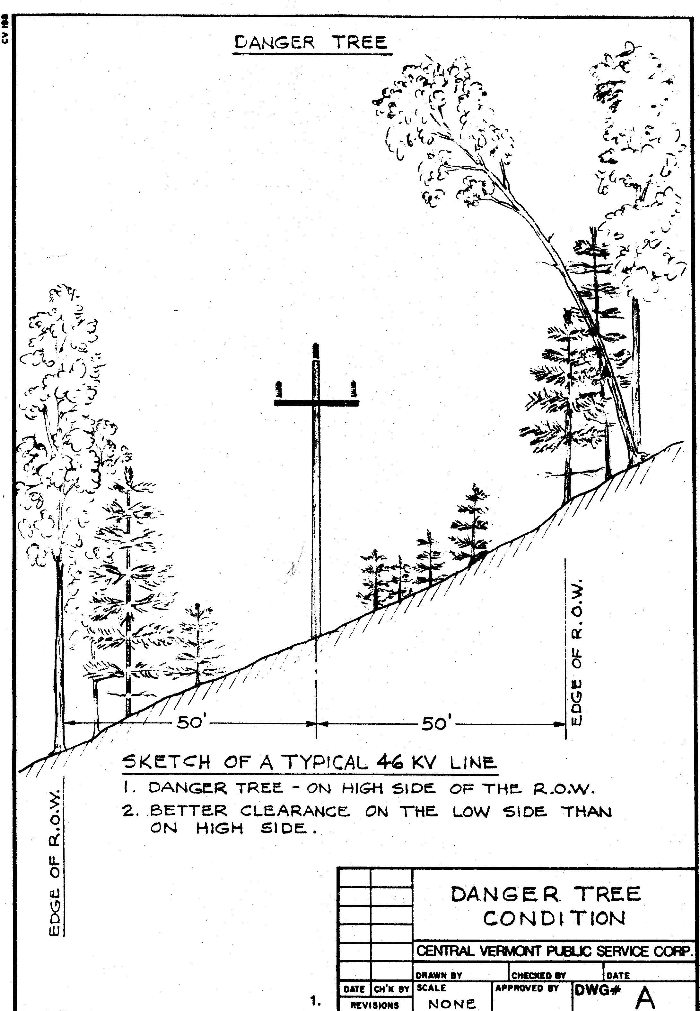
IX

APPENDIX E

LITERATURE CITED

American National Standards Institute, Inc., 2006, ANSI A300 (Part 7)-2006 IVM
Tree Care Industry Association, Inc. NH

Barrett, John W., 1962, Regional Silviculture of the U.S. 1962
The Ronald Press Co., New York Pp 2 - 5

Bramble, W.C., & Byrnes, W. R., 1974, Impact of Herbicides Upon Game Food and Cover on A
Utility Right of Way Ag. Expt. Sta. West Lafayette, Indiana 47902 Reas. Bull. No. 918

Cavanagh, John B., A Thesis, May 1976, Wildlife Use and Management Of Power Line Rights of
Way In New Hampshire University of New Hampshire, Durham, N.H.

Forbes, Reginald D., 1955, Forestry Handbook The Ronald Press Co., N.Y. Pp 6 - 43

Laughlin, S.B., and D.R. Kibbe, eds. 1985, Atlas of breeding birds of Vermont Univ. Press of New
England, Hanover, N.H. Pp 456

Ludlum, David, 1976, New England Weather Book 1910
Houghton Mifflin Co. 2 Park St., Boston, MA., 02107 Pg 2 - 3, 59

Nepool Operating Committee, 1980, Nepool Right Of Way Management Standard, New England
Power Service Co., Westborough, M.A., 01581

Niering, W.A., & Goodwin, R.H., 1974, Creation of Relatively Stable Shrublands With Herbicides:
Arresting “Succession” On Rights of Way And Pastureland Ecology Pg 784 – 795

Nowak, C.A., and B.D. Ballard. 2005, Applying Integrated Vegetation Management on Rights-of-
Way. Journal of Arboriculture 31(1): January 2005. Pp 28 - 37
LITERATURE CITED (Cont’d)

Penlac Co., System Forestry Dept., 1980, Specification For Chemical Treatment,
Johnstown, P.A., 15907

Rachman, David J., Mescow, Michael H., 1976, Business Today 1976
Random House, New York Pg 136 - 137

Thompson, Zadock, 1983, Natural History of Vermont 1972 Charles Tuttle Co., Inc., Rutland, VT

Tillman, Robert, Ed 1976, Proceedings Of First National Symposium On Environmental Concerns
In R.O.W. Management Mississippi State University Jan. 6 - 9, 1976

U.S. Government, 1957, Yearbook Of Agriculture 1957 U.S. Government Printing Office,
Pg 600 - 601

