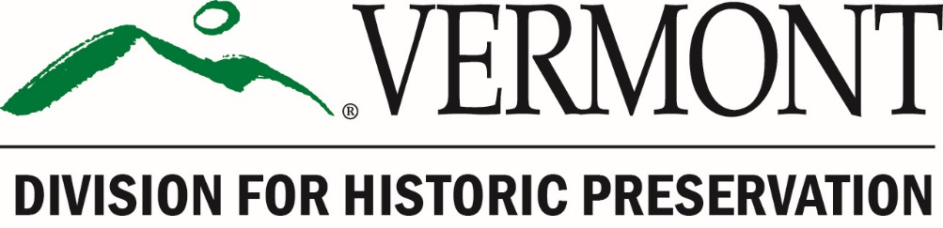

Certified Local Government Program

2023 CLG Grant Application
ROUND II

FFY 2023 grant funding provided by the
National Park Service/Historic Preservation Fund

Grant Period: October 1, 2022 – September 30, 2025

Vermont Certified Local Government Program
2023 Grant Application Form – ROUND II

Application Deadline: On or before 4:30 PM, Monday, April 17, 2023.

Application Format: All application materials should be submitted electronically via email.
If you are unable to do so, please contact Devin Colman at 802-585-8246 or devin.colman@vermont.gov.

What to Submit: All application materials must be submitted prior to the application deadline. A complete application consists of the following items, in the following electronic formats:

☐ A fully completed Application Form, signed by the applicant, the Chair of the CLG Commission, and the Chief Elected Local Official (or designee). Submit a scanned PDF of the complete application with all signatures.

☐ A fully completed Proposed Budget Form, signed by the Chief Elected Local Official (or designee). Submit the following:
☐ a scanned PDF of the signed Proposed Budget Form, and
☐ a MS Word version of the Proposed Budget Form.

☐ Any supporting materials, such as photographs, reports, assessments, etc. that support and inform the proposed project. Submit these materials as PDFs.

How to Submit the Application: Please submit all the above items as attachments to an email message, identified as follows:

Email Subject Line: [Name of CLG Community] – 2023 CLG Grant Application – Round II

Attachments: [Name of CLG Community] – Application Form (PDF)
[Name of CLG Community] – Proposed Budget Form (PDF & Word)
[Name of CLG Community] – Supporting Materials (PDF)

To complete this Grant Application, simply click in the gray text boxes and type your responses. Please keep your responses as concise as possible and specific to the proposed project.

Good Luck!

If you have any questions about the application process, please contact
Devin Colman at 802-585-8246 or devin.colman@vermont.gov.

Vermont Certified Local Government Program
2023 Grant Application Form – Round II

Name of CLG Community:

Name of CLG Coordinator: Telephone:
Email:
Mailing Address:

Name of Municipal Treasurer: Telephone:
Email:

Project Name:

Will this project be administered by a designated third-party? ☐ Yes or ☐ No
If yes, name of organization:

Project Category: Please check the appropriate category below and provide the requested information where indicated or on a separate page.

Priority I Projects
Top priority in the selection of projects and award of grant funds is given to Priority I projects.

☐ Survey Project. Please describe in Project Summary:
- purpose of the project;
- area to be surveyed (indicate on map);
- estimated number of properties to be surveyed;
- estimated number of acres to be surveyed;
- status of completion of town-wide or city-wide survey; and
- plans for completion of survey.

☐ National Register Project. Please describe in Project Summary:
- purpose of the project;
- building or historic district to be nominated (indicate on map);
- property type or theme for Multiple Property nomination;
- for a historic district, the number of contributing properties within the district;
- status of completion of town-wide or city-wide survey;
- plans for completion of survey; and
- status of survey through the National Register process.

☐ Preservation Planning Project. Please describe in Project Summary:
- purpose of the project;
- area to be covered by the plan (describe and indicate on map);
- status of completion of town-wide or city-wide survey, and plans for completion of survey; and
- status of survey through the National Register process.

☐ Information and Education Project. Please describe in Project Summary:
- purpose of the project;
- audience, methods and products;
- status of completion of town-wide or city-wide survey, and plans for completion of survey;
- status of survey through the National Register process; and
- status of historic preservation planning.

☐ Pre-Development Project. Please describe in Project Summary:
- purpose of the project;
- property or area to be covered by the plan (describe and indicate on map);
- scope of work and products;
- status of completion of town-wide or city-wide survey, and plans for completion of survey;
- status of survey through the National Register process; and
- status of historic preservation planning.

Priority II Projects
Awarded only if grant funds remain after all Priority I projects have been selected.

☐ Development Project. Please describe in Project Summary:
- purpose of the project;
- property or area to be covered by the plan (describe and indicate on map);
- scope of work and products;
- status of completion of town-wide or city-wide survey, and plans for completion of survey;
- status of survey through the National Register process; and
- status of historic preservation planning.
- Please include a location map showing the footprint of the building, the parcel boundaries, and any areas of possible ground disturbance resulting from the project.

Project Summary (please address the bulleted items in the Project Category selected above):

Please Answer the Following Questions:

- How will the public be informed about the purpose of this project and the value of historic preservation? (note: public information and education is a required component of all CLG grant projects)

- Describe the impact that this project will have on historic resources. Will it be significant and long lasting?

- Describe the project schedule assuming starting date of July 2023 and completion date of August 1, 2025. List dates for subcontracting with consultants, on-site meetings, delivery of draft products, such as survey and National Register forms, and public meetings, as applicable. All products, including a final project report and auditable financial documentation are due by the completion date.

DATE | Task/Product Competed
5/18/2023 | DHP notifies applicants of grant awards
7/2023 | Execute Grant Agreement with DHP
12/1/2023 | First Progress Report Due to DHP
4/1/2024 | Second Progress Report Due to DHP
12/1/2024 | Third Progress Report Due to DHP
4/1/2025 | Fourth Progress Report Due to DHP
8/1/2025 | Completion Date: Deadline to submit final project report, final product, and request reimbursement
9/30/2025 | Deadline for DHP to process payment requests and disburse grant funds

- Who will participate in the project and what will they do? Relate the personnel listed in the budget (CLG staff and commissioners, consultants, volunteers) to their role in completing the project.

- What are the dates of the local government’s fiscal year? to

- If applicable, what are the dates of the designated third-party administrator’s fiscal year?
to or ☐ not applicable

Signatures: After completing the application, print it out and have each of the three signatories sign and date this page. Then scan the complete application as a PDF and email it as an attachment along with the other required application materials.

THIS APPLICATION IS NOT COMPLETE UNTIL ALL REQUIRED SIGNATURES ARE ENTERED BELOW:

Name of person preparing this application Title

Signature Date

Name of CLG Commission Chair

Signature Date

Name of Chief Elected Local Official (or Designee) Title

Signature Date

