Vermont Historic Preservation Grants
2025 Application

Due Monday, October 7, 2024

IMPORTANT INSTRUCTIONS:
Before beginning this application, please read the 2025 Vermont Historic Preservation Grant Program Application Manual. It contains more directions to help you respond to each section below. The Manual is available online.

To complete the Word version of this application, click in the grey box next to each question to begin entering text. For sections with check boxes, double click on the box you wish to check and select checked from the pop-up menu.

Please do NOT alter the formatting of the application form in any way. Answers must use the format provided. Do NOT leave any sections of this application blank. Incomplete applications will not be considered for funding.

Submit completed application forms through our new digital DropOff portal at: https://gs.anr.vermont.gov/dropoff. See additional submittal instructions on page 11-12 of this application.

Questions? Email Caitlin Corkins at caitlin.corkins@vermont.gov.

Applications are due by midnight on October 7, 2024.

1A. APPLICANT

Organization/Municipality Name:
Address:

City: State: Zip Code:

Daytime phone: Email address:

1B. PROJECT CONTACT/ADMINISTRATOR (if different from above)

Name/Title:
Daytime phone: Email address:

1C. PERSON AUTHORIZED TO EXECUTE CONTRACTS FOR PROJECT

Name/Title:
Daytime phone: Email address:

1D. PROPERTY OWNER (if different from applicant)

Organization/Municipality Name:
Address:

City: State: Zip Code:

1E. HISTORIC NAME AND LOCATION

Historic Name:
Physical Address:

Vermont County:

2. GRANTEE EXPERIENCE

2A. In the last five years, has rehabilitation work on this building been funded with a State Historic Preservation Grant? If yes, please list the year and grant project.
Yes No

2B. Does your organization have experience with the last five years with similar federal or state grant programs? If yes, please list the year and grant project.
Yes No

2C. Does your organization use a manual or automated accounting system?
Manual Automated

3. BUILDING INFORMATION

3A. Date(s) of original construction and major additions:

3B. Original Building Type:
Church House Library School Town Hall
Other

3C. Is the building listed in the State Register of Historic Places?

Yes No, but determined eligible No

3D. Is the building listed in the National Register of Historic Places?

Yes No, but determined eligible No
4. HISTORY
Briefly describe the building/structure and give a short summary of its history. What is the ownership history and what are the original/historic use(s) of the building?

5. PRESERVATION OF HISTORIC FEATURES
For each subsection below rate the condition of building elements using the following scale: Excellent, Good, Fair, Poor. Then write a short summary of the work needed to repair/restore this element. If no work is needed in any subsection, say so. Do not leave any section blank. Indicate how any planned or necessary repairs listed in this section meet the Secretary of the Interior’s Standards for Rehabilitation, including the methods and materials to be used.
5A. Roof
Condition:

Repairs Needed (including methods and materials):

5B. Frames & Structure

Condition:

Repairs Needed (including methods and materials):

5C. Exterior (siding, trim, etc.)

Condition:

Repairs Needed (including methods and materials):

5D. Interior (plaster, stenciling, decorative trim, tilework etc.)

Condition:

Repairs Needed (including methods and materials):

5E. Windows & Doors

Condition:

Repairs Needed (including methods and materials):

5F. Foundation and Site (drainage, etc.; conditions impact the building)

Condition:

Repairs Needed (including methods and materials):

5G. Special Features (steeples, cupolas, porches, etc. if applicable)

Condition:

Repairs Needed (including methods and materials):

6. PUBLIC BENEFIT AND LONG-TERM USE
6A. Is the property protected through a preservation or conservation easement through VHCB, the Preservation Trust of Vermont, or another non-profit entity?
Yes No If yes, briefly describe.

6B. What is the current use of the building(s) and property?

6C. What is the planned use of the building following this project? If the building is rehabilitated, will it have a new or expanded use? Describe any changes that will be made to the building to accommodate a new use and whether these changes will impact any historic features.

6D. Describe the public benefit of this project. Who will benefit? Is the building visible from public places? Is it important to the history of the community or an important local landmark? Does the community support the project? Are other organizations involved?

7. ARCHITECTURAL OR HISTORICAL SIGNIFICANCE
Briefly describe the architectural and/or historical significance of the building and its site. Is it vulnerable or a rare survivor? Does it have an unusual history or unique features that will be preserved as part of this project? Reference or summarize professional documentation to support your evaluation.

8. LONG-TERM PRESERVATION PLANNING AND BUDGET

8A. Describe any substantial rehabilitation, restoration or improvement projects completed on this building in the last five years. Then provide a prioritized list of additional work that needs to be done following completion of this project. How will these projects be funded? What is the plan for routine maintenance and long-term preservation of the building?

8B. Briefly summarize the proposed grant project. If estimate(s) included with the application suggest multiple options for completing a project or propose work that is not appropriate, indicate which method is preferred and why and/or how the project will be modified to meet the Secretary Standards for Rehabilitation.

8C. Briefly list work items for your project in priority order. Only include those items for which you are seeking grant funding. If estimates obtained for the project provide a lump sum cost or a “time and materials” cost, include each work item and then enter the total project cost at the bottom of this section. Separate costs for each work item are not required.

WORK ITEMS IN PRIORITY ORDER

1. | Estimated Cost: $
2. | Estimated Cost: $
3. | Estimated Cost: $
4. | Estimated Cost: $
5. | Estimated Cost: $
6. | Estimated Cost: $
7. | Estimated Cost: $
8. | Estimated Cost: $
9. | Estimated Cost: $
10. | Estimated Cost: $
 | TOTAL COST: $
8D. GRANT REQUEST
The maximum grant amount you may request is $20,000.00. The Grant Request cannot exceed 50% of the total estimated project cost.

GRANT AMOUNT REQUESTED: $

8E. MATCHING AMOUNT SUMMARY
List sources of matching funding below. Matching funds that equal the grant request must be in-hand at the time of application and the total amount of matching funds should match, but not exceed the grant amount requested.

SOURCE: | AMOUNT: $
SOURCE: | AMOUNT: $
SOURCE: | AMOUNT: $
SOURCE: | AMOUNT: $
TOTAL AMOUNT OF MATCHING FUNDING: $

8F. SOURCES OF ADDITIONAL FUNDS
List additional sources of funds over and above your grant request that will be used to pay for the project work prior to reimbursement. Indicate whether these funds are in hand or must still be raised.

8G. PARTIAL AWARD
Could your organization accept a partial award to successfully complete a phase of this project? Yes No

If yes, describe what funds are necessary to support each discrete portion of the project. Be specific about how much funding is required to complete each phase.

9. ACCESSIBILITY FOR PERSONS WITH DISABILITIES

9A. Is the building fully compliant with the Americans with Disabilities Act (ADA)?

Yes No

9B. If the building is not ADA compliant, describe plans to make it accessible.

10. REQUIRED ATTACHMENTS

- Contractor Estimate(s). (See the 2025 Vermont Historic Preservation Grant Application Manual for additional instructions.

- Photographs. See the 2025 Vermont Historic Preservation Grant Application Manual for additional instructions.

- Non-profit Applicants: Proof of non-profit status – IRS 501 (c)(3) certification is preferred. Municipal applicants are not required to submit proof of non-profit status.

- *OPTIONAL Preservation plans, reports, evaluations, or maintenance plans completed within the last five years that are applicable to your grant request.

- *OPTIONAL If your building is currently vacant or underutilized, you may provide 1-2 letters of support with your application. These letters should provide evidence of a commitment for future use/expanded use of the building. This could be from your municipality, an organizational partner, or a future renter/user of the space. Do NOT provide more than two letters of support. Do NOT provide letters of support if the use of your building will not change/expand because of this project.

SUBMISSION INSTRUCTIONS:

Applicants should submit their completed application form and attachments via the new digital DropOff portal.

- In your web browser, go to https://gs.anr.vermont.gov/dropoff
- Fill out the fields within the form, which includes the following:
  - From
  - To
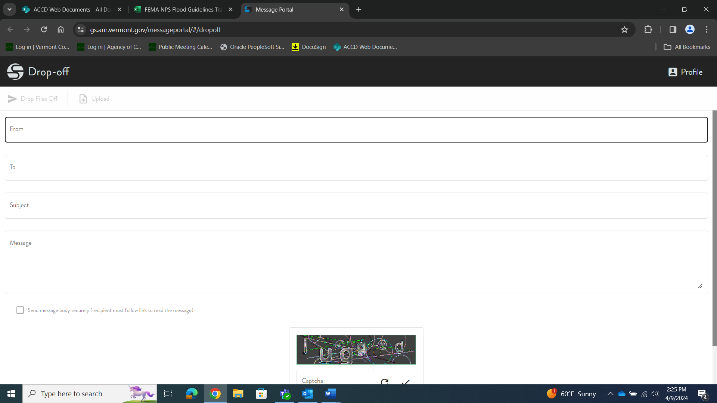
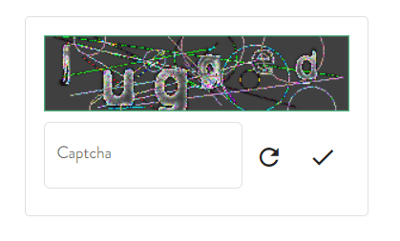
  - Subject
  - Message

- Next, you must solve the Captcha located at the bottom of the form before uploading any files. Type the letters as shown in the image, and then click the Check Mark.
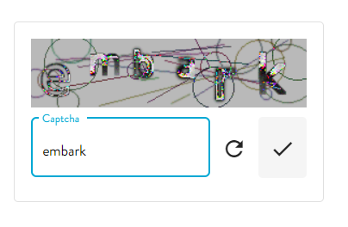

When the Captcha has been correctly solved, the Captcha box will disappear, and the “Upload” button will change from gray to black:
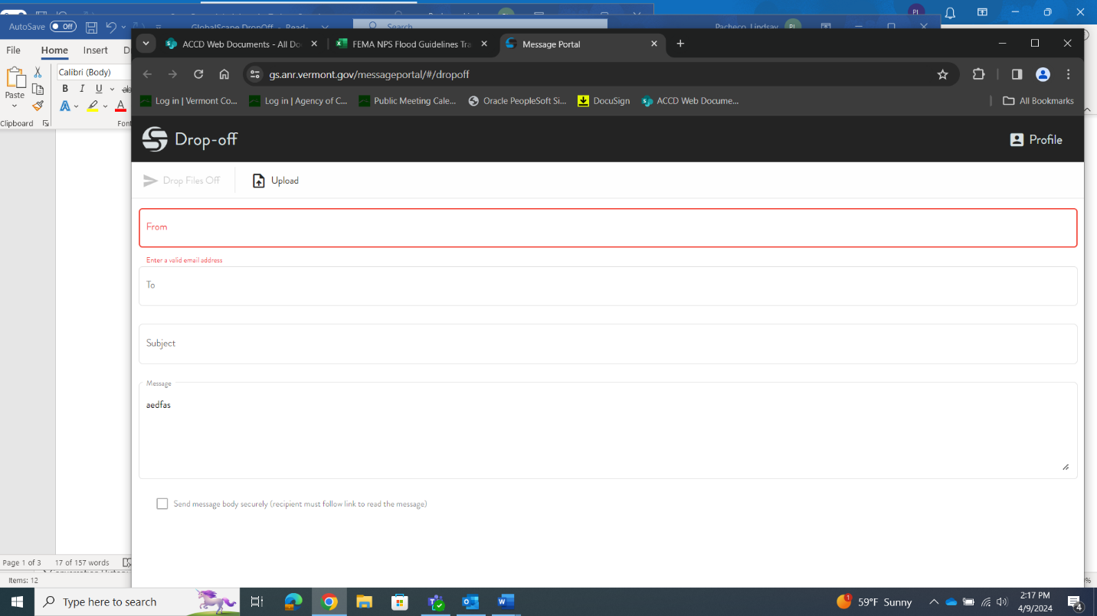
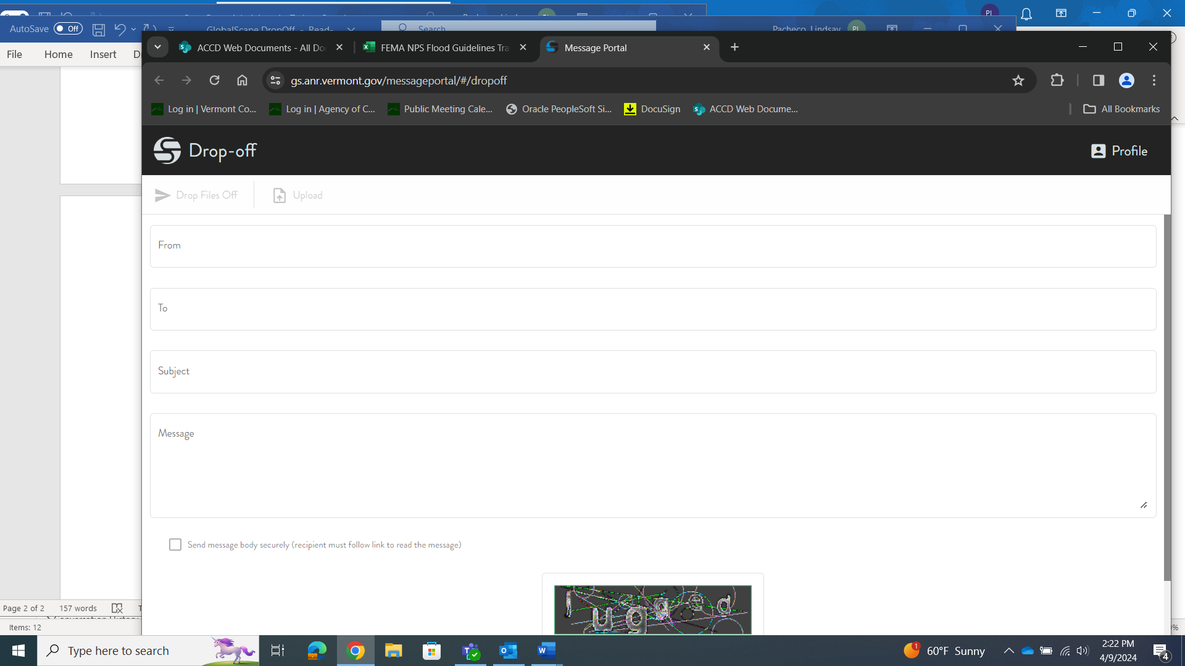

- You can now upload documents to the DropOff portal. To do this, you will select the “Upload” button, which will automatically cause your File Folder to pop up. From here, select the files and/or folders you would like to upload. YOU MAY RUN INTO ISSUES UPLOADING FOLDERS. PLEASE COMPRESS FOLDERS FIRST INTO A .ZIP FORMAT
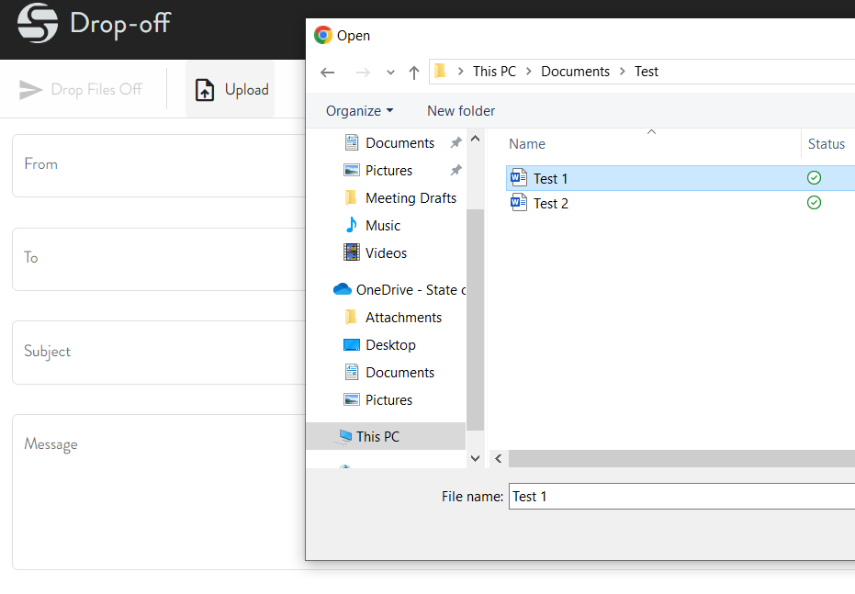

- Once all documents are selected, they will appear at the bottom of the page (where the Captcha box originally was) with a blue check mark on them. You may press the black trash icon to remove items as needed.
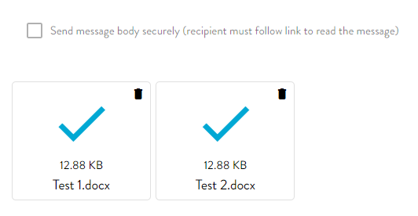

- From this point, if all the above information has been filled out and files are attached, you will have the option to submit. The “Drop Files Off” will change from grey to black.
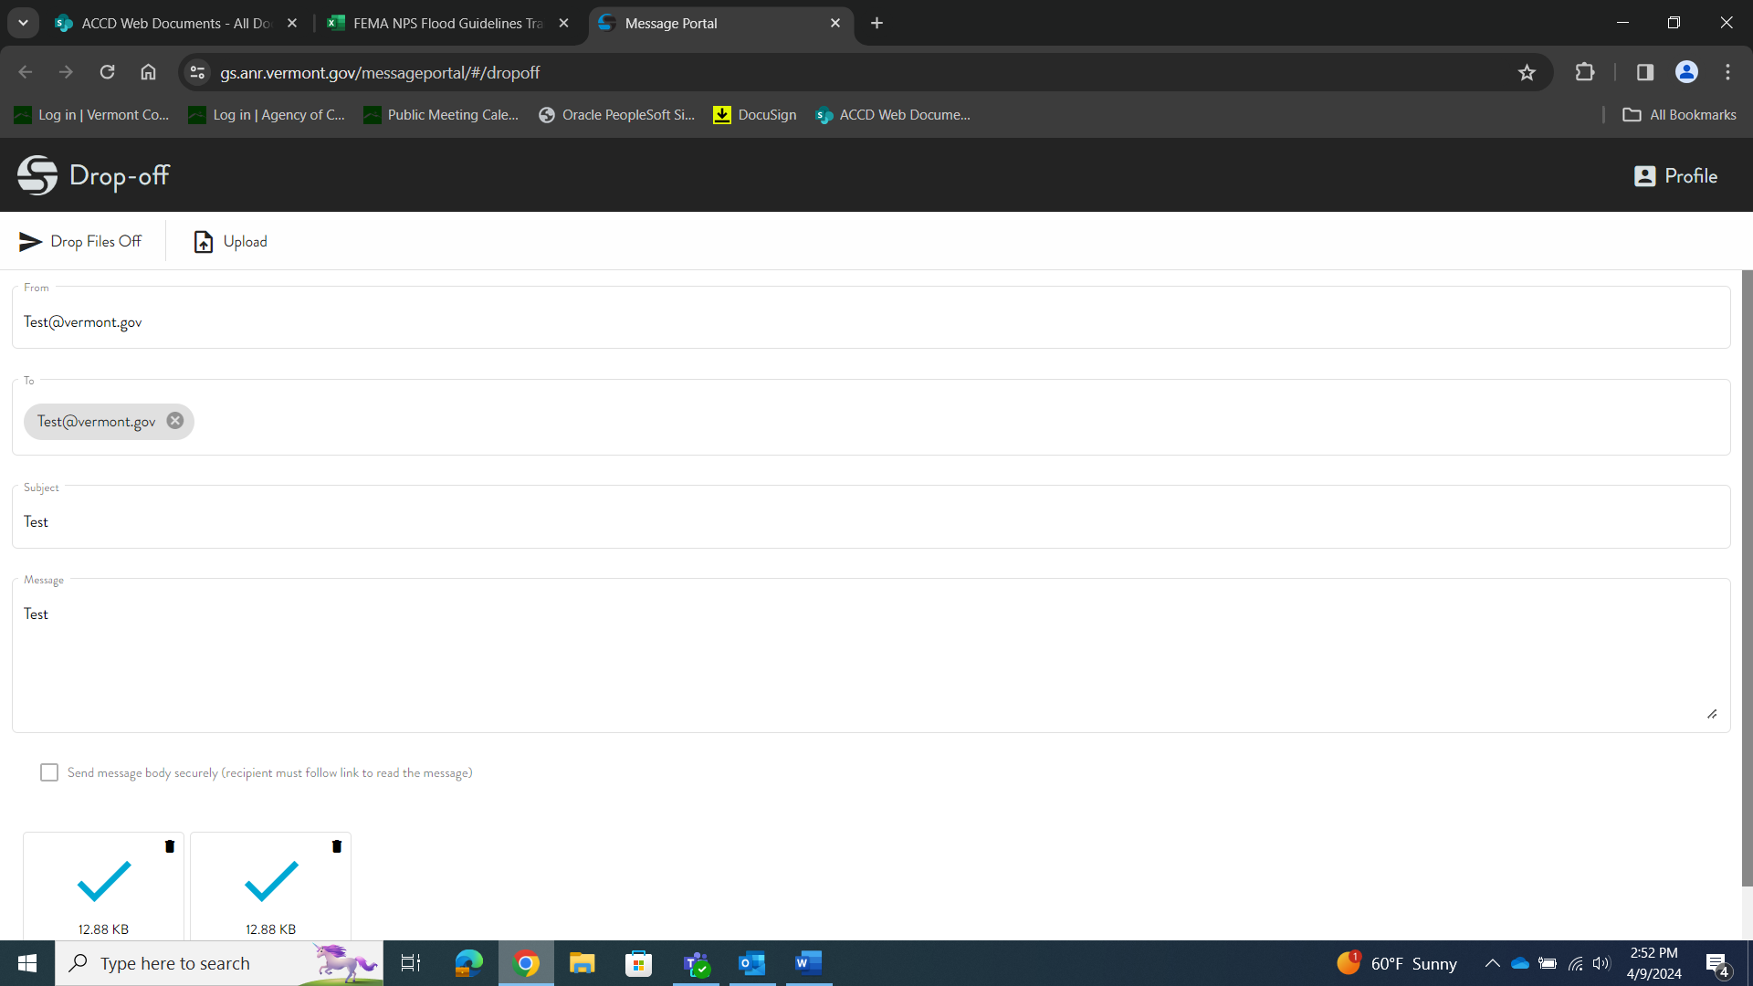
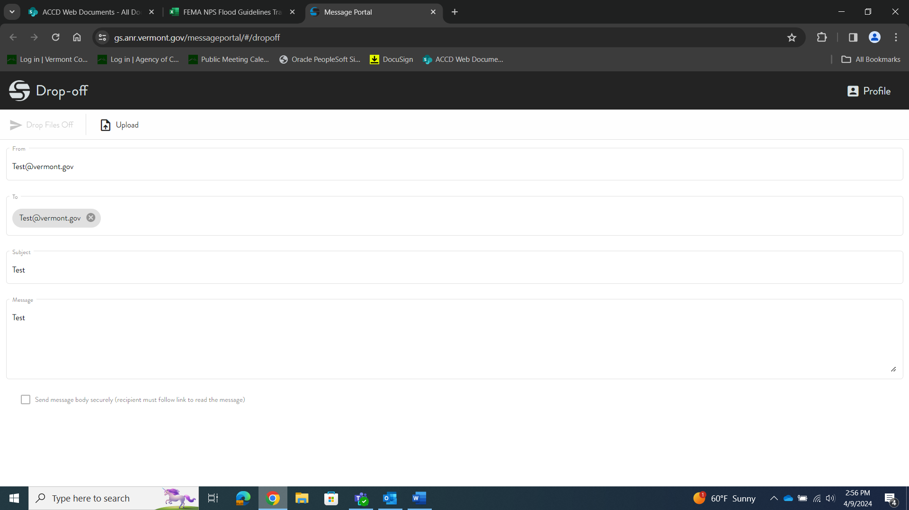

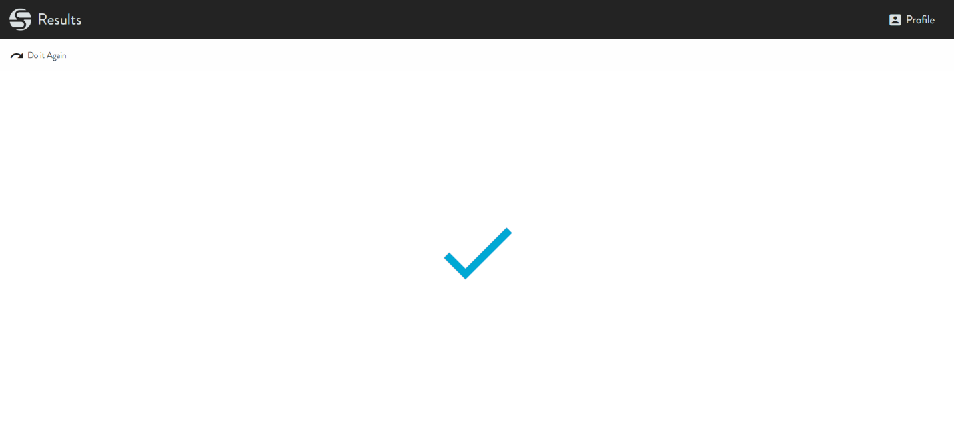
- After you have clicked “Drop Files Off,” the screen will show a blue checkmark across it. All your attached files will automatically be sent to the email address entered in “To.” You will not receive a confirmation email after submitting. We receive notification immediately, so if you would like to confirm that everything has been received you may reach out to us directly.
CERTIFICATION:
Please complete section A or section B below as applicable. If you are unable to submit your application digitally you may submit a paper copy to the address listed in the 2024 Grants Application Manual. Mailed applications must be typed. We no longer accept handwritten applications.

A. Before submitting your application via our DropOff portal, check the box below to certify your application. If submitting digitally, you do NOT need to complete section B.

I am submitting this Application digitally. I am applying for a 2025 Vermont Historic Preservation Grant and am authorized to submit this application on behalf of the Applicant. I certify that the information presented in this Application is complete and accurate and I am authorizing the Vermont Division for Historic Preservation to accept the submittal for review and potential award. I understand that upon submission to the State, I relinquish sole rights to ownership or control over the photographs and digital images I am submitting and that the photographs shall become the property of the State upon receipt by the State.

B. If you are unable to submit your application digitally and are submitting a paper copy of the application, you MUST sign and enter the date in the box below. Mailed applications must be postmarked by October 7, 2024.

By signing this application, I certify I am applying for a 2025 Vermont Historic Preservation Grant and am authorized to submit this application on behalf of the Applicant. I certify that the information presented in this Application is complete and accurate and I am authorizing the Vermont Division for Historic Preservation to accept the submittal for review and potential award. I understand that upon submission to the State, I relinquish sole rights to ownership or control over the photographs and digital images I am submitting and that the photographs shall become the property of the State upon receipt by the State.

APPLICANT NAME:
SIGNATURE: | DATE:

Submit Complete Applications at https://gs.anr.vermont.gov/dropoff by midnight on October 7, 2024.

Direct any questions about this application to Caitlin Corkins at caitlin.corkins@vermont.gov or at 802-828-3047.
Thank you for applying for a State Historic Preservation Grant!

