24 CFR Part 58 Environmental Review Process Memo

Vermont Community Development Program (VCDP)
U.S. Department of Housing and Urban Development
This memo provides general guidance in preparing an Environmental Review (ER) compliant with 24 CFR Part 58. However, projects and their impacts are evaluated on a case-by-case basis. For ER questions or concerns, please contact the Environmental Officer.

Contact Information
To receive this information in an alternative format or for other accessibility requests, please contact:
Grace Vinson, Environmental Officer
Agency of Commerce and Community Development
Grace.vinson@vermont.gov, 802-622-4236

Table of Contents

Background Information …………………………………………. 3

Environmental Review and the VCDP Application Process …. 3

Environmental Review Record ………………………………….. 3

Compliance Checklist …………………………………………….. 4

Supporting Documentation ……………………………………… 4

Choice Limiting Activities ……………………………………….... 4
Planning Activities ……………………………………………...…. 5

Non-Planning Activities ………………………………………….... 5

Levels of Environmental Review ………………………………… 5

Convert to Exempt ………………………………………………… 6

Tiered Environmental Reviews …………………………………... 6

GEARS Process and Status Changes ………………………….. 7

Public Notice and Comment Period Information ……………….. 8

ER Release Letter and Conditions…………………….……….… 9

Background Information
Under 24 CFR Part 58, every U.S. Department of Housing and Urban Development (HUD) assisted project must complete an Environmental Review. The purposes of the ER are to assess the impacts of the project on the environment and the impacts of the environment on the project; to involve the public in the decision-making process; and to make better-informed decisions. The ER demonstrates compliance with the National Environmental Policy Act (NEPA), and all other local, state, and federal laws and authorities triggered by HUD Part 58 ER. For more information, please contact the VCDP Environmental Officer and review additional guidance materials on the ACCD Environmental Review webpage.

Environmental Review and the VCDP Application Process
The ER does not need to be completed before a grant application is submitted, but applicants are highly encouraged to start the ER early in the application process. The ER must be completed before any choice limiting activities occur. If the ER is not completed prior to receiving an award, the ER will be listed as an Award Condition. Please note that if there are any potential environmental concerns and the ER has not progressed or completed, it is possible that the Community Development Board may table the project until the ER has moved far enough along to rule out any possible issues.
A VCDP Grant Agreement will not be executed until the Environmental Review has been completed and an Environmental Review Release letter has been issued. The ER Release letter signifies full completion and approval of the ER. This letter may also identify ER Conditions that must be satisfied before the grant is closed out.
Please note that if a significant amount of time has passed (e.g. a year) since the ER was completed but no application has been submitted the Environmental Officer should be contacted to discuss if the ER is still valid. In addition, if the project activities or the scope of work has changed, an updated ER may be required.

Environmental Review Record
The entire environmental review, including all supporting documentation, is completed and saved in GEARS, the State of Vermont’s Grants Electronic Accounting and Reporting System. The entire record is made available to the public for their review, comments and/or objections during designated periods and is referred to as the Environmental Review Record (ERR). This file demonstrates compliance with NEPA, and all other associated local, state, and federal laws and authorities triggered by the HUD ER. The primary ERR components are the Environmental Review Compliance Checklist and Supporting Documentation.

Compliance Checklist
The compliance checklist is filled out by the ER preparer to document the proposed project’s compliance with all local, state, and federal laws and authorities triggered by the HUD Part 58 ER. The content and formatting of this checklist vary according to the level of review for the project. This fillable document can be found both on GEARS and on the Agency’s Environmental Review webpage.

Supporting Documentation
Supporting Documentation includes maps, reports, photos, site plans and other materials that show compliance with the laws and regulations applicable to the project. These materials are directly referenced in the compliance checklist and are submitted on the Supporting Documentation page on GEARS.
The Agency’s Environmental Review webpage has guidance documents that can assist the ER preparer in obtaining the necessary Supporting Documentation. Documentation from specific sources is required to demonstrate compliance. In particular, the Floodplain Management and Toxic Sites compliance factors of the ER often require a substantial amount of Supporting Documentation.
Please note:
- If the project is located in the floodway, and the activity is not a functionally dependent use (such as a bridge, marina, or culvert), the project is ineligible for HUD funding.
- Permits will be required prior to the completion of the ER whenever a permit is needed for mitigation purposes. This may or may not involve an environmental impact but may be required as prevention of an impact. In some instances, one permit may be inextricably linked to another permit. In those cases, all associated permits will be required prior to the completion and approval of the ER.

Choice Limiting Activities
Choice limiting activities are certain activities that are prohibited until the ER is completed and the ER Release letter has been issued. Conducting a choice limiting activity, especially buying a property, prior to the completion of the ER means that the action itself reduces or eliminates potential opportunities to select project alternatives that would minimize or avoid environmental impacts. Engaging in these activities prior to the approval of the ER compromises the unbiased consideration of alternatives and is therefore forbidden.

It can be acceptable to send out a request for proposals (RFP) or request for bids for a project ONLY if the request is caveated that the project is contingent upon successful completion of the environmental review, and that the project scope may change as a result of the environmental review. However, bid evaluations and decisions cannot be made until after the environmental review is complete as these are choice limiting activities.

Planning Activities
Choice limiting activities for planning grants are those where the grant work product includes planning activities which the applicant will request funding (e.g. a feasibility study, engineering report, Phase 1 Environmental Site Assessment, etc.). For planning grants, it is prohibited to perform any planning activities until the ER is completed.

Non-Planning Activities
Choice limiting activities for non-planning grants include actions such as: signing a Purchase and Sales Agreement; signing an Option Agreement that does not allow the purchaser to elect to terminate the Option Agreement if the subject property is not desirable; acquisition of a property; leasing a property, or entering into a commitment for repair, rehabilitation, construction, or demolition. For non-planning grants, planning activities are often completed as predevelopment work or as supporting documentation for the environmental review itself, and are not considered choice limiting.

Levels of Environmental Review
There are three levels of Environmental Review:
- Exempt (this section also includes Categorically Excluded Not Subject To 58.5)
- Categorically Excluded Subject To 58.5 (Categorically Excluded)
- Environmental Assessment (EA)
The level of environmental review is determined by the project activities and scope; parameters are outlined in 24 CFR 58.34, 24 CFR 58.35 and 24 CFR 58.36. Each subsequent level requires more documentation than the last because the proposed project activities have greater potential to cause environmental impacts. See the Environmental Review Steps FAQ webpage for more information about how to determine the appropriate level of environmental review for your project. Contact the Environmental Officer for assistance in making this determination.
Please note:
- The Exempt level does not mean that the project is exempt from an environmental review in its entirety. Exempt level projects are exempt from compliance with Part 58.5 regulations, but they are still subject to Part 58.6 regulations including Airport Runway Clear Zones, Floodplain Management and Coastal Resources.
- The project description for an ER is extremely important as this is how the level of review is determined. If the project description is not inclusive of all proposed activities, even if it seems as if some activities have no environmental impact, a change of level of review may be required after the ER is in progress or completed which may delay ER completion.
All projects, even those at the exempt level, require the completion of a Preliminary Review Form. This form must be submitted to the Vermont Division for Historic Preservation (VDHP) using the online CHAMP system. VDHP will review the submission and make a determination of effect on historic resources. This review period can take up to 30 days. VDHP will sign and date the reviewed form and return it to the applicant. The Preliminary Review Form serves as the Supporting Documentation for the Historic Preservation compliance factor.

Convert to Exempt
Certain Categorically Excluded projects that, after review, do not require mitigation measures or formal compliance steps are able to “convert” to Exempt. This does not mean that the project could have started at the Exempt level, but rather it means that the project can be treated as Exempt moving forward because no further compliance is needed. The project remains in GEARS as a Categorically Excluded project in order to maintain all of the supporting documentation, but it does not require a public notice, public comment period, objection period, or Request for Release of Funds. An ER Release letter is still required before initiating project activities or choice limiting activities.

Tiered Environmental Reviews
In some cases, the project may include unidentified locations. In this instance, a tiered ER is appropriate. A Tier I ER is a broad level review of statutory factors that the project can demonstrate compliance with while the exact project location is unknown. The completion of the Tier I ER results in a Tier I ER Release letter which includes a condition stipulating that a Tier II ER will be completed once the exact project location becomes known. A Tier II ER is linked to the Tier I ER, and demonstrates compliance with the remaining statutory factors that are related to the exact project location. The ER is complete and funds can be expended once the Tier II ER Release letter is issued.

GEARS Process and Status Changes
Throughout the review process, the ER will progress through certain stages. To mark the status of the ER at these intervals, the ER preparer and the Environmental Officer will both perform status changes on GEARS. Status changes initiate email notifications that communicate requests for review, requests for modification or prompts to complete the next required action.
The ER process begins with the Responsible Entity (either the Municipality or the Agency, depending on funding circumstances) opening a new ER. Typically, ER preparers and consultants are assigned a “writer” role in GEARS.
When the ER is first opened, it will default to the status “Env Review in Process”. In this status, the ER preparer is able to freely make edits and uploads.
Each page of the ER in GEARS has written guidance to assist you in completing the Environmental Review. In addition, all forms needed are linked within GEARS.
The ER has several pages that need to be completed before being submitted for preapproval. Once all pages are complete and Supporting Documentation is uploaded, the ER preparer changes the status from “Env Review in Process” to “Env Review Pre-Approval Submitted.”
At this stage, the ER is reviewed by the Environmental Officer. Any required modifications or revisions, additional documentation, and feedback will be communicated via email to the ER preparer and the Environmental Officer will change the status to “Env Review Pre-Approval Modifications Required”. When all revisions have been made, the ER preparer will change the status to “Env Review Pre-Approval Modifications Submitted”. When the Environmental Review is compliant, it will proceed to the next stage when the Environmental Officer changes the status to “Env Review Public Notice Required”.
(Skip this stage if project is Exempt) At this stage, the ER preparer will draft the public notice (see next section for requirements). Once the public notice period has expired, the draft notice and tear sheet from the newspaper publication must be uploaded to GEARS. The ER preparer must also upload documentation of all public outreach that has been completed for the project up to this point (this includes minutes and lists of attendees of any applicable public hearings or meetings) and then change the status to “Env Review Public Notice Submitted”. After review, the Environmental Officer changes the status to “Env Review Public Notice Accepted”.
At this stage, the person holding the Municipal Authorizing Official (MAO) role in GEARS must certify the ER, affirming that they find the information contained to be accurate to the best of their knowledge and they agree with the Finding indicated. Once this action is completed, the MAO changes the status to “Env Review Submitted”.
The Environmental Officer changes the status to “Env Review Approval Pending”, which marks the beginning of the 15-day objection period (unless the project is Exempt, in which case the release is issued immediately after the ER is Certified). Once the objection period has expired, the Environmental Officer changes the status to “Env Review Approved” and issues the Environmental Review Release letter on GEARS and over email.

Public Notice and Comment Period Information
A public notice is required for Categorically Excluded and Environmental Assessment level reviews, but not for Exempt level reviews. The ER preparer should draft the public notice and email it to the Environmental Officer for review and potential edits prior to publication. If the public notice is not reviewed prior to publication and there are deficiencies, the public notice may need to be reissued. All public notices must be posted in a newspaper that serves the project area or on an accessible government website. The dates in the public notice must coincide with the required public comment period. If comments or objections are received, the Responsible Entity (in collaboration with VCDP and other project partners) must prepare written responses to each commenter and include the comments and responses in the ERR.
The length of the public comment period is based on the level of review for the project.
Exempt level projects do not require a public notice, a public comment period or an objection period.
Categorically Excluded “convert to exempt” projects that do not require formal compliance steps or mitigation do not require a public notice, a public comment period or an objection period.
Categorically Excluded projects require a public notice, a 7-day public comment period starting the day after the publication date and a 15-day public objection period starting the day after the ER is certified by the MAO. See the color-coded calendar below for an example public comment and objection period for an Environmental Assessment level ER.
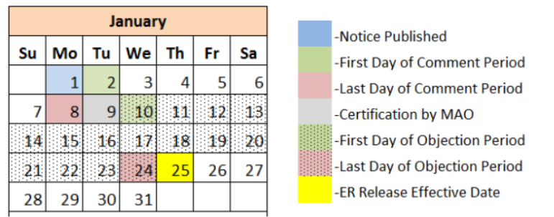
Figure 1: Public Notice Period for CATEX Projects
Environmental Assessment projects require a public notice, a 15-day public comment period starting the day after the publication date and a 15-day public objection period starting the day after the ER is certified by the MAO. See the color-coded calendar below for an example public comment and objection period for an Environmental Assessment level ER.
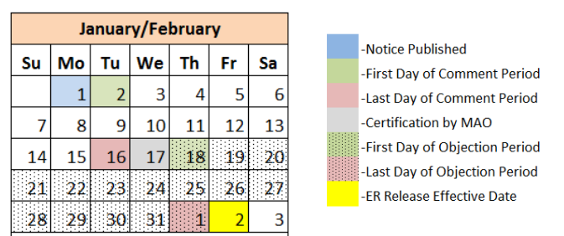
Figure 2: Public Notice Period for Assessment Projects

ER Release Letter and Conditions
If no public comments or objections are made during the designated periods, the ER Release letter will be issued by the Environmental Officer. If environmental review conditions are required, they will be identified in the letter along with necessary steps and documentation required to satisfy the conditions. Condition documentation must be uploaded to the ERR on GEARS prior to grant closeout. Upon receipt of the ER Release letter, the ER is complete and you may move forward with expending funds, signing contracts, and other choice limiting activities.

