April 2, 2026, DR Board Meeting Minutes
ACCD-Calvin Coolidge Conference Room 6th Floor, National Life
Virtual Microsoft Teams (Meeting ID: 263 346 946 466 24 Passcode: gw6vF3Bs)

Board Members in attendance in-person: John Biondolillo
Board Members in attendance virtually: Cynthia Gubb, John Kascenska, Liz Ruffa, Angus Chaney, Gabe LaJeunesse
Board Members Absent: Maura Collins
Staff in attendance in person: Ann Karlene Kroll, Nate Formalarie, Devon Hanna, Caroline Studer, Julia Connell

Staff in attendance virtually: Patrick Scheld, Grace Vinson, Kristie Farnham (Department of Economic Development), Erik Filkorn and Pat Moulton (Office of Disaster Recovery)

Members of the public virtually: Phil Dodd, Karen Hatcher, Michael Miller, Arion Thiboumery, Lauren Geiger, Nicola Anderson, Rick Burroughs, Donny Osman

Members of the public in person: Steve Whitaker

Cynthia Gubb chaired the meeting and called the meeting to order at 9:00 a.m.

Public Comment Period
Steve Whitaker stated that a federal compliance review filed March 8th is pending at HUD and has been delivered to the Agency as of this morning 4/2 and added that the Board was not made aware of this pending review. He explained that the City of Montpelier’s (the City) certification of no other available funds on their Urgent Need Certification is contradicted by simultaneous federal applications (the City applied for a BUILD grant from the U.S Department of Transportation before the filing of their CDBG-DR application) and by the Planning Director’s own public statements regarding redirection of funds if both USDOT and CDBG-DR grant funds are awarded. In addition, Steve noted that the certification of immediacy is contradicted by the physical and regulatory conditions on the ground.

Cynthia asked Ann if these issues were addressed with HUD and cleared to which Ann responded that several of the issues were discussed and cleared with HUD before the Agency accepted the application. Steve responded, saying that wasn’t possible as some of the issues are subsequent to the filing of the application to which Ann agreed.

CDBG-DR Funding & Requirement Overview
Devon gave a brief overview of the program, detailing the program areas, LMI Benefit requirements, and HUD/State MID splits. A comparison of program area allocations and awards to date was presented along with an update on the current LMI Benefit standing (82%).
Devon discussed that the high-level priorities for the Housing-only round are projects that are transformative, offer net new housing units, and create housing out of harm’s way. He gave an overview of the staff analysis process and presented the five funding requests.

Country Club Road (CCR):
John B asked if the City of Montpelier (the City) had sent out RFPs for developers and whether the staff had any involvement in the RFP process. Devon responded that the City had first put out an RFQ and received 10 responses with five developers selected to submit an RFP. He added that the proposals are on the CCR website and that the City was in close communication with the Agency throughout the process and no issues had been identified.

Cynthia said that this is a housing-only round and the CCR project sounded more like an infrastructure project. She questioned how the Agency justified this as a housing project. Devon explained that the project is infrastructure in the support of housing and HUD determines if a project is eligible by how it achieves a benefit. With the CCR project, the benefit will be the construction of affordable housing units, and the construction of these units is enabled by the construction of the infrastructure. Ann emphasized that this was vetted by HUD.

Liz Ruffa asked how many total units will be in the development to which Devon responded that it depends on which developer is selected but the numbers are in the 250-350 range.

Acquisitions & Redevelopment
John B questioned why the Agency is receiving projects that are not eligible and whether staff are providing guidance to applicants for preparing eligible projects that create housing units. Devon explained the threshold review process and Ann added that staff have tried to coach applicants throughout the application process. Devon explained further that both proposals submitted by the City of Barre (the City) were submitted as a single application in the first round of funding and feedback was given to the City on what would be needed to make the application eligible; however, the City chose to submit their application without redevelopment plans.

There were no questions on the Downstreet North Branch, Barre Buyout & Elevations, or Plainfield East Village Expansion projects.

CDBG-DR Consent Agenda and Funding Recommendations
John B expressed that he has issues with the Plainfield project as it’s over $5MM for infrastructure for 20 units, there is no agreement with the town to take over the road, and no firm development plans. Devon responded that the site plan includes more parcels on the site that will be developed outside of what’s in the current proposal. Ann explained that PCDC tailored back the number of housing units in their application to a smaller number to achieve the benefit within the CDBG-DR timeframe. John B added that PCDC have no experience and that while there is demand for housing in Barre and Montpelier, there is little to no demand in Plainfield. He feels strongly that this project is not the best use of funds and funding it would be a mistake.

Housing Consent Agenda

Devon presented the consent agenda below and turned it over to board for questions and discussion.
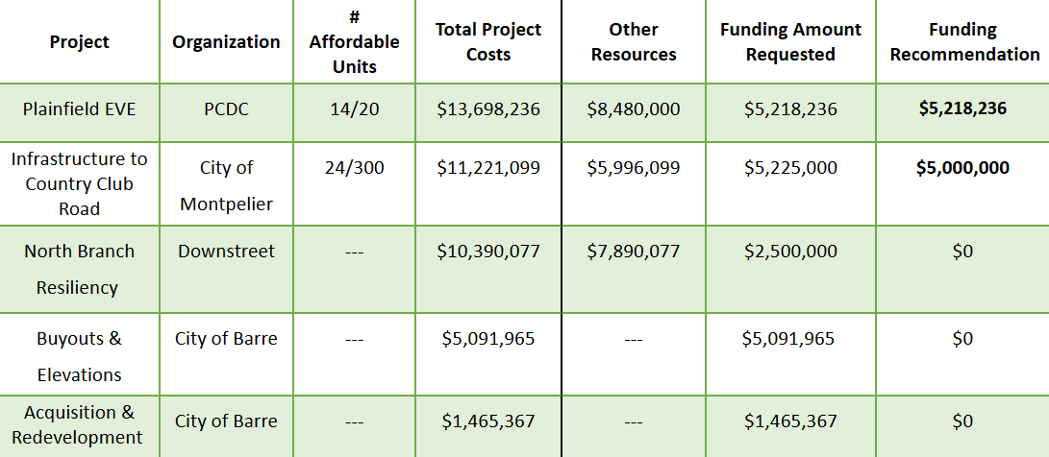

Cynthia asked the Board members if there are any projects that they want to remove from the consent agenda.

John B asked to remove the Plainfield East Village Expansion (EVE) project from the consent agenda. Liz said it would be prudent to have further discussion about the removal of Plainfield EVE from the Consent Agenda as well as the remaining projects and suggested a vote.

Gabe recused himself from the projects in Montpelier.

Cynthia asked for a motion to remove the Plainfield EVE project from the Consent Agenda.
John B made motion to approve and Angus seconded.
The motion is lost – 1 Yes – 4 No

John B: Yes
Gabe: No
John K: No
Liz: No
Angus: No

Cynthia asked for motion to accept the Consent Agenda as it stands.
John K made the motion to fund recommendations as presented by the Consent Agenda; Angus seconded the motion.
The motion carried – 3 Yes – 1 Abstention – 1 No

John B: No
Gabe: Abstained
John K: Yes
Liz: Yes
Angus: Yes

Adjourn

The meeting adjourned at 9:49 AM.

