April 10, 2026, DR Board Meeting Minutes
ACCD-Calvin Coolidge Conference Room 6th Floor, National Life
Virtual Microsoft Teams (Meeting ID: 227 102 520 832 395 Passcode: Rp97XP9k)

Board Members in attendance in-person:
Board Members in attendance virtually: John Kascenska, Lisa Sullivan, Angus Chaney, John Biondolillo, Maura Collins, David Riegel, Liz Ruffa
Board Members Absent: Cynthia Gubb
Staff in attendance in person: Alex Farrell, Nedah Warstler

Staff in attendance virtually: Ann Karlene Kroll, Devon Hanna, Caroline Studer, Patrick Scheld, Maxwell Krieger

Members of the public virtually: Karen Hatcher, Nicola Anderson

Members of the public in person: Steve Whitaker

John Kascenska chaired the meeting and called the meeting to order at 1:30pm.

John K. noted that Cynthia Gubb could not attend the meeting today and that he was asked to Chair in her absence. John K. requested that all parties remain on mute unless recognized to speak and stated that the Board will only accept public comment during the 10-minute public comment period.

Public Comment Period
Steve Whitaker stated that he wrote to Board Chair Cynthia Gubb and every board member on April 7th asking them to use their authority to reconsider the recommendation to fund Montpelier. The grounds for his request are the multiple public participation failures throughout the application process. A complete application was not made available prior to the pre-submission public hearing. The first item on Steve’s compliance challenge filed to HUD on March 8th relates to the Urgent Need Certification. Steve contends that the application cannot attest to a serious and immediate threat to public health and welfare if construction is not anticipated to begin until late 2027, early 2028. Additionally, there are potent neurotoxins on the site with no site plan or corrective action plan identified. The second item on the compliance challenge pertains to the LMI benefit claim. The board packet identifies Downstreet Housing as the identified affordable housing delivery partner, yet no developer has been selected and no partnership with Downstreet exists. Additionally, the staff analysis for the performance measures shows question marks for several metrics. The final item on the challenge relates to plan conformity. Vermont’s Community Investment Board unanimously revoked Montpelier’s Growth Center designation for Country Club Road.

Steve stated that the Agency is calling for an unconditional ratification of the recommendation presented on April 2nd and that he would like the board to consider an alternative: ratify with the condition that the Agency Secretary not make an award to Country Club Road until HUD completes its review of the compliance challenge.

No other public comments.

CDBG-DR Funding & Requirement Overview
Devon gave a brief overview of the five applications received for the Round 2 of CDBG-DR funding.

There were no questions from the board on the applications.

Housing Consent Agenda

Devon presented the consent agenda below and turned it over to the board for questions and discussion.

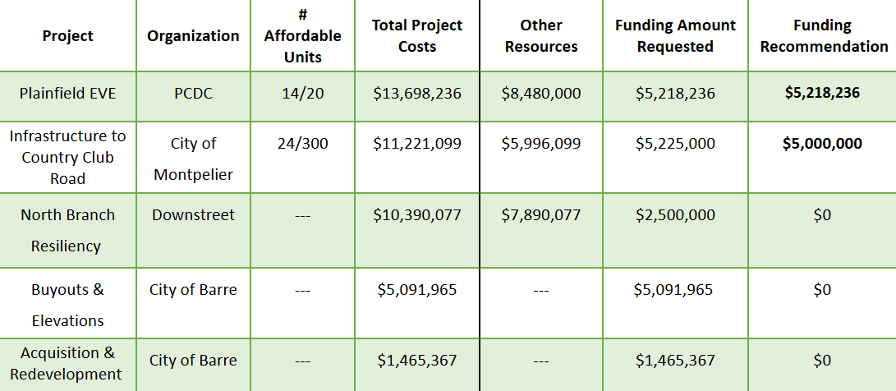

If the consent agenda is approved, there will be ~ $4.2MM left in funding for housing.

No questions from the Board.

John K asked for a motion to accept the consent agenda as presented.

Lisa made the motion. John B. seconded.

John K. asked for a roll call vote.

Maura: yes
David: yes
John B: yes
Liz: yes
Lisa: yes
Angus: yes
John K: yes

Unanimous vote to accept the consent agenda as made in the motion.

Adjourn
Maura made a motion to adjourn the meeting. The motion was seconded by John B.
The meeting adjourned at 1:50pm.

